Surviving in retirement
Teacher guide

Why should I use it?
The purpose of this retirement interactive is twofold:
- To show students how financial choices and events throughout their life impact on their ability to save for the long term, specifically towards retirement. Students will have to make choices about their career, savings, KiwiSaver contributions, insurances and car/home ownership, whilst trying to save for the long term. And as life is full of surprises, there are also a few unexpected events that may occur - all with an impact on their ability to save and wellbeing.
- As students have reached the milestone age of 65, they will be learning the difficulties of budgeting in retirement with the savings they have accumulated throughout the first part of the interactive. They will learn about the value of their personal savings and KiwiSaver to help them finance their life in retirement.
What are the learning objectives?
- Explore the financial capability concept of making smart money decisions with the eye on saving for retirement.
- Understand and analyse budgeting in retirement that shows the impact of life choices on the ability to live off retirement savings.
Who is it for?
It is designed for students who are working towards NZ curriculum level 4/5.
What do I need?
Students needs a computer/ chromebook or a handheld device such as tablet. This is not suitable for a mobile (i.e. phone) device.
How can I use it?
It can be used:
- as part of lessons related to financial capability concepts such as savings, KiwiSaver and retirement.
- as a set of lessons to use with other online interactive resources from Sorted in Schools.
- as a set of stand-alone lessons to teach financial capability with whānau groups.
- as students’ self-directed learning resource.

How does it work?
Group work/Individual: Students can work individually, in pairs or groups.
Prior knowledge: Students should understand the vocabulary prior to starting the activity.

PART I and II
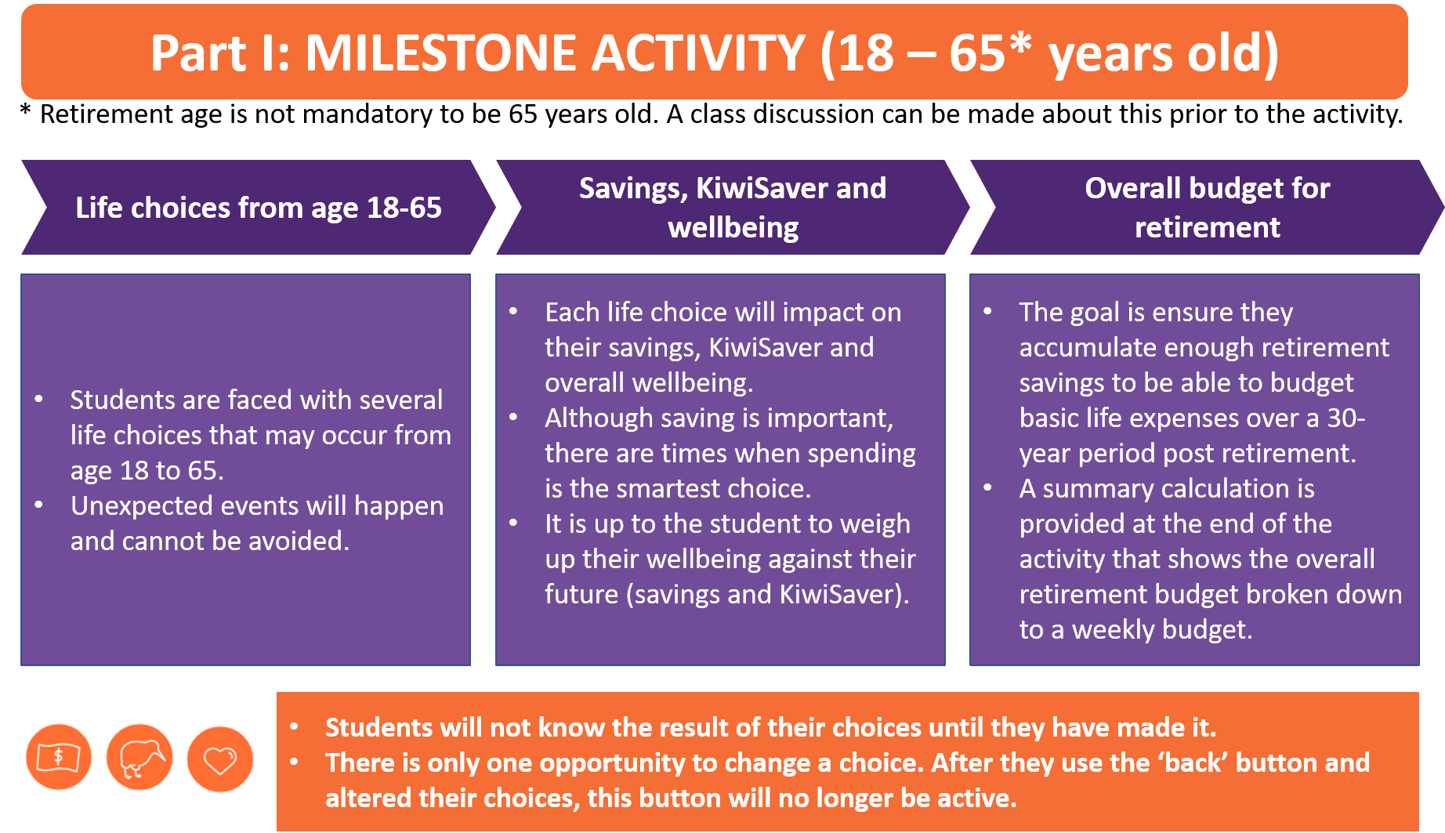

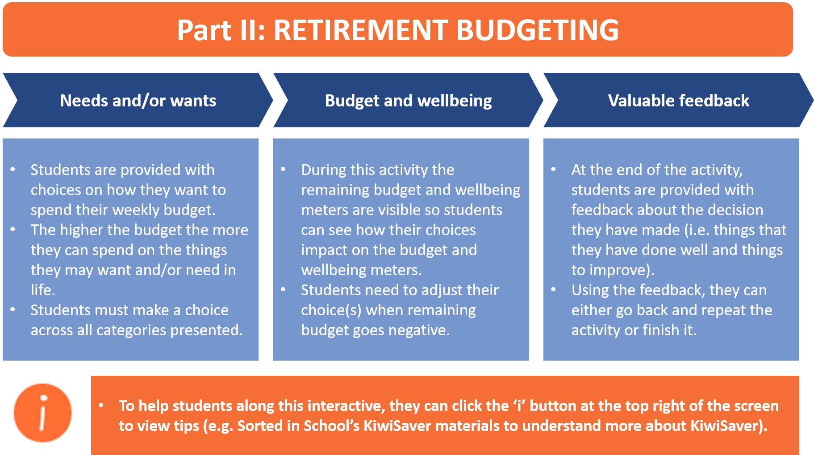

How does this activity link to the Level 4/5 Financial Capability progressions?

- Spending: Compare individual spending choices and priorities at different stages of life.
- Savings & investing
  - Explore how age, income, and circumstances affect financial decisions.
  - Investigate different investment products as a way of saving, e.g. KiwiSaver
- Budgeting & financial management: Describe life-stage financial event/s and the financial decisions required.
- Setting goals: Investigate how financial planning can help to attain life goals.

Financial vocabulary

Budget, Contents insurance, Debt, Deposit, Employer contributions, Expenses, Finance, Financial crisis, Financial goals, Income, Insurance, Interest, Invest, KiwiSaver, Loan, Long term, Managing money, Superannuation, Retirement, Salary, Savings, Wellbeing.

To view definition of these terms please visit: https://sortedinschools.org.nz/about/support/glossary/

Sorted Themes

In this interactive, students are given information and activities that relate to the Sorted Themes. These help students build financial attitudes and beliefs, knowledge, and behaviours specific to each theme.

