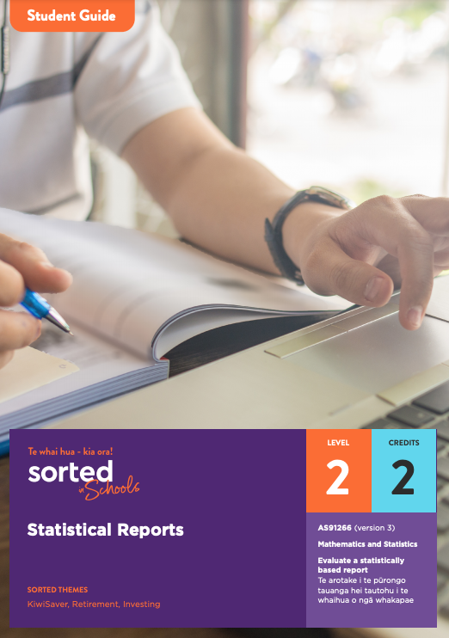

Student Guide

Statistical Reports

AS91266 (version 3)
Evaluate a statistically based report | Te arotake i te pūrongo tauanga hei tautohu i te whaihua o ngā whakapae
Mathematics and Statistics

Level: 2
Credits: 2

Sorted Themes:
KiwiSaver
Retirement
Investing

Nau mai haere mai!
Welcome to the Statistical Reports module. This module is part of a series of NCEA learning materials available from Sorted in Schools - Te whai hua - kia ora!
This student guide provides an overview of the content and context explored in the module, assessment information, resources, and useful links.

The other documents in the module are:

- A student booklet that supports you to develop the skills, knowledge, and understanding that you need to meet the requirements of an NCEA achievement standard.
- A practice booklet that provides opportunities for you to apply and consolidate your learning.
- An answer booklet to accompany the practice booklet.
- A vocabulary list of key terms.

Each booklet is provided as a Word document and PDF to use online or printed. When used online, you can type your answers into the practice booklet.
As you work through the module, you’ll be completing activities that will prepare you for an internal assessment of AS91266: Evaluate a statistically based report Te arotake i te pūrongo tauanga hei tautohu i te whaihua o ngā whakapae (version 3).

Achievement Criteria

Achievement | Achievement with Merit | Achievement with Excellence
Evaluate a statistically based report. | Evaluate a statistically based report, with justification. | Evaluate a statistically based report, with statistical insight.

Achieving AS91266 contributes two credits towards the 10 Numeracy credits at Level 1 or above that you need for University Entrance (UE). Other Sorted in Schools modules that can support you to gain Literacy and Numeracy credits are:
- Money Matters (AS91026, Level 1, 4 credits)
- Questionnaire Design (AS91263, Level 2, 3 credits)
- Statistical Inference (AS91264, Level 2, 4 credits)
- Economic Data, Issues, and Analysis (AS91226, Level 2, 4 credits).

About Sorted in Schools – Te whai hua – kia ora!
Sorted in Schools is a government-funded financial capability programme fully aligned to the New Zealand Curriculum. Free to use, Sorted in Schools helps young New Zealanders develop their money skills.

Why financial capability matters
Being good with money is an essential life skill. Financial capability means being equipped with the knowledge, skills and confidence to make good financial decisions at each life stage, and attain goals with choices. Research shows that 16-24 year olds are, however, vulnerable to falling into debt that can hold them back. In addition, over 80% of school leavers told us they wished they had learned more about money at school. We’re changing that! Our learning materials equip you with know-how to start your financial journey on the right foot. The earlier you become good with money, the better you will fare throughout your life.

Build your financial capabilities while you learn about statistical reports
This module is designed to support you to both achieve success in selected NCEA assessment and build your financial capability toolkit.
Financial capability involves developing skills that will help you to feel confident about how to use and manage your money in order to achieve your goals, both now and in the future.
All of the Sorted in Schools learning materials include a combination of key financial capability concepts, or Sorted Themes, to help you develop your financial skills, knowledge, and behaviours. In this module, you will come across these Sorted Themes:
SavingsKiwiSaver Investing

You can find resources linked to each of these themes on the student activities page of the Sorted in Schools website. Click on Theme and select an option from the dropdown menu. The resources include booklets, powerpoints, infographics, videos, and interactive activities. You can search for different types of resources using the Media option.
The particular focus in this module involves understanding some of the decisions involved in investing in KiwiSaver.
Investment should always be an active and informed process that involves recognising and weighing up your personal needs, goals, and values. The report you will be exploring within the module is about ethical KiwiSaver investing, but this is just one of several factors that you should consider when choosing a KiwiSaver provider.
Here is some background information on KiwiSaver, along with some useful links to find out more.

KiwiSaver
KiwiSaver accounts are investment funds, and we need to get savvy about how and where we’re investing our savings. It’s a voluntary scheme that any New Zealand citizen can join. When you invest in KiwiSaver, investment experts invest the money in your KiwiSaver account so that it grows over time.
KiwiSaver funds are mainly for retirement, so although it's your money, you can’t use it until you turn 65. Two important exceptions are that you can use your funds to help buy your first home (after investing in KiwiSaver for at least three years) and, if you end up in a situation where you can’t afford to pay for things such as food or shelter, you can apply to get access to the contributions you have made.
To encourage people to invest in KiwiSaver, the government contributes 50 cents for every dollar people aged 18 to 65 invest, up to a maximum of $521 a year.
You can read more about KiwiSaver using this Sorted KiwiSaver guide.
There are a number of choices to be made when you join KiwiSaver, including: which provider you will use, what level of investment you will make, the level of risk you want to take, what fees you are prepared to pay, and, for some investors, what you are willing or not willing to invest in. Each of these factors is described below.

KiwiSaver provider
KiwiSaver providers are organisations that manage and invest KiwiSaver funds. You can choose which KiwiSaver provider you want to use. If you don’t choose a provider, Inland Revenue will assign you to one of the nine default KiwiSaver schemes. When you invest in KiwiSaver, it’s important to play an active role in choosing which scheme best suits your needs. Sorted.org provides a handy tool to help people understand their options: http://fundfinder.sorted.org.nz/

Level of investment
If you are an employee, you can choose how much of your pay goes into your KiwiSaver account. The options are 3%, 4%, 8%, and 10% of your pay. You can also make lump sum payments at any time. Your employer has to put in at least 3% of what you get paid as well – that’s extra money that you don’t get if you’re not a KiwiSaver investor.
If you are a freelancer, gig worker, contractor, or work for yourself, you can choose how much money you want to invest and have the option of making regular payments and/or paying lump sums.

Level of risk
All investments involve an element of risk. When you join KiwiSaver, you can choose the level of risk you want to take. There are five different levels. For example, if you want a low level of risk, you might choose a “defensive” fund. If you want a higher level of risk, with potentially higher returns, you might prefer a “growth” or “aggressive” fund. If you’re somewhere in-between, you might choose a “balanced” fund.
Factors that contribute to the level of risk that people choose include how soon they will want to use the money and their personal feelings about taking financial risks.
You can read more about KiwiSaver fund types and levels of risk on the Sorted website. This Fund Finder tool can help New Zealanders work out which type of fund is right for them.

Fees and level of service
KiwiSaver providers charge fees for investing and managing your investment. Some KiwiSaver providers charge more than others.
This Smart Investor tool allows anyone to see what their KiwiSaver is being invested in along with fees and returns.

Ethics
Each KiwiSaver provider pools together the money people have saved and invests it in different companies and industries. They do this because investing in a range of things helps to spread out the risks involved in investing.
For many KiwiSaver investors, it’s important that the ways their money is being invested aligns with their values. For example, some KiwiSaver investors don’t want their money invested in companies that make money out of selling land mines, weapons, tobacco, or fossil fuels. “Socially responsible” KiwiSaver providers offer options that can filter out investments like these.
Finding out what your KiwiSaver funds are invested in is not always straightforward. A KiwiSaver fund that promotes itself as being ethical may still invest in things that don’t match your values, for example, gambling or alcohol.
You can read more about ethical KiwiSaver investments on the Sorted.org.nz website.

Overview of the Statistical Reports student booklet
Here is an overview of the topics you will explore in this module:

Topic One: Introduction to statistical reports and the contexts for this module
What a statistical report is, the statistical enquiry cycle, background information on KiwiSaver and Mindful Money

Topic Two: Identifying the purpose and the population of interest
How to identify the purpose, target and sample populations.

Topic Three: Population measures and variables
Types of data (qualitative and quantitative), Likert scales

Topic Four: Sampling methods and statistical errors
Sampling methods (simple random, stratified, quota, volunteer), sampling error, non-sampling errors, weighting.

Topic Five: Survey methods
Postal questionnaires, telephone surveys, online surveys.

Topic Six: Commenting on the findings of a report and structuring your own report
Making links between the findings of the report and its purpose, evaluating the findings, using the PPDAC statistical enquiry process to structure your report.

Understanding how you will be assessed
For your assessment, you’ll be given an excerpt of a statistical report to evaluate. This table provides a summary of the evidence required for achievement at different levels:

Evidence/Judgements for Achievement | Evidence/Judgements for Achievement with Merit | Evidence/Judgements for Achievement with Excellence
I can identify the purpose of a statistical report.  I can identify and comment on features of the survey relevant to its purpose, for example:  - the population measures and variables  - the sampling methods  - the survey methods  - sampling and possible non-sampling errors  - the sample size  I can identify and comment on the findings of the survey relevant to its purpose. | I can identify the purpose of a statistical report.  I can support my comments on the features of the report with reference to statistical evidence and the statistical processes used to carry out the sample, for example:  - identifying the survey method and commenting on the response rate with specific reference to the data provided in the report  - commenting on the effectiveness of an aspect of the survey method with respect to the purpose of the report  - identifying and discussing the sampling method with reference to a practical aspect of obtaining adequate data relevant to the purpose of the survey  - making specific reference to examples in the report that link summary comments with how the data has been presented.  I can support my comments on the findings of the report, with reference to statistical evidence and the statistical processes used to gather and interpret data. | I can identify the purpose of a statistical report.  I can integrate statistical and contextual information to assess the quality of the report in terms of its purpose. This could include:  - evaluating the survey method used to gather data, including limitations of the approach and/or sample size  - identifying omissions or gaps in either the data collection process or in the information provided in the report  - identifying potential sources of bias and suggesting how these could be avoided  - suggesting improvements or areas of further exploration  - evaluating the reliability, usefulness and/or comprehensiveness of the conclusions of the report  - referring to examples that support and examples that do not clearly support the conclusion.

Report Template
You may wish to use the following template to help you organise your report.
Title:
Source of statistically based report:
Summary of the report – a one paragraph summary of the report, including the purpose of the report and identification of the population of interest.
A description of population measures and variables. | Evaluation
A description of sampling method(s). | Evaluation
A description of survey method(s). | Evaluation
A description of the sampling and possible non-sampling errors. | Evaluation
A description of the sample size | Evaluation
A description of the presentation | Evaluation
An evaluation of the findings of the survey and how they relate to the purpose of the report.
An overall evaluation of the effectiveness of the statistically based report.

