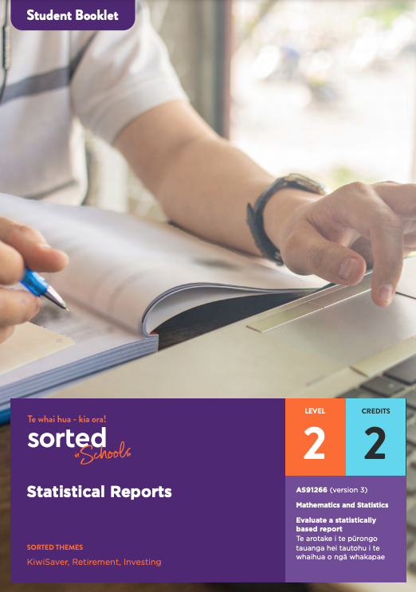Student Booklet

Statistical Reports

AS91266 (version 3)
Evaluate a statistically based report | Te arotake i te pūrongo tauanga hei tautohu i te whaihua o ngā whakapae
Mathematics and Statistics

Level: 2
Credits: 2

Sorted Themes:
KiwiSaver
Retirement
Investing

Nau mai haere mai!
Welcome to the Statistical Reports module. Please read through the Student Guide for an overview of the module, context, and assessment before starting this Student Booklet.

Contents

Topic One: Introduction to statistical reports and the contexts for this module

Topic Two: Identifying the purpose and population of interest

Topic Three: Population measures and variables

Topic Four: Sampling methods and statistical errors

Topic Five: Survey methods

Topic Six: Commenting on the findings of a report and structuring your own report

Topic One: Introduction to statistical reports and the contexts for this module
Learning outcomes for Topic One:
- Understand what statistical reports are
- Understand the contexts explored in this module; KiwiSaver and ethical investing
Success criteria:
- I can explain what a statistical report is
- I can give an example of investments that some people consider to be unethical.

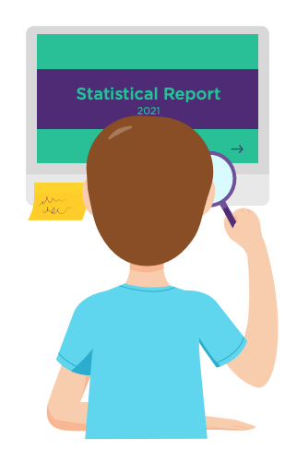
Introduction
The focus of this module is on learning how to evaluate a statistical report.
A statistical report is a written document that interprets and communicates the results of a data gathering process such as a survey. A good quality statistical report is easy to understand, uses everyday language, and is based on sound statistical processes.
Statistical reports play an important role in our society because data and statistics can be powerful agents of change. Governments and individuals need reliable and up-to-date data to help make good decisions. For example, we need reliable and up-to-date data to better address and overcome challenges such as child poverty, inequality, and climate change.
As a citizen of Aotearoa New Zealand, you have a right to public information. A well-written statistical report can help you to make sense of patterns and trends in data and build your understanding of important topics.
For examples of statistical reports see StatsNZ’s Reports web page.
The statistical enquiry cycle
A statistical report should provide information related to each component of the statistical enquiry cycle:
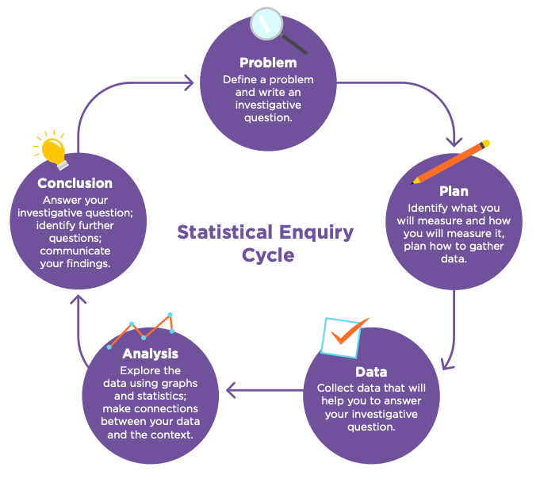
We’ll be returning to this cycle later in the module.

The context of this module
Throughout this module, we’ll be referring to a statistical report published by Mindful Money:
Responsible investment: NZ Survey 2019 A report exploring New Zealander’s attitudes towards responsible investment.
The steps we go through in evaluating this report are similar to the steps you’ll be going through in your assessment. The first step is to read the report. Activity One in the practice booklet has some tips on what to pay attention to on your first read.

<Now do Topic One Activity One>
The next step when evaluating a statistical report is to make sure you understand the context it is exploring. Context is background information that helps us to understand the circumstances around an event, statement, or idea. Before reading about the Mindful Money report, make sure that you have read the information in the Student Guide about KiwiSaver and ethical investing.

<Now do Topic One Activity Two>
Mindful Money
Mindful Money is an Aotearoa New Zealand charity that aims to shift the ways that people invest their money away from investments involving pollution and exploitation and towards sustainability.
This is how Mindful Money views ethical investment.
Most investment has traditionally focused only on financial returns and risks. This means the financial world has been separated from the impacts that arise from investment decisions. The consequences of decisions like selling cigarettes to children or clear-cutting native forests have not been taken into account. If there is a good financial return, investors have ignored the real world impact.
Times have changed. We live on an increasing small and ecologically-stressed planet and there is rising concern over the impact of companies on individuals and communities. Consumers are now far more conscious about the impact of their purchases and governments are strengthening regulation.
There is also a growing movement of investors who understand that the connection between investment and real world impact. They want their funds to avoid pollution or exploitation, and to invest in companies with high ethical standards.
Watch Mindful Money’s About Us video

<Now do Topic One Activity Three>
Before moving on to Topic Two, check that you understand:
- What a statistical report is
- What the vision of Mindful Money is.

Topic Two: Identifying the purpose and population of interest
Learning outcomes for Topic Two:
- Understand how to identify the purpose of statistical reports
- Understand how to identify the target population of statistical reports.
Success criteria:
- I can use the title and introduction of a statistical report to identify its purpose
- I can explain why it’s useful to know who funds a statistical report
- I can identify the target population of a statistical report.

Identifying the purpose
Gathering statistical data that is reliable and accurate is a time-consuming and expensive process, so no one would create a statistical report just for the sake of it. Statistical reports are always created for a purpose.
The purpose of a report will determine what data is provided, which findings are highlighted, and how the report is presented.
To identify the purpose of a report, you need to think about:
- what it is about
- who funded it
- how the data and findings might be used.
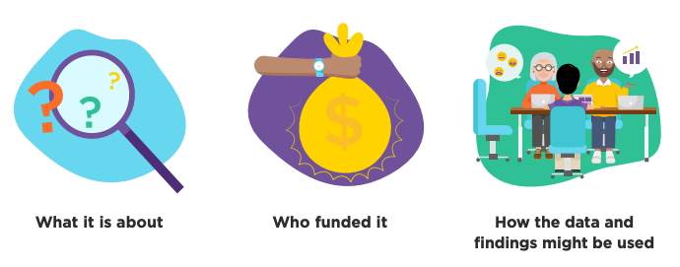
Assessment tip
Identifying the purpose of the statistical report is an essential requirement of the assessment.
When evaluating features of the statistical report, you will need to show how each of these features relate to the purpose of the report.

The first place to look when identifying the purpose of the report is the title. A good title should inform readers about the focus of the report and the time period it relates to.

<Now do Topic Two Activity One>
Identifying who funded the research
Knowing who funded the research can help you to understand why it was created. For example, Mindful Money is a charity that promotes ethical investing. They want to make it easy for New Zealanders who want to invest ethically to be able to find out information about how money in funds such as KiwiSaver are invested.
How might the data be used?
The audience of a report are the individuals or groups who might be interested in the context it explores.
Individuals, organisations, iwi, businesses, and community groups may be able to use the information to influence decision making.
Assessment tip

One way to identify who might use the information in a statistical report is to do an internet search to find out who is already sharing or quoting it.

Mindful Money can use their report to show KiwiSaver providers that many New Zealanders are interested in ethical investing. This might encourage KiwiSaver providers to be more active about offering ethical funds and more likely to make the investment process more transparent.

Target populations
The most common meaning of the word population is the number of people who live in a particular place. For example, in March 2020, the population of New Zealand reached 5 million people. The word population can also mean a group of people who have something in common, for example, New Zealanders who live in rural areas.
In statistics, the word population has a much broader meeting. It means an entire group of people, animals, plants, or things that we want to learn about or describe. So the target population you need to identify in your assessment task needs to be the particular group of people that the report is about.
Assessment tip:
When identifying the target population, include the time and place as well as the group of people, for example: KiwiSaver investors in Aotearoa New Zealand in 2019.
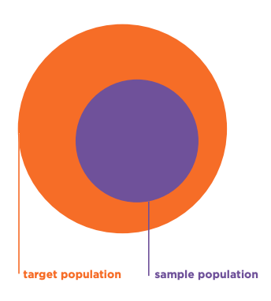
The difference between a target population and a sample population
In Topic Four of this module you’ll explore ways that a sample can be taken from a population. One thing to look out for is whether the target population is the same as the sample population.
A sample population is the group that you actually take the sample from. So what’s the difference?
The Mindful Money report is on the attitudes of New Zealanders to responsible investment. At first glance, it sounds like the target population is “all New Zealanders”. However, it doesn’t make sense to ask a five-year-old what they think about responsible investment. Instead, the sample population is people 18 and over who have access to the internet.
If information on the target and sample populations isn’t directly stated, you can usually work out both based on both the title of the report and the data that is gathered.

<Now do Topic Two Activity Two>
Before moving on to Topic Three, check that you understand:
- How to identify the purpose of a statistical report
- Why it’s important to know who has funded a statistical report
- What a target population is.

Topic Three: Population measures and variables
Learning outcomes for Topic Three:
- Understand what population measures are and how to identify them
- Understand what population variables are
- Understand different types of data.
Success criteria:
- I can explain the difference between qualitative and quantitative data
- I can explain what a Likert scale is and why they are often used in surveys.
After you have identified the purpose of the statistical report you are evaluating, the next step is to identify the data that the report is based on.
Assessment tip

In your assessment, give a specific example of the type of data that the report is based on, and show how this relates to the purpose of the statistical report.

Population measures
Population measures are the key characteristics of the population that researchers are estimating based on the data they collect. Key population measures include:
- the mean or median of a population, for example, the median amount people invest in KiwiSaver each year.
- the proportion of a population who have a certain attribute, for example, the percentage of people who choose to invest their KiwiSaver funds in growth fund types.

Variables
Variables can be quantitative or qualitative.

Types of data
Quantitative data involves data that has been counted or measured. Surveys that gather quantitative data often have questions that start with words such as how many, how much, or how often. One advantage of quantitative data is that it is easy to analyse.
Qualitative data describes qualities or characteristics; for example, gender, cultural identity, or opinions.
In Aotearoa New Zealand, many statistical reports gather data on the ethnicity, gender, age, and location of respondents. These variables are important because there may be differences between these groups that deserve further investigation.
<Now do Topic Three Activity One>

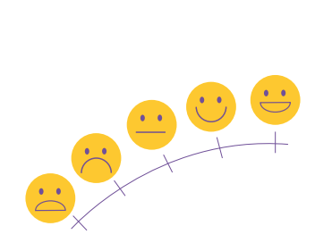
Likert scales
Likert scales are an example of a way that qualitative data such as people’s opinions or attitudes towards something (qualitative data) can be quantified (analysed using numbers).
Likert scales involve giving respondents statements and asking them to rate how much they agree or disagree with them.
A format of a typical five-level Likert scale could be:
- Strongly disagree
- Disagree
- Neither agree nor disagree
- Agree
- Strongly agree
Several of the questions in the Mindful Money survey were based on Likert statements. Here is an example:
Question 11: How much do you agree or disagree with the following statement:
I expect my KiwiSaver and investments to be invested responsibly and ethically.
Not sure Strongly disagree Disagree Neither agree nor disagree Agree Strongly agree
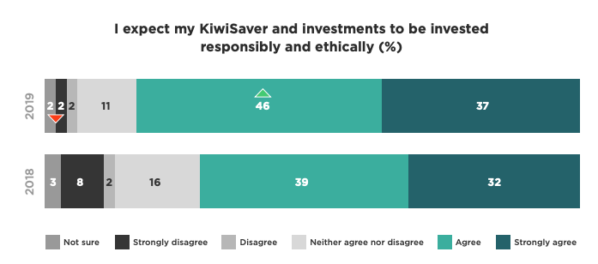
Image source: mindfulmoney.nz/media/blog/file/da/nz-consumer-survey-2019.pdf page 10
Before moving on to Topic Four, check that you understand:
- What the terms “population measures and variables” mean, and how to identify them within a statistical report
- The difference between qualitative and quantitative data.

Topic Four: Sampling methods and statistical errors
Learning outcomes for Topic Four:
- Understand different sampling methods
- Understand sampling and non-sampling errors
Success criteria:
- I can explain three sampling methods
- I can explain what sampling error is
- I can give two examples of non-sampling errors.
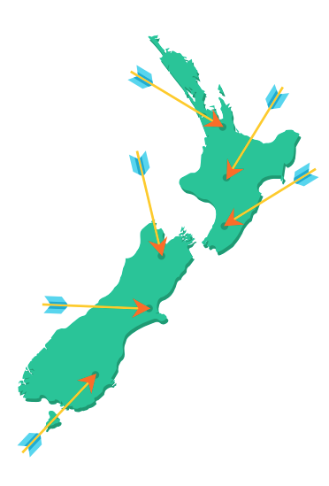
An important part of evaluating a statistical report is critiquing the accuracy of the data it is based on. If the report is based on a survey, it’s important to consider who was included in the survey and who was left out.
Gathering information from everyone in a target population would make the data you gather very reliable and trustworthy. However, in real life this is seldom possible because:
- It may not be possible to contact everyone in the target population, for example, if you are sharing the questionnaire electronically, people who don’t have access to the internet won’t be able to participate
- Inviting everyone in the target population is often time-consuming and expensive
- Not everyone you invite to take part in the survey will want to be involved.
Because of these challenges, a statistical report is almost always based on a sample, which is a group taken from a population.
In an ideal world, a sample would be exactly the same as the population it comes from, just smaller in size or amount. A sample is representative if it accurately reflects the characteristics of the population. For example, if one third of a school are senior students, then a sample would be representative (in terms of juniors and seniors) if one third of the sample are seniors.
In real life, it’s very difficult to get a sample that is a perfect match for the population it is from. Statisticians know that their findings will not be perfect. However, if a sample is large enough and chosen carefully, it can still provide lots of important information about the population from which it is taken.
There are different methods of selecting a sample. Here are some common methods, along with their strengths and weaknesses.

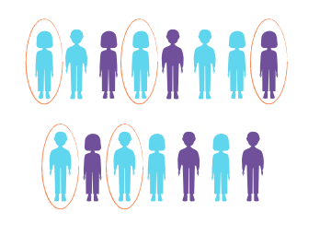
Simple random sampling
A statistical sample is random if everyone or everything in the population has an equal chance of being selected.
To conduct a simple random sample, you first need a list of everyone in your target population. Once you have this, you can use a computer programme to randomly select people.
Simple random sampling works best when you have a small population.
Advantages of simple random sampling | Disadvantages of simple random sampling
Simple random sampling is unbiased – if you have a list of everyone in your population, everyone has an equal chance of being in the sample.  If the sample is large, it is likely to have similar characteristics to the population. | If your target population is large, it may not be possible to get a list of everyone in it.  You may not be able to contact the people who are selected.  The people selected for the sample may not want to be involved.  Simple random sampling can be time consuming and expensive.

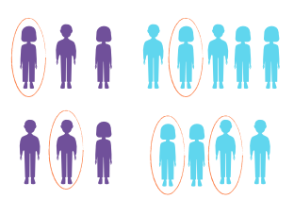
Stratified sampling
Stratified sampling involves identifying sub-groups in the population, for example, the percentage of people who are employed full-time, part-time, or unemployed. The sample is selected in a way that means that each group makes up the same percentage of the sample as they do of the population. Importantly, the sample taken from each group is selected using random sampling methods.

Advantages of stratified sampling | Disadvantages of stratified sampling
Stratified sampling can make a sample more representative of the population than simple random sampling. | Stratified sampling can be time consuming.

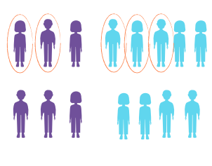
Quota sampling
Like stratified sampling, quota sampling involves dividing the population into subgroups, for example, groups defined by age, gender, region, employment status, or ethnicity. The researcher selects people from each subgroup to be in the sample. However, unlike stratified sampling, the sample taken from each group isn’t selected randomly. Instead, the person collecting the data can select people from each group anyway they like, as long as they reach the required quota.

Advantages of quota sampling | Disadvantages of quota sampling
It helps to ensure that different subgroups are represented in the survey. | The researcher may not gather people in an unbiased way.

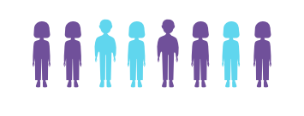
Volunteer sampling
A volunteer sample involves inviting people to take part in your survey, for example, via a public online survey. In other words, you don’t choose the sample, they choose you.

Advantages of volunteer sampling | Disadvantages of volunteer sampling
Volunteer sampling can be cheap and fast. | Volunteer sampling is biased – not everyone in the population has an equal chance of being chosen.  The respondents might not represent the population. For example, they might all be people who have strong feelings or views about an issue.

These are just four types of sampling, but there are lots of other types, each with advantages and disadvantages.
You can learn more about sampling methods using this Statistical Learning Centre video Sampling: Simple Random, convenience, systematic, cluster, stratified - Statistics Help.

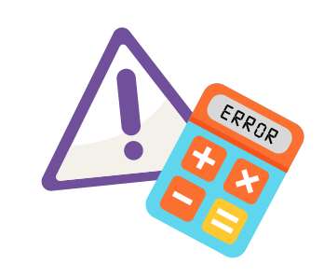
Statistical errors
In everyday use, the word “error” means that a mistake has been made. In statistics, the word error has a more specific meaning.
A statistical error is the difference between the value you get from a data collection process and the true value for a population.
If the error is small, the data you have gathered accurately represents the population. If the error is large, the data you have collected is not very accurate.
No one likes errors, but they are an accepted part of the survey process.
Assessment tip

A good statistical report makes it clear that there is some uncertainty in the statistical information that the report is based on. They can do this by providing information about the strengths and limitations of the data gathering process.
The presence or absence of such information is something that you can comment on in your evaluation.

Here are some examples of statistical errors that relate to surveys.

Sampling error
Sampling error is the error that happens whenever you use a sample rather than surveying the whole population.
Because a sample is only a part of the population, we can never guarantee that the information that a questionnaire gathers is a perfect match for the population; if we take a different sample, we will almost certainly get a different result. Using a large sample and making sure that everyone has an equal chance of being in the survey can help to reduce sampling error.

Non-sampling errors
Non-sampling error is the error that comes from other factors in the data collection process. Some non-sampling errors can occur even if everyone in the population is included in the survey.
There are lots of different types of non-sampling errors.
Sampling bias is a statistical error that relates to the way that a sample is selected from the target population. For a sample to be unbiased, everyone in the target population needs to have an equal chance of being selected for the sample.
Non-response bias occurs when people decide not to complete some or all of the survey. Non-responses increase the sampling error because they reduce the sample size, and if the people who decide not to complete the survey have a characteristic in common, it creates bias.
Response bias is when respondents don’t answer questions accurately or truthfully.
Here are some examples of factors that can lead to response bias.
- Some people may have barriers that make it difficult for them to participate or to understand a question, for example, if English is not their first language
- People aren’t always honest when participating in a survey because they don’t want to look bad
- People might interpret a question or answer differently to the way you intended.
Assessment tip
One of the requirements for achievement with Excellence is to “integrate your statistical and contextual knowledge”. This means making connections between statistical concepts and the report you are evaluating. One way to do this is to discuss sampling and non-sampling errors and how these might relate to the design of the survey the statistical report is based on.

<Now do Topic Four Activity One>

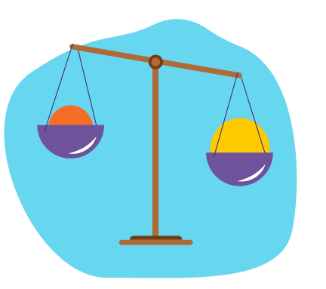
Weighting
Weighting is a statistical process that involves balancing out differences between the sample and the population. For example, in 2018, 15.1 percent of the population of Aotearoa New Zealand identified as being Asian. If a sample intended to represent the population ends up with a lower percentage of Asian participants, the data can be adjusted to try to make it better represent the population. This is done by giving greater “weight” to some data values, for example, by treating one data value as representing 1.25 people instead of just a single person. You don’t need to understand the maths behind how this is done, but it’s worth commenting on if you see reference to it in a report.
Data weighting can make the sample a better match for the population it represents, but it can also make the findings less accurate. This is particularly true when the sample is small. If the survey involves thousands of respondents, weighting has very little impact on accuracy. If the survey has less than 100 people, then weighting can have a significant impact on accuracy and should only be used with caution.

Before moving on to Topic Five, check that you understand:
- What a sample is and some ways that samples can be selected
- The difference between sampling error and non-sampling errors.

Topic Five: Survey methods
Learning outcomes for Topic Five:
- Understand the strengths and weaknesses of different survey methods
- Understand how survey methods can lead to bias.
Success criteria:
- I can identify at least two types of survey methods
- I can give an example how survey methods can create bias.

Once you have critiqued the sampling method used to gather data, the next step is to examine how the data was collected.
One of the most common ways to gather information from a large number of people is to create a questionnaire (a set of written questions). Questionnaires can be used to collect quantitative data, such as how much people save each week, as well as qualitative data about people’s beliefs, behaviours, and opinions.
There are several ways to get questionnaires out to people. These are called survey methods.
Assessment tip

The survey method used to gather data is a key feature that you can comment on in your report, including the strengths and weaknesses of the method. If the statistical report doesn’t mention which survey method was used, you can comment on the absence of this important information.

Three common survey methods are:
- Postal questionnaires – participants are sent a paper copy of a questionnaire and asked to complete it and return it via mail
- Telephone calls – people are contacted by phone (both landline and mobile). The numbers called are randomly generated. Sometimes the “interviewer” is a computer rather than a human.
- Online surveys – people are invited to fill in a survey via email, social media, survey websites, messaging apps, or through QR codes.
Bias happens when not everyone in the population has an equal chance of being in the survey and is a key issue with any survey method.
Here are some advantages and disadvantages of different survey methods.

Postal questionnaires
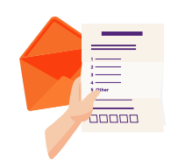
Advantages | Disadvantages
Participants can choose when and where they complete the questionnaire. This is particularly important if the questionnaire is very long. | There’s a high likelihood that people won’t send back the questionnaire, creating non-response bias.  Sending out questionnaires via post is expensive and it takes a long time to collect the data.

Telephone surveys
Advantages | Disadvantages
Telephone interviews can have higher response rates than web surveys.  Using telephone interviews can make it easier to fulfil a quota (a set number of people from different groups). | People who don’t have telephones are excluded from the survey, creating bias.  Some people don’t answer their phones if they don’t recognise the caller.  The time of day that the call is made can influence how likely it is that someone receives and/or answers the call (note that some researchers make repeated calls to address this).  People may not give honest answers if they think their responses could be judged in a negative way.

Online surveys
Advantages | Disadvantages
Online surveys are a relatively cheap option.  People may be more honest in an anonymous online survey than they would be in a telephone call.  People can choose when they want to complete the questionnaire. | Online surveys are more likely to be completed by people who are active online, especially people with social media accounts. This means that people on lower incomes, people living in rural areas where there is poor connectivity, and elderly people may be less likely to be included in the survey.  Online surveys are often voluntary. People who participate in the survey may have characteristics in common such as having similar or strong views on a topic.

<Now do Topic Five Activity One and Two>

Before moving on to Topic Six, check that you understand:
- Different survey methods
- How different survey methods can create bias.

Topic Six: Commenting on the findings of a report and structuring your own report
Learning outcomes for Topic Six:
- Understand how to discuss and evaluate the findings of a statistical report
- Understand how to structure your statistical report.
Success criteria:
- I can discuss the findings of a statistical report with respect to its purpose
- I know how to structure my report.

The final stage of your evaluation of a statistical report involves commenting on its findings. An important distinction here is that you are not required to make your own conclusions from the report. One thing to look out for is whether the report makes links to other statistics, data, and research on the same (or related topics). For example, is the survey building on or challenging previous research findings?
Assessment tip
At Achieved level, the focus is on:
- how the findings relate to the purpose of the report, for example, do they help to answer the investigative question and/or match the title of the report
- why (or whether) the findings are useful and who could use them.
At Merit level, you also need to refer to statistical evidence and the processes used to gather and interpret data. For example, you could
- discuss how reliable the findings are by referring to the sample size and/or survey method
- identify differences between the target population and the sample population
- discuss sampling or non-sampling errors.
At Excellence level, you need to evaluate the findings in terms of its purpose. There’s no set way to do this, but it could include:
- identifying gaps in the data gathered or the groups represented
- evaluating the usefulness of the findings, for example, can it contribute to societal change
- suggesting possible improvements or areas that need further investigation.

<Now do Topic Seven Activity One>
Structuring your report
At the start of this module, a connection was made between the statistical enquiry cycle and statistical reports. Now that you’ve seen the steps involved in identifying features of a statistical report, let’s take a look at how these relate to the statistical enquiry cycle. You can use the questions under each stage of the cycle to structure your own evaluation of a statistical report:
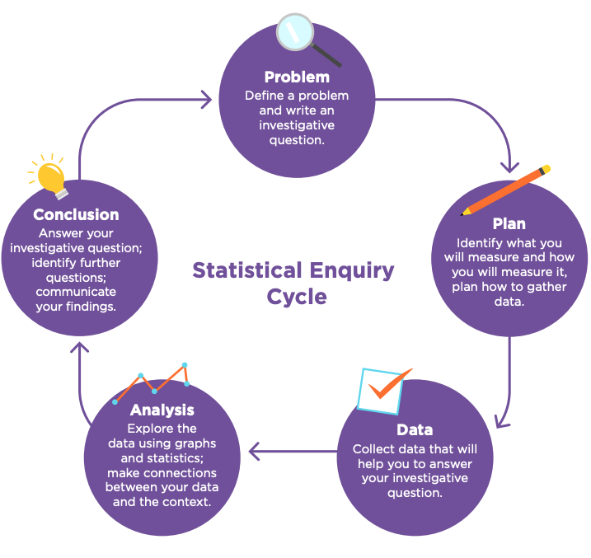
Problem:
- What is the overall purpose of the report?
- What is the purpose of the survey (what is the investigative question)?
- What is the population of interest?
- Who would be interested in the report?

Plan:
- Where does the data quoted/used in the report come from?
- What were the variables of interest?
- How were the variables of interest measured?
- What sampling method was used? Was it appropriate?
- What survey method was used? What are the strengths and weaknesses of this method?
- Were the survey questions appropriate?

Data:
- What sort of data was collected (qualitative or quantitative)?
- Is there evidence of sampling or non-sampling errors?
- Is any important data missing?
- How accurate is the data?

Analysis:
- How was the data analysed?
- What statistics were calculated?
- How are the data communicated (displays, statistics)?
- Is the communication of the data effective (displays, statistics)?
- Does the way information is presented reflect uncertainty in the statistics?
- Could the data have been analysed and interpreted differently?

Conclusion:
- Are the claims made valid or sensible?
- Are the claims communicated clearly?
- What further information is needed?
- What could the information in the report be used for?
- Are there aspects of the statistical process which cast doubt on the conclusions?

You’ve had a close look at the Mindful Money report on New Zealander’s attitudes towards responsible investment. Now it’s time for you to attempt a practice task that involves evaluating another statistical report.

<Now do Topic Seven Activity Two>
Before moving on to your assessment, make sure that you understand:
- How to evaluate the findings of a statistical report in relation to its purpose
- How to use a framework to structure your evaluation of a statistical report.

https://mindfulmoney.nz/pages/1/responsible-investment/

