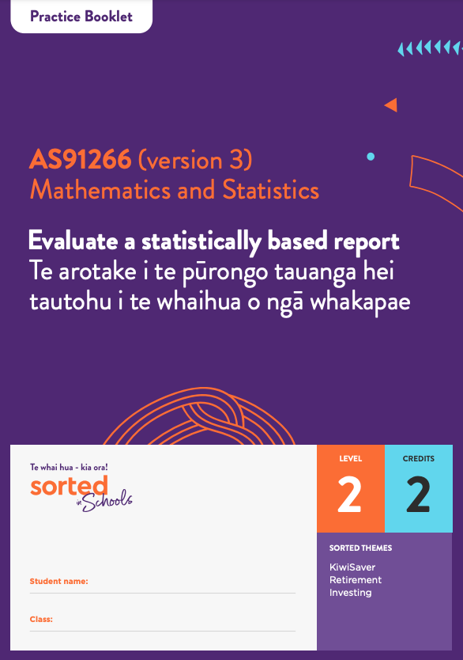

Practice Booklet

Statistical Reports

AS91266 (version 3)
Evaluate a statistically based report | Te arotake i te pūrongo tauanga hei tautohu i te whaihua o ngā whakapae
Mathematics and Statistics

Level: 2
Credits: 2

Sorted Themes:
KiwiSaver
Retirement
Investing

Topic One: Introduction to statistical reports and the contexts for this module
Topic 1 Activity 1

Download the 2019 Mindful Money report on attitudes to responsible investment.
Have a look at the report, paying particular attention to:
- the title (page 1)
- the key findings (page 4)
- the method used to collect data (page 6)
- the people surveyed (page 6)
- the headings of each page (pages 16–30).
Highlight, or make notes on, key ideas.
Identify words that you think are important, but you are not sure that you understand.
Try to get a sense of the overall message of the report and why it has been created.

Topic 1 Activity 2
- Answer these True/False questions about KiwiSaver
True/False
KiwiSaver is an investment scheme set up by the government to help people get ready for retirement.
You have to be at least 18 to invest in KiwiSaver.
You can’t access your KiwiSaver funds until you retire.
Your employer can choose whether to put money into your KiwiSaver account.
The government gives KiwiSaver investors up to $521 per year.
Your employer chooses which fund your KiwiSaver money is invested in.

Topic 1 Activity 3
- Read this Sorted.org blog on ethical KiwiSaver investments.
- What are three examples of investments that might be considered unethical?

Example 1 - _________________________________________________________

Example 2 - __________________________________________________________

Example 3 - _________________________________________________________

- Why might one person’s opinion about what an ethical investment is be different to another person’s opinion?

____________________________________________________________________
____________________________________________________________________

- Visit the “About us” section of the Mindful Money website:
Write down three facts about Mindful Money.

Fact 1 - ______________________________________________________________

Fact 2 - ______________________________________________________________

Fact 3 - _______________________________________________________________

Topic Two: Identifying the purpose and population of interest
Topic 2 Activity 1
The title of the Mindful Money report is:
Responsible investment: NZ Survey 2019
A report exploring New Zealanders’ attitudes towards responsible investment.
- Highlight keywords that let readers know what the focus of the report is, who the population of interest is, and what year the survey was done.
- On a scale of 1 to 5 (1 = very poor and 5 = excellent) how well does the title of the report let readers know what it is about? _____

Topic 2 Activity 2
- Read page 6 of the Mindful Money report. Based on the information provided, who is the population of interest? Remember to include the year and place in your answer.
____________________________________________________________________

- How does this population relate to the purpose of the report?
____________________________________________________________________
____________________________________________________________________

Topic Three: Population measures and variables
Topic 3 Activity 1
- Based on the information on page 6 of the Mindful Money report, what variables did the survey collect information on?
____________________________________________________________________

- Skim read the report to see whether you can find any other categorical variables.
____________________________________________________________________

- What might be another categorical variable that they could have collected information on?
____________________________________________________________________

Topic Four: Sampling methods and statistical errors
Topic 4 Activity 1
- The Mindful Money statistical report does not provide information on how the sample was selected.
Why would this information have been useful for your evaluation?
____________________________________________________________________
____________________________________________________________________
____________________________________________________________________
____________________________________________________________________

- If you were conducting a survey on New Zealanders’s attitudes to responsible investment, which sampling method would you use?
____________________________________________________________________

Give one advantage and one disadvantage of this sampling method.
____________________________________________________________________
____________________________________________________________________

- Explain why an unbiased sample may not be representative of the population it comes from.
____________________________________________________________________
____________________________________________________________________

Topic Five: Survey methods
Topic 5 Activity 1
A poll is a survey about people’s opinions on a subject that is taken from a selected or random group of people. Colmar Brunton is a well-known research agency who, among other research, collects data for 1 News polls.
Colmar Brunton provides information about the method they use to conduct their polls.
Visit the Colmar Brunton 1 News webpage and download the full report for the latest poll.
Use the table of contents to locate the Methodology summary.
- What was the target population? How does this relate to the purpose of the poll?
____________________________________________________________________
____________________________________________________________________

- What was the sample population? What differences are there between the target population and the sample population?
____________________________________________________________________
____________________________________________________________________

- Identify the sample size.
____________________________________________________________________
____________________________________________________________________

- Identify the interview (survey) method. What are the advantages and disadvantages of this method?
____________________________________________________________________
____________________________________________________________________

- Identify information about the variability of the sample results. Explain why this is useful.
____________________________________________________________________
____________________________________________________________________

Topic 5 Activity 2
a. Identify the survey method used to gather data for the Mindful Money statistical report (page 6).

____________________________________________________________________

b. What are the advantages of this survey method?

____________________________________________________________________
____________________________________________________________________

c. How might this survey method create bias?

____________________________________________________________________
____________________________________________________________________

d. Identify another non-sampling error that might affect the accuracy of the findings from the survey.

____________________________________________________________________

Topic Six: Presentation
Topic 6 Activity 1

Watch this TED talk on How to spot a misleading graph

- What are three ways that people can create misleading graphs?

1 - ____________________________________________________________________

2 - ____________________________________________________________________

3 - ____________________________________________________________________

Topic 6 Activity 2
Examine the visuals on page 14 of the Mindful Money report.
- Comment on the visual presentation of the information on this page.
For example:
- What is the key message of this page?
- How do the visuals support the numerical information?
- Are any aspects of the visuals misleading?
____________________________________________________________________
____________________________________________________________________
____________________________________________________________________

- How does the information on this page relate to the purpose of the report – New Zealanders’ attitudes to responsible investment?
____________________________________________________________________
____________________________________________________________________

Topic Seven: Commenting on the findings of a report and structuring your own report
Topic 7 Activity 1
Comment on the findings of the Mindful Money report in terms of its purpose by answering the following questions.
- Based on the Key findings on page 4 of the report, does the Mindful Money report provide relevant information about New Zealanders’ attitudes towards responsible investment?
Give a specific example to support your answer.

____________________________________________________________________
____________________________________________________________________
____________________________________________________________________

- Suggest one way that the findings of the report might be useful, for example, to a KiwiSaver fund provider.

____________________________________________________________________
____________________________________________________________________

- How reliable are the findings of the report? For example:
- Are they based on a large sample that is likely to represent the population?
- Are there any differences between the target population and the sample population?
- Are there any examples of non-sampling errors?
____________________________________________________________________
____________________________________________________________________
____________________________________________________________________

- Evaluate the findings in terms of its purpose. For example:
- Are there any noticeable gaps in the data, for example, groups that are not represented or mentioned?
- Can the findings of the report contribute to positive change in Aotearoa New Zealand?
- Can you identify areas of further exploration related to the attitude of New Zealanders towards responsible investment?
____________________________________________________________________
____________________________________________________________________
____________________________________________________________________

Topic 7 Activity 2
This last activity provides an opportunity for you to evaluate a statistically based report before you attempt the assessment task.
Download the Commission for Financial Capability report on the Impact of Covid-19 on Financial Wellbeing.

Use the framework below to evaluate this report.
You may wish to use the following template to help you organise your report.
Title:
Source of statistically based report:
Summary of the report – a one paragraph summary of the report, including the purpose of the report and identification of the population of interest.
A description of population measures and variables. | Evaluation
A description of sampling method(s). | Evaluation
A description of survey method(s). | Evaluation
A description of the sampling and possible non-sampling errors. | Evaluation
A description of the sample size | Evaluation
A description of the presentation | Evaluation
An evaluation of the findings of the survey and how they relate to the purpose of the report.
An overall evaluation of the effectiveness of the statistically based report.

