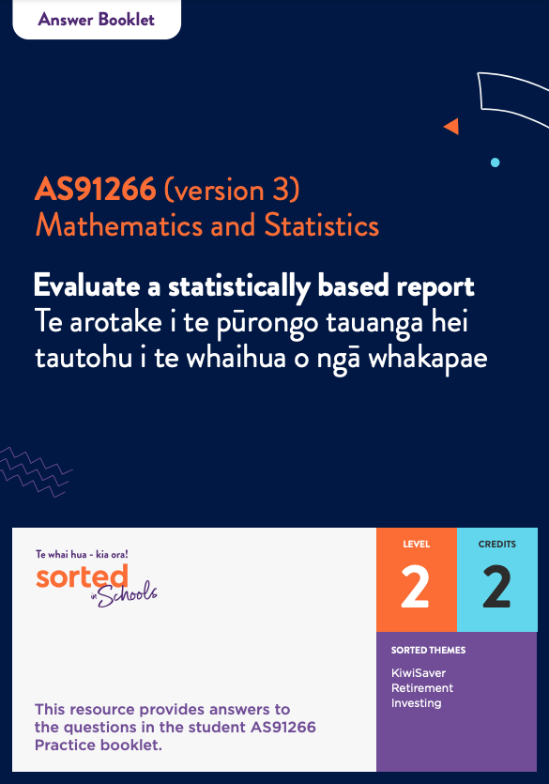

Answer Booklet

Statistical Reports

AS91266 (version 3)
Evaluate a statistically based report | Te arotake i te pūrongo tauanga hei tautohu i te whaihua o ngā whakapae
Mathematics and Statistics

Level: 2
Credits: 2

Sorted Themes:
KiwiSaver
Retirement
Investing

Topic One: Introduction to statistical reports and the contexts for this module
Topic 1 Activity 1

This activity requires students to skim read the report to get a sense of its purpose and key ideas.
Students may need support with the literacy demands of this report and the one they will use in the assessment. Encourage them to highlight words or concepts that are unfamiliar to them.
Have students work in groups to define key concepts such as:
- investment
- responsible investment
- attitudes
- values
- sustainability
- barriers (to responsible investment)
- social and environmental issues and impacts.
Topic 1 Activity 2
- Answer these True/False questions about KiwiSaver
 | True/False
KiwiSaver is an investment scheme set up by the government to help people get ready for retirement. | True
You have to be at least 18 to invest in KiwiSaver. | False – you can join KiwiSaver at any time.
You can’t access your KiwiSaver funds until you retire. | False – if you have invested in KiwiSaver for three or more years, you can use some of your KiwiSaver funds to help buy your first home.  You may also be able to access some of your funds if you experience extreme financial hardship.
Your employer can choose whether to put money into your KiwiSaver account. | False – if you contribute to KiwiSaver through your pay, your employer needs to match your contributions up to 3 percent of your pay.
The government gives KiwiSaver investors up to $521 per year. | True – the government gives KiwiSaver investors 50 cents for every dollar they invest each year, up to a maximum value of $521.
Your employer chooses which fund your KiwiSaver money is invested in. | False – KiwiSaver investors choose which fund their money is invested in. If they don’t choose, the Inland Revenue Department (IRD) puts the fund into a default scheme.

- Examples of investments that might be considered unethical include:
- landmines and cluster bombs
- weapons manufacturing
- tobacco
- pornography
- fossil fuels
- genetically modified organisms
- nuclear power
- gambling
- alcohol.

- Our sense of whether an investment is ethical is shaped by our individual values and ideals. For example, if someone has strong environmental values, they might think that investing in fossil fuels is unethical. Another person may think that it’s more important to avoid investing in gambling.

3. Answers may differ. Examples of responses include:

- Mindful Money is a charity that promotes ethical investment
- Mindful Money helps people compare investments.
- The vision of Mindful Money is to shift over a billion dollars of investment funds away from pollution, exploitation, and inequality.

Topic Two: Identifying the purpose and population of interest
Topic 2 Activity 1
- Keywords include:
- New Zealanders
- attitudes
- responsible investment.

- Answers may vary. Have students compare and discuss their answers.

Topic 2 Activity 2
- The population of interest is New Zealanders aged 18+ in 2019.

- The purpose of the report is to examine the attitudes of New Zealanders to responsible investment. The report does not include children because children are unlikely to be active KiwiSaver investors (however, that doesn’t mean that people under 18 don’t have strong feelings about ethical investing).

Topic Three: Population measures and variables
Topic 3 Activity 1
- The survey collected information on people’s:
- age
- gender
- region.

- The survey also collected information on people’s:
- level of education
- whether they live in a rural or urban area.

- Answers may vary. One significant gap is that the report does not mention specific ethnic groups, for example, Māori, Pākehā, Pasific Peoples, Asian or any other ethnic groups.

Topic Four: Sampling methods and statistical errors
Topic 4 Activity 1
- Knowing how a sample was selected would allow us to evaluate whether the sampling method was biased or unbiased.

- Answers will vary. Have students compare and discuss their answers. Refer students to pages [** to **] of the Student Booklet if they need support identifying the advantages and disadvantages of their chosen sampling method.

- If everyone in a population has an equal chance of being selected for a sample, the sample will be unbiased. However, because the sample is random, there may be a disproportionately high (or low) number of people who share certain characteristics.

Topic Five: Survey methods
Topic 5 Activity 1
Answers will vary depending on the latest poll.

Topic 5 Activity 2

- a. The survey was an online survey.
b.
- Online surveys are a relatively cheap option.
- People may be more honest in an anonymous online survey than they would be in a telephone call.
- People can choose when they want to complete the questionnaire. This may make it more likely that people will complete it.
c.
- Online surveys are more likely to be completed by people who are active online, especially people with social media accounts. This means that people on lower incomes, people living in rural areas where there is poor connectivity, and elderly people may be less likely to be included in the survey.
- Online surveys are often voluntary. People who participate in the survey may have characteristics in common such as having similar or strong views on a topic.

d. Answers may vary. Here are some examples:
- People might give answers that they think are desirable, for example, saying that they would change their KiwiSaver provider if they discovered that investments do not align with their personal values (see page 11 of the report).
- The report uses some technical language that not everyone completing the survey might understand, for example, “an investment scheme certified by an independent body” (page 12).
- Some people may have chosen not to complete the report.

Topic Six: Presentation
Topic 6 Activity 1
Ways that people can create misleading graphs include:
- using a distorted scale, for example, a vertical axis that doesn’t start at 0 or has uneven time intervals on a line graph
- cherry picking, for example, leaving out significant events that have impacted on the data being displayed
- ignoring the effects of population growth when showing changes over time.

Topic 6 Activity 2
- The key message of this page is that the biggest barrier to responsible investment is not having time to compare investments.
The visuals support this message by using a large circle to represent “I don’t have the time to look/compare” and smaller circles for the other perceived barriers.
The visuals are not misleading. The area of the largest circle (representing 55 percent of respondents) is roughly three times larger than the area of the smallest circle (representing 17 percent of respondents), which is as it should be. The creator of the report has been careful not to distort statistical information through the way it is displayed.

- The information relates to the purpose of the report because it helps to explain why people’s attitudes towards responsible investment may not necessarily be reflected in their investment choices.

Topic Seven: Commenting on the findings of a report and structuring your own report
Topic 7 Activity 1
Answers will vary. The examples provided below are indicative only.

- Yes, the Mindful Money report provides a lot of useful information about New Zealanders’ attitudes towards responsible investment. For example, it provides information on:
- the proportion of New Zealanders who would consider moving their investments if they thought that their current fund involved investing in things that don’t match their values (see page 6)
- which particular issues New Zealanders want to avoid when it comes to investing, which are investments that involve human rights violations and labour rights abuses.

- The Mindful Money report could be used by KiwiSaver fund providers to understand what investors care about. This could influence whether or not they provide a wider range of socially responsible investment options and how transparent they are about what KiwiSaver funds are invested in.

- The findings of the report seem to be reliable because they are based on a sample of 1,000 people.

However, because the survey was conducted online, some people will have been excluded from participating, for example, people who don’t have access to the internet or to social media.

- Overall, the report provides useful and important information about New Zealanders’ attitudes towards responsible investment. It shows that New Zealanders care a lot about how their KiwiSaver money is invested and highlights some of the barriers to people switching to a responsible fund, investment, or company. A lack of time is the biggest issue, so making information about what different funds invest in easy to find is a natural next step.

The report does not provide any information about whether there are differences based on people’s ethnic groups. It would be good to see the next report better reflect our cultural diversity.
It would be interesting to understand how young people perceive responsible investment to see whether there is a generation shift taking place.
The survey does not appear to include people who have not invested in KiwiSaver. It would be interesting to learn why some people choose not to invest in KiwiSaver.

Topic 7 Activity 2
Answers will vary. The examples provided below are indicative only.

Title: CFFC Impact of Covid-19 on Financial Wellbeing (May 2020)
Source of statistically based report:
The report was created by the CFFC. CFFC is an organisation that aims to equip New Zealanders with the knowledge, skills, and confidence they need to make good financial decisions at each stage of their lives.
Summary of the report – a one paragraph summary of the report, including the purpose of the report and identification of the population of interest.
The purpose of the Commission for Financial Capability (CFFC) report on the impact of Covid-19 on financial wellbeing is to report on how the pandemic has impacted on people’s personal and household finances.
The survey took place between April 14 to 28, 2020, which was while Aotearoa New Zealand was still at Level One of the first Covid-19 lockdown. The report will be useful for making comparisons as we move through the different phases of the pandemic, both as a nation, and as part of the global community.
Although the focus of the report is New Zealanders, the survey it is based on is part of an international study involving eight countries.
CFFC is an organisation that aims to equip New Zealanders with the knowledge, skills, and confidence they need to make good financial decisions at each stage of their lives. The report can help CFFC focus on areas of greatest need at this time.
The report also provides information that is useful to the government and other agencies that support people in need. Accurate and up-to-date information is very important when deciding how to respond to a global pandemic.
A description of population measures and variables.  People who participated in the survey were asked about their “income, payment of bills, borrowing, debt, savings, and ability to pay for other essentials such as food” (page 2).  The survey also collected demographic information, for example, gender, the ethnic group(s) people identify with, whether or not they have children, whether they have a mortgage (home loan), and where they live.  The data that is collected is almost entirely qualitative (for example, strategies that people are using to make ends meet) rather than quantitative, although there is one question about which income bracket people are in. | Evaluation  The data collected provides important information about people’s everyday financial behaviours, along with information about how they are feeling about their current situation. This information is relevant to the purpose of the report because financial wellbeing is not just about having enough money. It’s about how we feel about our situation and the skills and support we have to get through challenging times.  The range of demographic data collected is very comprehensive and reflects the diversity of Aotearoa New Zealand.
A description of sampling method(s).  Specific information on the sampling method is not provided within the report. However, because the survey was conducted online, the sample may be volunteer based. | Evaluation  If the sample is voluntary, it may not accurately represent the population. However, the large number of people sampled and the fact that the questionnaire is not seeking people’s opinions on an issue, means that it is likely to be a representative sample.
A description of survey method(s).  The survey was conducted online. A footnote on page 2 of the report explains that this survey method create bias:  “This survey, as an online survey, excludes those without internet access. Online surveys can also under-represent harder-to-reach groups in the population, such as the very elderly and those in low socio-economic groups.” | Evaluation  Although ideally a survey will be unbiased, in reality there will almost always be some people who do not have an equal chance of being included. The fact that the report acknowledges this bias is a good thing.
A description of the sampling and possible non-sampling errors.  Any survey based on a sample rather than a census (gathering data from everyone in the population) will have sampling error, which is the difference between true population measures and estimates of these based on a sample.  There may be some response bias because some people may not have answered the questions accurately or honestly. | Evaluation  Sampling error is an accepted part of statistical investigations. Using a large sample (in this case around close to 3,000 people) reduces the scale of this error.  The report reflects the uncertainty that comes with any survey process, for example, by using language such as “an estimated 447,000 households”.  The data was gathered at a very unusual time period (the final weeks of the first lockdown) so it may not accurately represent how things are now.
A description of the sample size  The report is based on a survey of 2,778 people who are responsible for household finances. Some sections also include people who are only responsible for their own personal finances (for example, people aged under 25 who live with a parent or parents). The total number of people involved was 3,085 people. | Evaluation  The large sample size makes this data reliable.
A description of the presentation  The data gathered has almost entirely been displayed in tables. There is only one graph and there are no infographics. | Evaluation  There is a lot of information in the report and it would have been useful to have some more visuals that provide snapshots of information.  It is likely that the audience of this report is not the general public. It’s more likely that its purpose is to support CFFC and government agencies in their decision making.
An evaluation of the findings of the survey and how they relate to the purpose of the report.
The report provides useful information on how the Covid-19 pandemic was impacting on people’s financial wellbeing towards the end of the first nationwide Covid-19 lockdown. It identifies three categories of financial wellbeing:
- in financial difficulty
- exposed to financial shocks
- financially secure households.
The report also provides information about factors influencing people in each of these groups and ways that they may need support.
The report supports CFFC’s goal of equipping New Zealanders with the knowledge, skills, and confidence they need to make good financial decisions at each stage of their lives by highlighting specific areas of need.
The information in the report can be used as a comparison to see whether people’s financial wellbeing is improving or getting worse as the Covid-19 situation unfolds.
An overall evaluation of the effectiveness of the statistically based report.
The report recognises that it is a snapshot from a very particular time and that people might be “feeling more optimistic since lockdown ended” (page 10). However, it also shows that a large proportion of the population are struggling financially or at risk of slipping into financial difficulty.
The report also has some important recommendations about ways to strengthen people’s financial resilience, for example, through education and through policies that protect the rights of workers and consumers (page 10).

