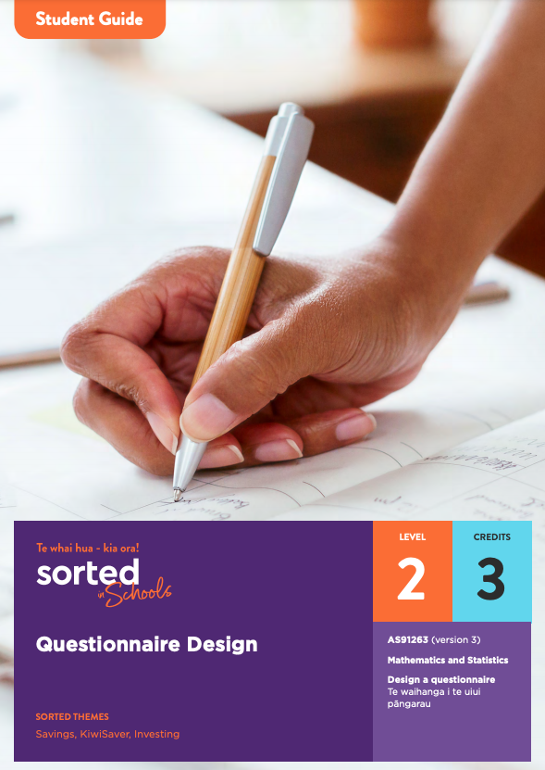

Student Guide

Questionnaire Design

AS91263 (version 3)
Design a questionnaire Te waihanga i te uiui pāngarau
Mathematics and Statistics

Level: 2
Credits: 3

Sorted Themes:
Savings
KiwiSaver
Investing

Nau mai haere mai
Welcome to the Questionnaire Design module. This module is part of a series of NCEA learning materials available from Sorted in Schools - Te whai hua - kia ora!
This student guide provides an overview of the content and context explored in the module, assessment information, resources, useful links and a vocabulary list of key terms.

The other documents in the module are:

- A student booklet that supports you to develop the skills, knowledge, and understanding that you need to meet the requirements of an NCEA achievement standard.
- A practice booklet that provides opportunities for you to apply and consolidate your learning.
- An answer booklet to accompany the practice booklet.

Each booklet is provided as a Word document and PDF to use online or printed. When used online, you can type your answers into the practice booklet.
As you work through the module, you’ll be completing activities that will prepare you for an internal assessment of AS91263: Design a questionnaire Te waihanga i te uiui pāngarau (version 3).

Achievement Criteria
Achievement | Achievement with Merit | Achievement with Excellence
Design a questionnaire. | Design a questionnaire, with justification. | Design a questionnaire, with statistical insight.

Achieving AS91263 contributes three credits towards the 10 Numeracy credits at Level 1 or above that you need for University Entrance (UE). Other Sorted in Schools modules that can support you to gain Literacy and Numeracy credits are:
- Money Matters (AS91026, Level 1, 4 credits)
- Statistical Reports (AS91266, Level 2, 2 credits)
- Statistical Inference (AS91264, Level 2, 4 credits)
- Economic Data, Issues, and Analysis (AS91226, Level 2, 4 credits).

About Sorted in Schools - Te whai hua - kia ora!
Sorted in Schools is a government-funded financial capability programme fully aligned to the New Zealand Curriculum. Free to use, Sorted in Schools helps young New Zealanders develop their money skills.

Why financial capability matters
Being good with money is an essential life skill. Financial capability means being equipped with the knowledge, skills and confidence to make good financial decisions at each life stage, and attain goals with choices. Research shows that 16-24 year olds are, however, vulnerable to falling into debt that can hold them back. In addition, over 80% of school leavers told us they wished they had learned more about money at school. We’re changing that! Our learning materials equip you with know-how to start your financial journey on the right foot. The earlier you become good with money, the better you will fare throughout your life.

Build your financial capabilities while you learn about Questionnaire Design
This module is designed to support you to both achieve success in selected NCEA assessment and build your financial capability toolkit.
Financial capability involves developing skills that will help you to feel confident about how to use and manage your money in order to achieve your goals, both now and in the future.
All of the Sorted in Schools learning materials include a combination of key financial capability concepts, or Sorted Themes, to help you develop your financial skills, knowledge, and behaviours. In this module, you will come across these Sorted Themes:
SavingsKiwiSaver Investing
You can find resources linked to each of these themes on the student activities page of the Sorted in Schools website. Click on Theme and select an option from the dropdown menu. The resources include booklets, powerpoints, infographics, videos, and interactive activities. You can search for different types of resources using the Media option.
The particular focus in this module involves understanding your values, beliefs and behaviours related to money. Take a look at the diagram below that shows some of the factors that influence the composition of your financial capability toolkit. Notice that knowing about money is only a small part of the picture. Important factors such as our family’s or culture’s attitudes towards money, our attitudes and habits, and how we feel about money also play a role.
You may like to explore aspects of financial identity when you create your own questionnaire as part of your assessment.

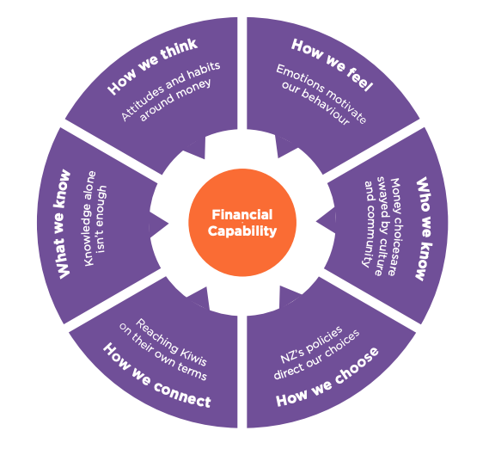

Resources
Interested in learning more about your financial identity and how this might impact the ways you manage your money? Sorted in Schools resources that have particular relevance to this module are:

- Thinklinkers on the Sorted in Schools website to explore ideas related to financial identity.
- What shapes my financial identity? to explore how place, people, beliefs, culture and community make your financial identity unique.

You can find more resources on the Student Activities page of the Sorted in Schools website.

Be sure to watch the video that accompanies this module: Questionnaire Design.

The context explored in the Questionnaire Design module
Throughout the module, you’ll be learning about a questionnaire-based study that is being used to research the relationship between Māori identity and financial decision-making. One of the lead researchers is Dr Carla Houkamau, who is an Associate Professor in Management and International Business at the University of Auckland.
Dr Carla Houkamau:
MIFAS YouTube Channel
MIFAS website

Te Rangahau o Te Tuakiri Māori me Nga Waiaro a-Putea, The Māori Identity and Financial Attitudes Study (MIFAS), has been designed to measure how Māori identity shapes financial choices and what ‘Māori economic success as Māori’ looks like in relation to economic outcomes.
Our aim in this research is to answer one of the fundamental questions facing contemporary Māori: How can we foster Māori entrepreneurial behaviour and economic savvy?
Dr Houkamau will provide you with expert insight into the process her team has used to develop their questionnaire and conduct their survey. Learning about their design process can help shape your decision making as you design your own questionnaire. This is important because at Level 2, all NCEA statistics assessment tasks require you to demonstrate an understanding of how statistical processes are applied in real life.

Topic overview
Here is an overview of the topics you will explore in this module:

Topic One: The purpose and audience of questionnaires
Why questionnaires are a useful tool for gathering data, surveys and the PPDAC statistical enquiry cycle, defining the purpose and audience of a questionnaire.

Topic Two: Defining the target and sample populations
Defining the target population, census versus sample, sample population, sampling frames, and statistical errors (sampling and non-sampling).

Topic Three: Ethical considerations when creating a questionnaire
Meeting ethical standards when designing a questionnaire, transparency, privacy, inclusion, and informed consent.

Topic Four: Question types
Closed question types including multiple choice, rating scales, and Likert scales; open question types including word association, and sentence completion.

Topic Five: The importance of good question design
Linking questions to the purpose, using simple language, and formatting tips.

Topic Six: Structuring your questionnaire
Components of a questionnaire including: title, introduction, instructions, order, formatting, feedback, and saying thanks.

Topic Seven: Doing a desk review
Checking the wording, format, and questions of your draft questionnaire.

Topic Eight: Doing a pilot survey
The purpose of pilot surveys, and approaches to getting feedback.

Topic Nine: Reflecting on the process
How to evaluate your questionnaire design and process.

Understanding how you will be assessed
In the assessment activity, you will be designing a questionnaire. You’ll be assessed on the process you use to design a questionnaire as well as the final result. This means that you need to keep a record of changes you make along the way and the reasons for them. You can use the Checkpoints in the Practice Booklet to help meet this requirement.
Your final product will be the presentation of a report about your questionnaire design process and the final questionnaire.
Discuss options for presenting your report with your teacher, for example, as a written report, a visual presentation, or an oral presentation.
Your report needs to include the following parts:
● Introduction – a description of the purpose of your questionnaire and a summary of the key information your questionnaire provides about your target population.
● Design process – a discussion of the process you used to design your questionnaire that reflects on how well your questionnaire aligns with its purpose.
● Questionnaire – a copy of your final questionnaire. Your questionnaire could be handwritten, typed or made using a specialist application such as Google Forms, Microsoft Forms, Survey Monkey etc.
● Appendix – evidence of your design process, for example, a journal or logbook, and links to:
○ your draft (initial) questionnaire
○ the results of your desk review and any changes you make in response
○ a summary of the pilot survey responses including statistics and graphs.
You will be assessed on the quality of your report, including your discussion and reasoning about the questionnaire design process, and how well you link these to the context.

This table provides a summary of the evidence required for achievement at different levels:
Evidence/Judgements for Achievement | Evidence/Judgements for Achievement with Merit | Evidence/Judgements for Achievement with Excellence
I can:  - state the purpose of my questionnaire  - identify the groups who will use the data  - provide a brief overview of what information the questionnaire will provide  ● write an initial set of survey questions with:  ○ relevant variables  ○ appropriate measures for each variable  ○ an appropriate range of question types.  ● check my survey questions by:  ○ carrying out a desk review  ○ conducting a pilot survey(s) including collecting and recording data.  ● refine my questionnaire based on the results of the pilot survey.  ● document the design process including providing copies of my draft and final questionnaires. | I can:  - state the purpose of my questionnaire  - identify the groups who will use the data, with explanation  - provide an overview of the type of data and information the questionnaire will provide  - write an initial set of survey questions with:  ○ relevant variables  ○ appropriate measures for each variable  ○ an appropriate range of question types.  ● link components of the questionnaire design process to the context, for example, by:  ○ explaining how the questions I have asked relate to the purpose of my questionnaire  ○ explaining why the data my questionnaire will gather will be useful for its audience.  ● explain relevant decisions made in the design process, for example:  ○ why I included or left out particular questions  ○ why I used specific types of questions  ○ how different questions build on each other or link together.  - create a final questionnaire that is well structured, with questions appropriate to the purpose of the survey. | I can:  - state the purpose of my questionnaire  - identify the groups who will use the data, with explanation  - provide a detailed overview of the type of data and information the questionnaire will provide  - write an initial set of survey questions with:  ○ relevant variables  ○ appropriate measures for each variable  ○ an appropriate range of question types.  ● integrate statistical and contextual knowledge relevant to the purpose of the survey, for example, by:  ○ providing evidence that I have independently researched the context of my questionnaire  ○ providing statistical reasons for including or rejecting some questions  ○ explaining how my questions build on each other or link together and how this relates to the purpose of the questionnaire  ○ reflecting on the limitations of my pilot survey and the implications of this for my final questionnaire in terms of meeting its purpose  ○ discussing how the purpose of my questionnaire could be extended or explored further, including how the questionnaire would need to be altered to cater for these.

Assessment tips
The student booklet provides assessment tips that will help you understand the requirements of achieving at Merit and Excellence level.

Checkpoints
As you work through the module you will see this checkpoint ahead symbol:
This symbol lets you know that there is an important step in the questionnaire design process that you need to complete. Each checkpoint plays an important role in your assessment, so getting sign-off from your teacher is essential – don’t be tempted to skip ahead.
The table below provides a summary of the requirements of each checkpoint. Following the questionnaire, there are examples of questions you can answer at each checkpoint to gather the evidence you need for your report.
Checkpoint
Purpose, audience, and target population
I have:
- defined the context of my investigation and the research objectives of my questionnaire
- explained what data my questionnaire will gather
- explained the audience of my questionnaire
- explained how the data can be used
- defined my target population.
First draft
I have:
- provided a set of draft questions
- used different question types
- explained how the questions I have asked relate to my purpose
- explained why I have chosen particular types of questions.
Desk review
I have:
- provided evidence of my own desk review
- provided evidence of someone else’s review of my questionnaire
- identified what I need to change in my questionnaire based on the desk review.
Second draft
I have:
- revised my questionnaire
- explained any changes I have made.
Pilot questionnaire
I have:
- conducted a pilot questionnaire using my draft questionnaire
- provided the responses to my pilot questionnaire
- analysed my questionnaire based on the pilot questionnaire responses
- explained what I need to do to refine my questionnaire.
Final questionnaire
I have:
- made and explained changes to my questionnaire
- done a desk check to make sure the changes haven’t introduced any errors
- provided a final copy of my questionnaire.

The questions and templates below have been organised by checkpoint and provide a structure that you can use as the basis of your report.

Checkpoint one: Purpose, audience, and target population
Define the context of your investigation and the research objectives of your questionnaire.

- Explain what data your questionnaire will gather
- Explain the audience of your questionnaire
- Define your target population.

Context/topic | What context/topic are you going to research?  Why have you chosen this context/topic?
Purpose and audience | Who are you designing the questionnaire for?  How could the data it gathers be used?
Target population | Who is the target population? Include key information such as time, place, age, etc.  Why did you choose this target population?
Research goals | What do you want to find out?  Break your general purpose into three or four sub-categories.
Data | What data do you want to collect?  How might this data be analysed?

Checkpoint two: First draft
Write a first draft of your questionnaire.

- Provide a set of initial questions
- Use different question types
- Explain how the questions you have asked relate to your purpose
- Explain why you have chosen particular types of questions.

You can use the table below to explain decisions you have made and/or explain how different components of your questionnaire relate to its purpose.

 | Draft text | Explanation/link to the purpose
Title
Introduction
Informed consent
Screening question
Questions

Feedback
Thank you statement

Checkpoint three: Desk review
Do a desk review of your draft survey.

- Provide evidence of your own desk review
- Provide evidence of someone else’s review of your questionnaire
- Identify what you need to change in your questionnaire based on the desk review.

You can use this table to summarise findings from the desk review:
 | Desk review questions | Actions I will take in response to the desk review
Purpose | Are there any questions that don’t have an obvious link to my purpose? If so, which ones?
Target population | Is there a question near the start that screens for the target population?
Wording | Are the questions clear and easy to follow? If not, which question(s) need to be changed?  Are all the questions in everyday language?
Spelling and grammar | Is everything spelt correctly?  Is the grammar correct?
Format | Is the font easy to read?  Is the numbering correct?
Tone | Is the language used friendly and polite?
Instructions | Is it clear how to answer each set of questions?
Categories | Are questions on a similar theme grouped together?  Are there any questions that are too similar to be useful?
Flow | Does the order of the questions make sense?  Do the questions link together?
Length | Are there too many questions?

Checkpoint four: Second draft
Create a second draft of your questionnaire. Explain any changes you have made.
Note: You can explain your changes using comment boxes on an electronic document or record them in the table below.

Changes made | Reason for the change

Checkpoint five: Pilot survey
Conduct a pilot survey.
- Provide the responses to your pilot survey
- Analyse your questionnaire based on the pilot survey responses
- Explain what you need to do to refine your questionnaire.

Summarise the feedback that you got from the pilot survey. You may like to use the table below as a guide.
 |  | Actions I will take in response to the pilot survey
Purpose | Are there any questions that don’t have an obvious link to my purpose?
Target population | Is there a question near the start that screens for the target population?
Wording | Were the questions clear and easy to follow? If not, which question(s) need to be changed.  Are all the questions in everyday language?
Spelling and grammar | Is everything spelt correctly?  Is the grammar correct?
Format | Is the font easy to read?  Is the numbering correct?
Tone | Is the language friendly and polite?
Instructions | Did the respondents know how to answer each set of questions?
Categories | Were questions with similar themes grouped together?  Were there any questions that are too similar to be useful?
Response options | Did the response options provided for each question work well?  Were there a lot of “I don’t know” or “other” responses?
Flow | Does the order of the questions make sense?  Do the questions link together?
Length | Are there too many questions?  How long did it take to complete the questionnaire?
Other notes and/or observations

Checkpoint six: Final questionnaire
Complete your final questionnaire.

- Make and explain changes to your questionnaire
- Do a desk check to make sure the changes haven’t introduced any errors
- Provide a final copy of your questionnaire.

Note: You can explain your changes using comment boxes on an electronic document or record them in the table below

Changes made | Reason for the change

Checkpoint seven: Reflecting on the questionnaire design process
Read all of the questions below then answer at least three of them.
- What are three things you have learned about questionnaire design? What would you do differently next time?
- How important was the desk review and/or pilot survey in terms of your final questionnaire fulfilling its purpose?
- How well does your questionnaire match its purpose? Were there any gaps?
- What other avenues of enquiry related to your research goals could you explore?
- What connections can you make between your research, the purpose of your questionnaire, and its final design?
- Which aspects of your questionnaire design are likely to reduce non-sampling errors? How would this help the questionnaire to fulfil its purpose?
- How easy would it be to analyse the data your questionnaire would gather? Did you have to make any compromises with the questions you asked in order to make analysis easier?
- What advice would you give to another student doing this assessment standard?

