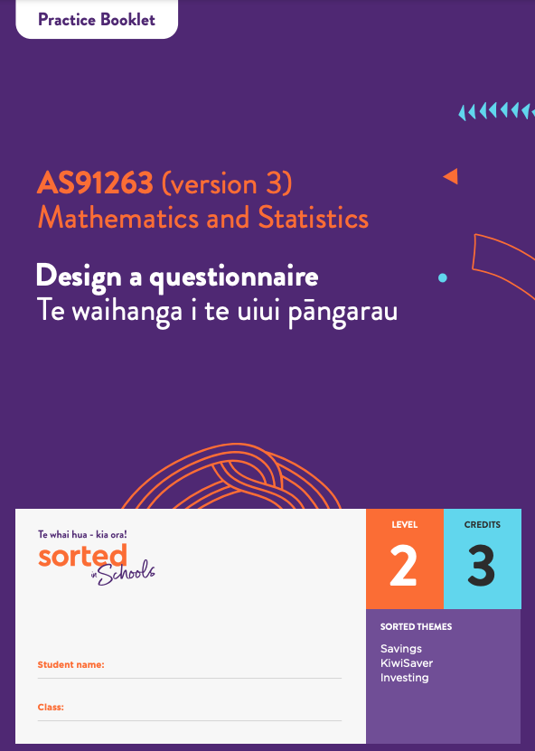

Practice Booklet

Questionnaire Design

AS91263 (version 3)
Design a questionnaire Te waihanga i te uiui pāngarau
Mathematics and Statistics

Level: 2
Credits: 3

Sorted Themes:
Savings
KiwiSaver
Investing

This workbook provides activities that you can use to develop and demonstrate your understanding of the questionnaire design process. It also guides you through the steps you need to take to complete your own questionnaire.
You can print this booklet or use it online by typing into the answer spaces. Use a specialist PDF app, not just your browser, to make sure your answers are properly saved.
Keeping a record of decisions that you make as you draft, test, and revise your questionnaire is an essential part of your assessment.
As you work through the modules you will see this checkpoint ahead symbol:
This symbol lets you know that there is an important step in the questionnaire design process for you to complete. Each of these checkpoints plays an important role in your assessment, so getting sign-off from your teacher before you move on to the next step is essential – don’t be tempted to skip ahead. The assessment task has a table you can use to keep track of your progress.

Topic One: The purpose and audience of questionnaires
- Identify whether the following types of data are quantitative or qualitative.

Variables | Qualitative | Quantitative
The number of people in a household.
The food items someone eats for breakfast.
The number of calories in people’s lunches.
A rating of a movie from 1 star to 5 stars.
Amount of screen time each week.
What religion a person is (if any).

- Watch this Maths and Stats video Designing a Questionnaire, by Dr Nic, to get a sense of the steps you’ll be following to design your questionnaire. Each of these steps is described in greater detail within this module.
Discuss with a partner or small group:
- Do you like filling in questionnaires? Why or why not?
- Why are questionnaires a useful research tool? What types of information can they provide?
- Do you have any other questions or considerations about questionnaires?

Discussion notes:

- Some people think that data is just facts and figures, but Statistics New Zealand states that data is powerful and that it can change lives.
Discuss with a partner or small group:
- Do you think data can change lives? Why or why not? Try to provide an example to support your ideas
Discussion notes:

- When conducting a survey, what is the difference between a focus group and a questionnaire?

- Decide whether the following statements are a strength, a weakness, or both when it comes to questionnaires.
 | Strength | Weakness | Both
Questionnaires are a useful way to get information from a large group of people.
Questionnaires can provide information on people’s attitudes, preferences, and opinions.
People may not provide accurate information in a questionnaire.
The questions you ask in a questionnaire can limit the responses you get.
People can choose whether or not to complete a questionnaire.

- Compare and contrast questionnaires with face-to-face interviews.

- Read the Te Rangahau o Te Tuakiri Māori me Ngā Waiaro ā-Putea case study information below and answer questions that follow it:

Te Rangahau o Te Tuakiri Māori me Ngā Waiaro ā-Putea case study

Te Rangahau o Te Tuakiri Māori me Ngā Waiaro ā-Putea, The Māori Identity and Financial Attitudes Study (MIFAS), has been designed to measure how Māori identity shapes financial choices and what ‘Māori economic success as Māori’ looks like in relation to economic outcomes.
Our aim in this research is to answer one of the fundamental questions facing contemporary Māori: How can we foster Māori entrepreneurial behaviour and economic savvy?
The concept of “Māori achieving success as Māori” is about Māori New Zealanders living and working in ways that reflect and honour their Māori identity, culture and language and that build on the riches and strength of being Māori. The study wants to explore what cultural factors inspire and motivate Māori in relation to economic choices.

Why did you decide to use a questionnaire to gather data for your research?
We had to think carefully before choosing to use a questionnaire for our research, as the use of survey data has sometimes been criticised. The Māori view of the world is holistic, which means recognising that things are interrelated and part of a bigger picture. A survey will often reduce complex ideas and experiences into boxes that can be ticked, which is not holistic or traditionally how Māori would gather information. For many people, answering questions that force you to choose from a fixed set of options is frustrating.
We agree that surveys are not ideal and sometimes the questions can seem a bit strange, however, they are still important and valuable tools for researchers.
Māori are a diverse population and attitudes vary in different regions in the country. Rather than having to rely upon stories or observations about small groups of Māori, we can use the survey method and random sampling to ensure that we have a truly representative and unbiased picture of it.
It is also important to interpret the numbers we gather in a sensitive way, to make sure we are thinking about contextual issues when making sense of patterns we see in the numbers we collect. It is very challenging to gather accurate information about the wide range of thoughts and feelings in Māori society just watching people or interviewing small groups of individuals. To understand the big picture, researchers need tools that allow us to measure attitudes, beliefs, values and perspectives and surveys are one of these tools.
How might the data you gather be used?

The Government, public organisations, business and education organisations are interested in the views and attitudes of Māori who use their services or are affected by their policies. The more they know about what Māori people prefer and what works for Māori development, the easier it is for them to improve and adapt for Māori.
Each iwi (tribe) and hapū (sub-tribe) has their own distinctive history. To date, there have been very few large-scale nationwide representative studies with Māori that link personal cultural beliefs and practices to economic choices. Our study aims to fill this gap.
If we do not have data on attitudes and opinions of a large group of Māori it makes it hard to provide evidence as to what does or does not work for Māori development.

- What was the purpose of the questionnaire?

- Who is one potential audience of the questionnaire?

- What two challenges of using questionnaires to gather data are mentioned in the case study?

- What is one advantage of using a questionnaire to gather information about Māori identity and financial attitudes?

Topic Two: Defining the target and sample populations

- What is the difference between a sample and census?

- Match each term with its definition by writing the corresponding term letter A–F alongside the correct definition:
Terms:
A | Doing a census
B | Using a sample
C | Target population
D | Sample population
E | Sampling frame
F | Respondents

Definitions:
Corresponding terms letter
A list that (ideally) includes everyone in the target population.
The total group of people you want to learn something about.
Surveying a group selected from a population rather than surveying the whole group.
Surveying the entire population.
The people who fill in and return the questionnaire.
The group of people given the questionnaire.

- Identify which one of the following is a sampling error (the rest are non-sampling errors).

Respondents don’t always share their actual beliefs because they are worried about how they will look if they tell the truth.
The response options provided for a question don’t match the experiences of respondents.
Only people with strong opinions choose to participate in a survey.
The difference between the results of a sample and the true population measure.

- Explain why it is important to use a screening question at the start of your questionnaire.

- Explain why, even if you do a census, the data you gather might not be exactly the same as the true population statistics.

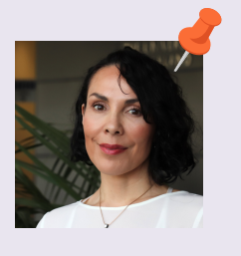

Dr Carla Houkamau:
Our target population is Māori living in Aotearoa New Zealand who are aged 18 and over.
For the survey we are asking people who are listed on the electoral roll and who indicated that they were of Māori descent to answer questions about their identity, education, financial choices and other details about their lives. (The electoral roll is a list of voters in each region. It includes people’s names, birthdate, occupation, address, and whether or not they have Māori whakapapa. The electoral roll can be used for scientific and health research.) Participants were randomly selected. This means everyone on the electoral roll who indicated that they were of Māori descent had an equal chance of being selected.
In our first study, we took a random sample of 100,000 people on the electoral roll who identified that they had Māori whakapapa. Each of these 100,000 people were sent a questionnaire, inviting them to take part in our survey. We also let people know about the survey by promoting it on television and on the radio.
In the end, 7000 people responded to our questionnaire.

- Read the Te Rangahau o Te Tuakiri Māori me Ngā Waiaro ā-Putea case study above.
Place the letters listed below (A to F) on the sampling process diagram to show which group is in which section.
A: Māori 18 or older who live in Aotearoa New Zealand.
B: People on the electoral roll who indicate that they are of Māori descent.
C: People with Māori whakapapa who are on the electoral roll but are under 18 years of age.
D: Māori 18 or older who live in Aotearoa New Zealand but are not on the electoral roll.
E: The 100,000 people sent the questionnaire.
F: The 7000 people who filled in and returned the questionnaire.

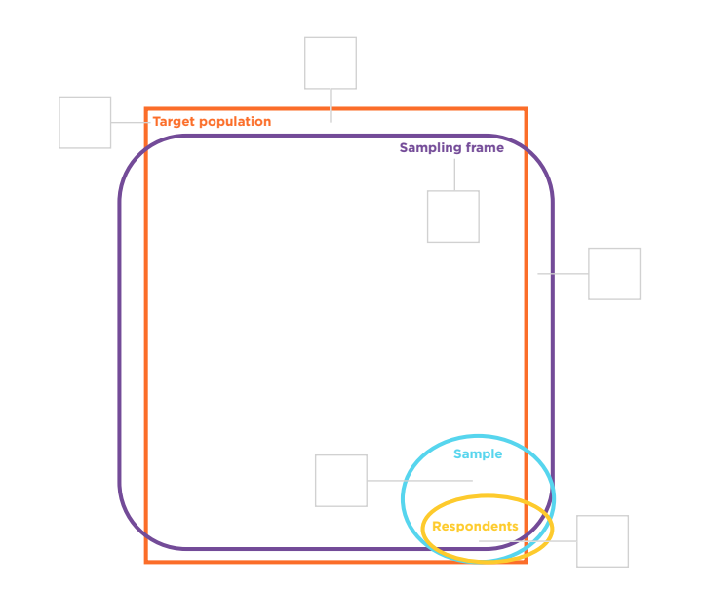

- Complete Checkpoint one

Checkpoint one: Purpose, audience, and target population
If you’re ready to do so, now would be a good time to define the purpose, audience, and target population of your own questionnaire.

Use this page to brainstorm ideas.
Begin by writing down a range of clubs, organisations, or businesses that you have personal interest in; for example, your school, your marae, a place of worship, or a sports team. Alternatively, you could explore an issue that you care about.
Next, think about any decisions, issues or future opportunities that could benefit from data that you might gather. If possible, talk to some people in your community about whether there are information needs that you could meet using a questionnaire.
Try to keep your ideas broad while you’re brainstorming.

Use this page to help you define your purpose and research goals.
Write a couple of sentences about the purpose of your survey, including who the audience might be and why the data you will gather would be useful.

Write down some questions you could ask.

Brainstorm the data your questions could gather.

Group your ideas into three or four areas of investigation. Give each group a label.

Complete the Checkpoint one table in your Questionnaire Design journal.

Topic Three: Ethical considerations
- Discuss with others, what are the advantages of a questionnaire being confidential in terms of:
- people choosing to fill in the questionnaire
- people answering questions truthfully.
Discussion notes:

- Match each ethical standard with its example by writing the corresponding ethical standard letter A–F alongside the correct example:
Ethical standard:
A | Transparency
B | Informed consent
C | Privacy
D | Confidentiality
E | Anonymity
F | Inclusivity

Example:
Corresponding ethical standard letter
Metiria avoids asking personal questions that are not directly related to the purpose of her questionnaire. She adds a “prefer not to say” option to any questions that might be considered personal.
The questionnaire doesn’t ask for or record respondents’ names or email addresses.
The introduction states that by filling in the questionnaire, the respondent is agreeing to be part of the research.
Metiria checks the wording of her questions to make sure they respect diversity.
At the start of her questionnaire, Metiria explains that she is a year 12 student doing a survey on young people’s money choices.
She explains that the data she gathers will be used by the Commission for Financial Capability to help them understand young people’s views on money.
The data gathered is kept in a secure and protected way.

- List three things you can do (or not do) to ensure that your questionnaire meets ethical standards.
1 -

2 -

3 -

Topic Four: Types of questions
- Identify whether these are closed or open questions.
 | Closed | Open
Do you get pocket money? (Yes/No)
Why do you think women are less likely to invest their money than men are?
What is the likelihood that you will use a student loan to pay for your studies?
1 2 3 4 5 6 7 8 9 10
Extremely unlikely Extremely likely
Use the scale provided to indicate whether you agree or disagree with this statement:

The minimum wage for young people should be the same as the minimum wage for adults.
1 2 3 4 5
Strongly disagree Strongly agree
Write down the first word you think of when you hear each of these words:

Saving_________
Investing_____________
Money_______________

- When it comes to gathering data, what is one advantage and one disadvantage of closed and open questions?
 | Advantage | Disadvantage
Closed questions
Open questions

- How can using a range of question types reduce non-sampling errors?

Topic Five: The importance of good question design
Topic 5 Activity 1
Watch the Sorted in Schools Questionnaire video.
Discuss with a classmate aspects of questionnaire design that are mentioned in the video.
Identify three flaws in the questions used in the flat interview.

- _______________________________________________________________
- _______________________________________________________________
- _______________________________________________________________

Topic 5 Activity 2
For each question below:
- identify an issue (or issues) with the question
- suggest a way to improve it.
The first example has been done for you.

Draft question | Issue(s) | Suggested improvement
Should school students be taught how to budget money and invest in shares? | The question is asking about two separate things (budgeting money and investing in shares). If someone supports one idea but not the other, they might skip this question or provide an answer that doesn’t accurately represent their views. | Create two separate yes/no questions:  Should school students be taught how to budget money?  Yes/No  Should school students be taught how to invest in shares?  Yes/No
What is the main thing you spend money on?

Food
Drinks
Clothes
Transport
Shopping

Do you think that people shouldn’t be unable to leave school before they turn 16?
Why should people have to invest in KiwiSaver?
How often do you worry about money?
Sometimes
Often
Always

Topic Six: Structuring your questionnaire
- Complete Checkpoint two:

Checkpoint two: First draft
Now is the time to write a first draft of your questionnaire.
Here’s a checklist you can use:

 |  | Done
Title | My questionnaire has a short title that explains what it is about.
Introduction | I have introduced myself and what I am researching.
 | I have explained whether the respondent’s information will be anonymous.
 | I have explained that the respondents data will be kept secure and confidential.
Informed consent | I have gained the respondent’s consent to be included in the research.
Instructions | Where required, I have written instructions on how to answer questions.
Order of questions | I have used a screening question to make sure the respondents are part of my target population.
 | The first questions I have asked are easy to answer.
 | My questions are organised in categories based on my research goals.
Variety | I have used at least three types of questions.
Length | I have asked at least five questions.
Feedback | I have invited the respondent to provide feedback on the questionnaire.
Thank you statement | I have said thanks for participating in the research.

Once you have written your first draft, save a copy of it to include with your assessment.

Topic Seven: Doing a desk review
- Complete Checkpoint three.

Checkpoint three: Desk review
Now is the time to do a desk review of your questionnaire. You can do this yourself or you can ask someone else to do it for you.
If someone is checking the questionnaire for you, make sure that they know what the purpose, audience, and target population of your questionnaire are.
Here’s a checklist you can use:
Purpose | Are there any questions that don’t have an obvious link to my purpose?
Target population | Is there a question near the start that screens for the target population?
Wording | Are the questions clear and easy to follow? If not, please indicate which question(s) need to be changed.  Are all the questions in everyday language?
Spelling and grammar | Is everything spelt correctly?  Is the grammar correct?
Format | Is the font easy to read?  Is the numbering correct?
Tone | Is the language used friendly and polite?
Instructions | Did you know how to answer each set of questions?
Categories | Were questions on a similar theme grouped together?  Were there any questions that are too similar to be useful?
Flow | Does the order of the questions make sense? Do the questions link together?
Length | Are there too many questions?

- Complete Checkpoint four
Checkpoint four: Second draft
Once the desk review has been done:
- make changes to your draft questionnaire
- explain any changes you have made in your Questionnaire Design journal.

Topic Eight: Doing a pilot survey
- Complete Checkpoint four
Checkpoint five: Pilot survey
Now it is time to do a pilot survey of your questionnaire.
Arrange for at least five people from your target population to be part of the pilot survey.
Explain that the purpose of the pilot survey is to check whether:
- the questions make sense and can be answered easily
- there are any problems with the words, the flow, or the length
- the data that the questionnaire can be analysed
- the information that the questionnaire gathers can be used to answer the enquiry question(s).
If you are present while they fill it in:
- encourage them to ask you if anything is unclear
- observe whether they seem to be finding a question challenging and, if so, ask them why
- time how long it takes them to complete the questionnaire.

Here’s a checklist you can give to the people in the pilot survey:
Purpose | Are there any questions that don’t have an obvious link to my purpose?
Target population | Is there a question near the start that screens for the target population?
Wording | Are the questions clear and easy to follow? If not, please indicate which question(s) need to be changed.  Are all the questions in everyday language?
Spelling and grammar | Is everything spelt correctly?  Is the grammar correct?
Format | Is the font easy to read?  Is the numbering correct?
Tone | Is the language friendly and polite?
Instructions | Did you know how to answer each set of questions?
Categories | Were questions on a similar theme grouped together?  Were there any questions that are too similar to be useful?
Response options | Did the response options provided for each question work well?  Were there a lot of “I don’t know” or “other” responses?
Flow | Does the order of the questions make sense? Do the questions link together?
Length | Are there too many questions?

Once the pilot survey has been completed:
- make changes to your draft questionnaire
- explain any changes you have made in your Questionnaire Design journal
- complete the pilot survey reflections table in your Questionnaire Design journal.
Here are some questions that you can use for your reflections:
- Did people understand what the questions were asking?
- Did you get any unexpected answers?
- Does the questionnaire measure what you want it to measure?
- Will the information gathered give you what you need for the purpose of the questionnaire?
- Were there many “I don’t know” or “Does not apply” responses? If so, does the question need to be changed? Do you need to add some more response options?
- What was the response rate? If it was low, is there a way to improve this?

Lastly, create a clean copy of your final questionnaire.

Topic Nine: Reflecting on the process
- Now that you’ve completed the questionnaire design process, it’s time to reflect and review.
Here are some questions you can use to help you reflect on your questionnaire design process. Read all of the questions then choose at least three to answer in the evaluation section of your report.
My three choices
What are three things you have learned about questionnaire design? What would you do differently next time?
How important was the desk review and/or pilot survey in terms of your final questionnaire fulfilling its purpose?
How well does your questionnaire match its purpose? Were there any gaps?
What other avenues of enquiry related to your research goals could you explore?
What connections can you make between your research, the purpose of your questionnaire, and its final design?
Which aspects of your questionnaire design are likely to reduce non-sampling errors? How would this help the questionnaire to fulfil its purpose?
How easy would it be to analyse the data your questionnaire would gather? Did you have to make any compromises with the questions you asked in order to make analysis easier?
What advice would you give to another student doing this assessment standard?

