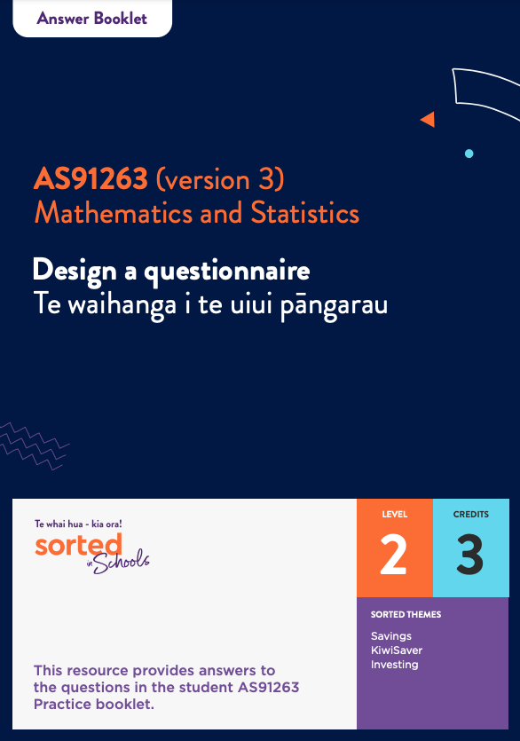

Questionnaire Design

Answer Booklet

AS91263 (version 3)
Design a questionnaire Te waihanga i te uiui pāngarau
Mathematics and Statistics

Level: 2
Credits: 3

Sorted Themes:
Savings
KiwiSaver
Investing

This resource provides answers to the questions in the student Design a Questionnaire Practice booklet.

Topic One: The purpose and audience of questionnaires
1.
Questions | Qualitative | Quantitative
The number of people in a household. |  | ☑
The food items someone eats for breakfast. | ☑
The number of calories in people’s lunches. |  | ☑
A rating of a movie from 1 star to 5 stars. |  | ☑
Amount of screen time each week. |  | ☑
What religion a person is (if any). | ☑
4.
A focus group involves talking to a small group of people in order to explore their ideas and opinions about a topic in depth.
A questionnaire is a written set of questions that people fill out independently and return to the researcher.

5.

Note: You may have come up with different responses to ones in the table below. This doesn’t mean that you’re wrong. Discuss your reasoning with another student or your teacher to see whether they agree with you.
 | Strength | Weakness | Both
Questionnaires are a useful way to get information from a large group of people. | ☑
Questionnaires can provide information on people’s attitudes, preferences, and opinions. | ☑
People may not provide accurate information in a questionnaire. |  | ☑
The questions you ask in a questionnaire can limit the responses you get. |  |  | ☑
People can choose whether or not to complete a questionnaire. |  |  | ☑

6.
Here a few ways examples of ways that questionnaires and face-to-face interviews are similar and different. You may have identified other examples. If so, discuss these with another student or with your teacher.
Similarities:
Questionnaire and face-to-face interviews both involve participants answering questions. These questions should match the purpose of the study.
Questionnaires and face-to-face interviews can both be used to gather data about peoples’ ideas, opinions, and behaviours.
Differences:
When you interview someone in person, you can:
- ask extra questions based on the participants responses to delve a deeper or to make sure you understand what they are telling you
- explain what an interview question means if it is unclear or phrase it in a different way
- observe non-verbal information such as their body language
- answer any questions the participant has about the study.
A face-to-face interview will usually take longer to complete than a questionnaire.
If you use face-to-face interviews to gather data, you might need to limit your sample population to people in one geographic area.
People may be less honest or accurate when they are answering questions in person because they don’t want to look bad.
Unlike questionnaires, face-to-face interviews can’t be anonymous.
A questionnaire is more practical for gathering data from a large group of people.
7.
- The purpose of the questionnaire is to measure how Māori identity shapes financial choices and what ‘Māori economic success as Māori’ looks like when it comes to money choices.
- Potential audiences of the questionnaire are:
- The Government
- public organisations
- businesses
- education organisations
- Challenges of using questionnaires to gather data include:
- it’s not a holistic approach to gathering data
- people can feel frustrated if they’re forced to choose a response from a limited range of options.
- Advantages of using a questionnaire to gather information about Māori identity and financial attitudes include:

- you can gather data from different iwi and hapū
- you can gather data from a large number of people
- organisations can use the information that is gathered to understand how to improve and adapt their organisation for Māori.

Topic Two: Defining the target and sample populations

A census involves surveying everyone in a target population.
A sample involves surveying a group selected from the target population.

Definitions:
 | Corresponding terms letter
A list that (ideally) includes everyone in the target population. | E
The total group of people you want to learn something about. | C
Surveying a group selected from a population rather than surveying the whole group. | B
Surveying the entire population. | A
The people who fill in and return the questionnaire. | F
The group of people given the questionnaire. | D

Respondents don’t always share their actual beliefs because they are worried about how they will look if they tell the truth.
The response options provided for a question don’t match the experiences of respondents.
Only people with strong opinions choose to participate in a survey.
The difference between the results of a sample and the true population measure. | ✅

A screening question makes sure that the person filling in your questionnaire is part of the target population. If they’re not, you can thank them for their time and tell them not to fill in the rest of the questionnaire.

Here are some reasons that the results of a census might not be completely accurate. You may have thought of other reasons. If so, discuss them with another student or with your teacher.
- Not everyone will choose to complete and return the questionnaire. The people who choose not to complete it may have a characteristic in common, which means that the data will be biased.
- People’s responses may not be accurate or honest.
- People might misunderstand a question.
- The response options provided might not include things that match people’s situation or opinions.

- Read the Te Rangahau o Te Tuakiri Māori me Ngā Waiaro a-Putea case study above.
Place the letters listed below (A to F) on the sampling process diagram to show which group is in which section.
A: Māori 18 or older who live in Aotearoa New Zealand.
B: People on the electoral roll who indicate that they are of Māori descent.
C: People with Māori whakapapa who are on the electoral roll but are under 18 years of age.
D: Māori 18 or older who live in Aotearoa New Zealand but are not on the electoral roll.
E: The 100,000 people sent the questionnaire.
F: The 7000 people who filled in and returned the questionnaire.
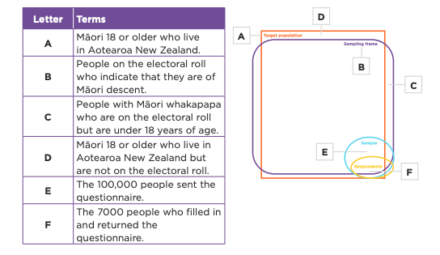

Topic Three: Ethical considerations

 | Corresponding ethical standard letter
Metiria avoids asking personal questions that are not directly related to the purpose of her questionnaire. She adds a “prefer not to say” option to any questions that might be considered personal. | C
The questionnaire doesn’t ask for or record respondents’ names or email addresses. | E
The introduction states that by filling in the questionnaire, the respondent is agreeing to be part of the research. | B
Metiria checks the wording of her questions to make sure they respect diversity. | F
At the start of her questionnaire, Metiria explains that she is a year 12 student doing a survey on young people’s money choices.  She explains that the data she gathers will be used by the Commission for Financial Capability to help them understand young people’s views on money. | A
The data gathered is kept in a secure and protected way. | D

Here are some examples of things you can do (or not do) to ensure your questionnaire meets ethical standards.
- Tell people who you are (if they don’t know you personally), for example, your name, year level, and contact details
- Tell people the purpose and audience of your questionnaire (why you’re doing the survey and who you are collecting data from)
- Let them know whether their responses are anonymous or identifiable and whether the data is confidential
- Tell people that they have a right to request that their data is deleted or removed from your survey.
- Get informed consent by using a phrase such as: “By completing this questionnaire, you are indicating your consent to participate in this research.”
- Avoid asking personal or sensitive questions
- Let people skip questions that they don’t want to answer
- Check that the language used and response options provided respects diversity.

Topic Four: Types of questions

 | Closed | Open
Do you get pocket money? (Yes/No) | ✔
Why do you think women are less likely to invest their money than men are? |  | ✔
What is the likelihood that you will use a student loan to pay for your studies?  1 2 3 4 5 6 7 8 9 10  Extremely unlikely Extremely likely | ✔
Use the scale provided to indicate whether you agree or disagree with this statement:  The minimum wage for young people should be the same as the minimum wage for adults.  1 2 3 4 5  Strongly disagree Strongly agree | ✔
Write down the first word you think of when you hear each of these words:  Saving_________  Investing_____________  Money_______________ |  | ✔

2.
Here are some advantages and disadvantages of closed and open questions.
 | Advantage | Disadvantage
Closed questions | Closed questions are often quick and easy to answer. This can make it more likely that respondents complete the questionnaire, reducing non-sampling errors.  Responses to closed questions are easy to analyse and display. | It can be frustrating for respondents if the answer they want to give is not offered.  Respondents who don’t have an opinion might just select a response at random.  Closed questions can reduce complex ideas down to overly simple responses.
Open questions | Allow for any response.  Can provide qualitative data.  An open question might introduce ideas that you haven’t considered.  Open questions provide more opportunities for in-depth opinions, explanations, and feelings than closed questions. | Open questions can be more time consuming for the respondents and require more thought.  Responses to open-ended questions can be harder to analyse objectively.

3. How can using a range of question types reduce non-sampling errors?
Using a range of question types can make it more enjoyable to complete, which might increase the response rate.

Topic Five: The importance of good question design
1 The flat interview questionnaire has a number of flaws. Examples include:
- the questionnaires don’t align with the purpose of the questionnaire (finding a reliable flatmate who is good to live with and pays their bills)
- there is a question with a double negative
- one question only has two answer options.
- one questions combines two different questions
- one question had a typo
- one of the questions is biased.
2.
For each draft question, at least one issue and one suggested improvement has been provided. You may have thought of others. If so, discuss them with another student or with your teacher.
Draft question | Issue(s) | Suggested improvement
Should school students be taught how to budget money and invest in shares? | The question is asking about two separate things (budgeting money and investing in shares). If someone supports one idea but not the other, they might skip this question or provide an answer that doesn’t accurately represent their views. | Create two separate yes/no questions:  Should school students be taught how to budget money?  Yes/No  Should school students be taught how to invest in shares?  Yes/No
What is the main thing you spend money on?  Food  Drinks  Clothes  Transport  Shopping | The responses are limited to only five things. There are lots of things that people might spend their money on, for example, rent, hobbies, technology, or pets.  If the number of options is too limited, the person filling in the questionnaire might choose an option that isn’t accurate or skip this question altogether. | Include an “other” option and provide a way for respondents to put in their own answer.  What is the main thing you spend money on?  Food  Drinks  Clothes  Transport  Shopping  Other  If you selected “other”, please state the main thing you spend money on.
Do you think that people shouldn’t be unable to leave school before they turn 16? | This question includes a double-negative which makes it hard to interpret.  People might give an inaccurate answer as a result. | Change to a positive question:  Do you think people should have to stay at school until they are 16?
Why should people have to invest in KiwiSaver? | This question is biased – the person completing the questionnaire may not think people should have to invest in KiwiSaver.  Biased questions can make a person filling in a questionnaire feel distrustful about the purpose of the questionnaire and they may not want to complete it. | Ask the person for their opinion on investing in KiwiSaver being compulsory first and then ask them to explain their answer.  Do you think investing in KiwiSaver should be compulsory?  Yes/No/Not sure  If you selected Yes, explain why.  If you selected No, explain why not.
How often do you worry about money?  Sometimes  Often  Always | This question doesn’t provide an option for people who don’t worry about money.  It’s also hard to interpret what is meant by each response option, particularly because the question is not time-bound. | Include an option for people who are not worried about money.  Make the question time bound to make it easier to  answer.  On a scale of 1 to 10, how worried do you feel about your money situation at the moment?  1 10  Not at all Very worried

