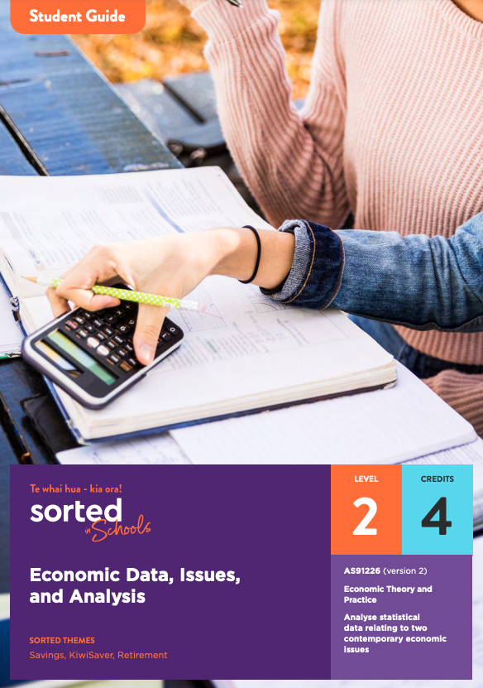

Student Guide

Economic Data, Issues, and Analysis

AS91226 (version 2) Analyse statistical data relating to two contemporary economic issues
Economic Theory and Practice

Level: 2
Credits: 4

Sorted Themes:
Savings
KiwiSaver
Retirement

Nau mai haere mai!

Welcome to the Economic Data, Issues, and Analysis module. The module supports you to develop your analysis of statistical data relating to two contemporary economic issues. It is about the inter-relationships between inequality, climate change and the New Zealand economy.
This module is part of a series of NCEA learning materials available from Sorted in Schools - Te whai hua - kia ora!

This student guide provides an overview of the content and context explored in the module, assessment information, resources, and useful links.

The other documents in the module are:

- A student booklet that supports you to develop the skills, knowledge, and understanding that you need to meet the requirements of an NCEA achievement standard.
- A practice booklet that provides opportunities for you to apply and consolidate your learning.
- An answer booklet to accompany the practice booklet.
- A vocabulary list of key terms.

Each booklet is provided as a Word document and PDF to use online or printed. When used online, you can type your answers into the practice booklet.
As you work through the module, you’ll be completing activities that will prepare you for an internal assessment of AS91226 Analyse statistical data relating to two contemporary economic issues (version 2).

Achievement Criteria
Achievement | Achievement with Merit | Achievement with Excellence
Analyse statistical data relating to two contemporary economic issues. | Analyse statistical data relating to two contemporary economic Issues in depth. | Comprehensively analyse statistical data relating to two contemporary economic issues.

Achieving AS91226 contributes four credits towards the 10 Numeracy credits at Level 1 or above that you need for University Entrance (UE). Other Sorted in Schools modules that can support you to gain Literacy and Numeracy credits are:
- Money Matters (AS91026, Level 1, 4 credits)
- Statistical Reports (AS91266, Level 2, 2 credits)
- Statistical Inference (AS91264, Level 2, 4 credits)
- Questionnaire Design (AS91263, Level 2, 3 credits).

About Sorted in Schools – Te whai hua – kia ora!
Sorted in Schools is a government-funded financial capability programme fully aligned to the New Zealand Curriculum. Free to use, Sorted in Schools helps young New Zealanders develop their money skills.

Why financial capability matters
Being good with money is an essential life skill. Financial capability means being equipped with the knowledge, skills and confidence to make good financial decisions at each life stage, and attain goals with choices. Research shows that 16-24 year olds are, however, vulnerable to falling into debt that can hold them back. In addition, over 80% of school leavers told us they wished they had learned more about money at school. We’re changing that! Our learning materials equip you with know-how to start your financial journey on the right foot. The earlier you become good with money, the better you will fare throughout your life.

Build your financial capabilities while you learn about Economics
This module is designed to support you to both achieve success in selected NCEA assessment and build your financial capability toolkit.
Financial capability involves developing skills that will help you to feel confident about how to use and manage your money in order to achieve your goals, both now and in the future.
All of the Sorted in Schools learning materials include a combination of key financial capability concepts, or Sorted Themes, to help you develop your financial skills, knowledge, and behaviours. In this module, you will come across these Sorted Themes:

SavingsKiwiSaver Retirement

You can find resources linked to each of these themes on the student activities page of the Sorted in Schools website. Click on Theme and select an option from the dropdown menu. The resources include booklets, powerpoints, infographics, videos, and interactive activities. You can search for different types of resources using the Media option.

Resources
Interested in learning more about your financial identity and how this might impact the ways you manage your money? Sorted in Schools resources that have particular relevance to this module are:

- Thinklinkers on the Sorted in Schools website to explore ideas related to financial identity.
- What shapes my financial identity? to explore how place, people, beliefs, culture and community make your financial identity unique.

You can find more resources on the Student Activities page of the Sorted in Schools website.
Be sure to watch the video that accompanies this module: Climate Crisis

Here is a selection of videos to explore inequality and climate change from a New Zealand perspective:
(2013) Professor Robert Wade, London School of Economics, discussing Inequality in New Zealand (16.41min)
(2014) Te Karere (TVNZ) article on worsening inequality for Maori and Pacific people (2.26min)
(2019) Prime Minister Jacinda Ardern speaking on inequality in New Zealand (3.39min)
(2018) The Prime Minister Jacinda Ardern speaking on gender inequality in New Zealand (1.45min)
(2015) Bill Nye explaining climate change and its effects (4.10min).
(2011) Richard Wilkinson, author, speaking on how inequality harms societies (16.54min)

The contexts explored in the Economic Data, Issues, and Analysis module
This module explores two societal issues as contexts presented throughout the learning and assessment materials:

Societal issue one: Inequality
Inequality is a contemporary issue in New Zealand society. To begin, take a moment to look back...
How different do you think your life would be now if you had been born into a different situation?
Whether that situation is country, race, gender, or time, the outcomes can be quite different. Much of those differences can be put down to what resources you have available, what opportunities you have to use those resources, and the potential that you see in yourself.
The expectations of other people and society can also be either an aid or an obstacle for you to overcome. Some of these obstacles have been around for so long, and are so built into the systems that society operates, they seem almost impossible to overcome.
What is inequality?
The United Nations [1] uses the definition of inequality as the state of not being equal, especially in status, rights, and opportunities. Economic inequality usually relates to inequality of outcome and inequality of opportunity. Inequality of outcomes occurs when individuals do not possess the same level of income and/or material wealth, or overall economic living conditions. Inequality of opportunity is the uneven access to opportunities of living that give people the freedom to pursue a life that they choose.
Economic inequality can result from such factors as ethnicity, family background, gender, religion, disability, age, access to education and health care, community relationships, and environmental conditions.
Inequality of outcome is seen as being objective because it is generally measurable. Income and material wealth can both be measured in dollars.

Is inequality fair?
We accept some types of inequality as fair because we reward people for higher skills, knowledge, experience, responsibility, effort, success, productivity, and risk. We also accept that some members of society should have extra resources so that they can enjoy similar outcomes and lifestyles to the rest of the community. Publicly funded health care, education, social welfare, and disability parking are ways to provide opportunities for people, with less advantage, to enjoy our society.
These are not the types of inequality that we usually see as being necessary to eliminate. These types of inequality are a motivator to develop, and a means to maintain, a fair society.
<Now do – Student practice booklet: Theme A, Activity 1>

Getting inequality correct
In New Zealand society we accept that some inequality is necessary. What can be less acceptable are the reasons for, and the magnitude of, the inequality that we have. We have a degree of common understanding of unacceptable reasons for inequality. Many of these are laid out in the Human Rights Act (1993)[2]. Concern is growing about the magnitude of inequality that exists in our society. There is a recognised relationship between higher levels of inequality and higher rates of civil unrest [3]. Increasing inequality in New Zealand is impacting on opinions around the degree of social justice in our society. Citizens of Aotearoa New Zealand are sensing that economic and social outcomes in our society are not quite right.
<Now do – Student practice booklet: Theme A, Activity 2>

Societal issue two: Climate change
Climate change is a contemporary issue in New Zealand society.
What is Climate Change?
There have been natural causes of changes in the Earth’s climate [4]. These were caused by such things as: changes in land and ocean floor topography, changes in the Earth’s orbit, changes in radiation output from the Sun, volcanic eruptions, and changes in sea currents. These vary in time span from a few years to 150 million years.
The issue of climate change is human-induced climate change that has become evident since the mid 20th century [5]. This is also referred to as the greenhouse effect. Certain gases in the atmosphere prevent heat from escaping. This results in the heating of the atmosphere which is causing changes to the Earth’s climate.
What is the problem with Climate Change?
Over the last century the burning of fossil fuels, coal and oil, has released carbon dioxide into the atmosphere. Soil cultivation has released nitrous oxide. Rice cultivation and livestock farming have released methane.
As a consequence the atmosphere, on average, is becoming warmer. Some areas of the world are becoming warmer, others are not. A warmer atmosphere also increases water evaporation and some areas are becoming wetter while other areas are becoming drier.
The warmer atmosphere is raising sea temperatures which in turn melt glaciers and ice. The impact of this will be a rise in the level of oceans around the world. This will swamp large areas of low lying, inhabited landmasses and displace millions of people.
<Now do – Student practice booklet: Theme B, Activity 1>

How could New Zealand react to climate change?
<Now do – Student practice booklet: Theme B, Activity 2>
Reduce emissions:
Nitrous oxide and methane emissions from agriculture make up almost half of New Zealand’s greenhouse gas emissions. Using new ways to produce agricultural goods, as well as using alternative energy sources, will have a significant impact on our greenhouse gas emissions.
Offset emissions:
Using carbon absorption, mainly through planting trees, will also move New Zealand towards being carbon neutral (when carbon absorption is equal to carbon emission).
Adapt to the impacts of climate change:
New Zealand could prepare for and adapt to changes that impact on infrastructure. For example, ensuring that drought-prone areas develop and maintain access to potable drinking water for their communities.
Invest in climate change action:
New Zealand could direct investment funds into public and private sector actions that will contribute to reducing climate impacts or adapting to climate impacts.
<Now do – Student practice booklet: Theme B, Activity 3>

Topic overview
Here is an overview of the topics you will explore in this module:

Topic One: Processing and presenting statistical data
Understanding how to process and present statistical data to show trends, including calculating summations, means (averages), percentages and percentage changes, and extrapolating data to make predictions

Topic Two: Explaining trends in statistical data
Understanding how to provide detailed explanations of relationships in statistical data using economic concepts and/or models

Topic Three: Explaining the inter-relationships between climate change and inequality
Understanding how to provide detailed explanations of inter-relationships between statistical data using economic concepts and/or models.

Topic Four: Making a justified forecast
Understanding how to provide a justified forecast for one contemporary economic issue by using extrapolated statistical data.

Understanding how you will be assessed
You will be provided with an internal assessment task which requires you to:
- Process and present statistical data
- Explain relationships in the data using economic concepts and/or models
- Explain inter-relationships between the statistical data for two contemporary economic issues using economic concepts and/or models
- Justify a forecast using extrapolated data
This table provides a summary of the evidence required for achievement at different levels:

Evidence/Judgements for Achievement | Evidence/Judgements for Achievement with Merit | Evidence/Judgements for Achievement with Excellence
Analyse statistical data relating to two contemporary economic issues. I can:  · Process and present statistical data for two contemporary economic issues to show trends.  · Provide explanations of relationships in statistical data for both of the two contemporary economic issues using economic concepts and/or models.  · Provide explanations of inter-relationships between statistical data for the two contemporary economic issues using economic concepts and/or models. | Analyse statistical data in depth relating to two contemporary economic issues. I can:  · Process and present statistical data for two contemporary economic issues to show trends.  · Provide detailed explanations of relationships in statistical data for both of the two contemporary economic issues using economic concepts and/or models.  · Provide detailed explanations of the inter-relationships between statistical data for the two contemporary economic issues using economic concepts and/or models. | Analyse statistical data comprehensively relating to two contemporary economic issues.  I can meet the requirements for Merit and:  · Make a justified forecast for one contemporary economic issue using extrapolated statistical data from both of the contemporary economic issues.

Assessment tips
The student booklet provides assessment tips that will help you understand the requirements of achieving at Merit and Excellence level.

References
1 Adapted from Oxford Advanced Learner’s Dictionary.
2 http://www.legislation.govt.nz/act/public/1993/0082/latest/DLM304475.html
3 https://www.who.int/violence_injury_prevention/violence/4th_milestones_meeting/marmot.pdf?ua=1
4 https://niwa.co.nz/our-science/climate/information-and-resources/clivar/variations
5 https://climate.nasa.gov/causes/

