Student booklet

Economic Data, Issues, and Analysis

AS91226 (version 2)
Analyse statistical data relating to two contemporary economic issues
Economic Theory and Practice

Level: 2
Credits: 4

Sorted Themes:
Savings
KiwiSaver
Retirement

Nau mai haere mai!

Welcome to the Economic Data, Issues, and Analysis module.

Please read through the Student Guide for an overview of the module and assessment before starting this Student Booklet.

Contents

Topic One Processing and presenting statistical data
Topic Two Explaining trends in statistical data
Topic Three Explaining the inter-relationships between climate change and inequality
Topic Four Making a justified forecast

Topic one: Processing and presenting statistical data
Learning outcome for Topic One:
- Understand how to process and present statistical data to show trends

Success criteria
- I can calculate summations, means (averages), percentages and percentage changes
- I can identify a trend
- I can extrapolate data to make predictions.

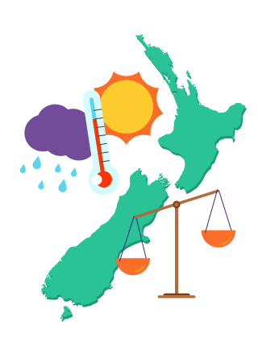
This topic focuses on reviewing common mathematical skills that are used in economic statistical analysis. It uses the contexts of climate change and inequality because these are significant, long term economic issues that New Zealand is facing.
When economists look for pathways for the economy, they first look for evidence to see if problems, patterns and connections exist. Much of the evidence they use is statistical data because it has the potential to show change over time. Economists are interested in how quickly things are changing as this helps to identify how quick the response may need to be and what resources might be needed to to correct an issue.

Data processing skills
Assessment tips

For this standard it is important that you can accurately process statistical data, which means that you are able to perform mathematical calculations correctly.
You also need to be able to identify a trend, and this means that (at the least) you can look at a spread of data and place a line that approximates where the data is heading.
Further into the assessment task you will also need to extrapolate the data – you will need to predict where the data will go in the future.

The expectation of the standard is that you can calculate summations, means (averages), percentages, and percentage changes.

Calculating Percentages
In economics the consideration of the significance of a category to an overall total is a common tool for comparison. This can be best seen when using percentages.
To calculate a percentage, use the following formula:
$Percentage of category to the total =\frac{category amount}{total amount}×100$

Consider this example related to retirement savings [1], which is based on 25-year-olds who earn the average wage for their gender, and contribute three percent of their income to KiwiSaver plus their employer’s contribution of three percent:

A 25-year-old female will, on average, reach 65 years of age with contributions to their KiwiSaver fund of $141,000. A 25-year-old male will, on average, reach 65 years of age with contributions to their Kiwisaver fund of $220,000.
The contributions of the average female are what percentage of the average male contributions?

$$\frac{141,000}{220,000}×100 = 64.1\%$$

Calculating Percentage changes
Economic statistics also tend to be time-series data. This enables us to make comparisons across years. Therefore, it is common to make comparisons of percentage changes.
To calculate a percentage change, use the following formula:

$Percentage change =\frac{Second year amount - First year amount}{First year amount}×100$

Consider the following data related to KiwiSaver contributors [2].
The number of contributing members to KiwiSaver funds in New Zealand increased from 1,681,977 in 2018 to 1,748,802 in 2019. What is that as a percentage increase?

$\frac{(1,748,802 - 1,681,977)}{1,681,977}×100$= 3.97%

<Now do Topic 1, Activities 1 and 2>

Presenting percentage data
Assessment tip
The standard requires you to show trends. The simplest way to do that is to insert an approximate trend line onto a time series graph. For that reason the best way to graph percentage data for this standard is to use a line graph or a series of percentage bar graphs.
Here is a simple strategy for successfully drawing a percentage bar graph: draw a rectangle 100mm high and 20mm across so that each millimetre up represents 1 percent.
For example, the table below provides data [4] relating to the percentage of people who are employed and earn less than 120% of the adult minimum wage. This is used as an indicator of the working poor.
Trends in low pay
 | Proportion of employed people (%)
 | 2006 | 2009 | 2012 | 2015
Percentage of employed people who earn less than 120% of the adult minimum wage | 17.9  (287,600) | 24.0  (396,600) | 23.9  (401,200) | 24.9  (463,000)

Percentage of employed people earning less than 120% of the Adult Minimum Wage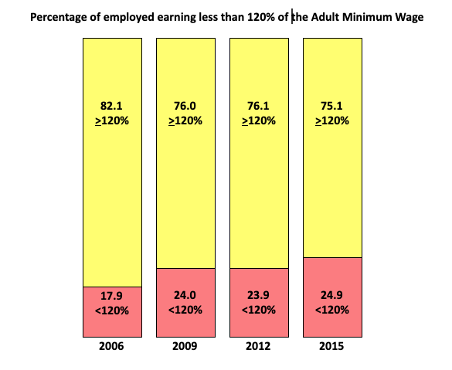

The same could be achieved with a line graph. The graph below has a broken vertical axis.

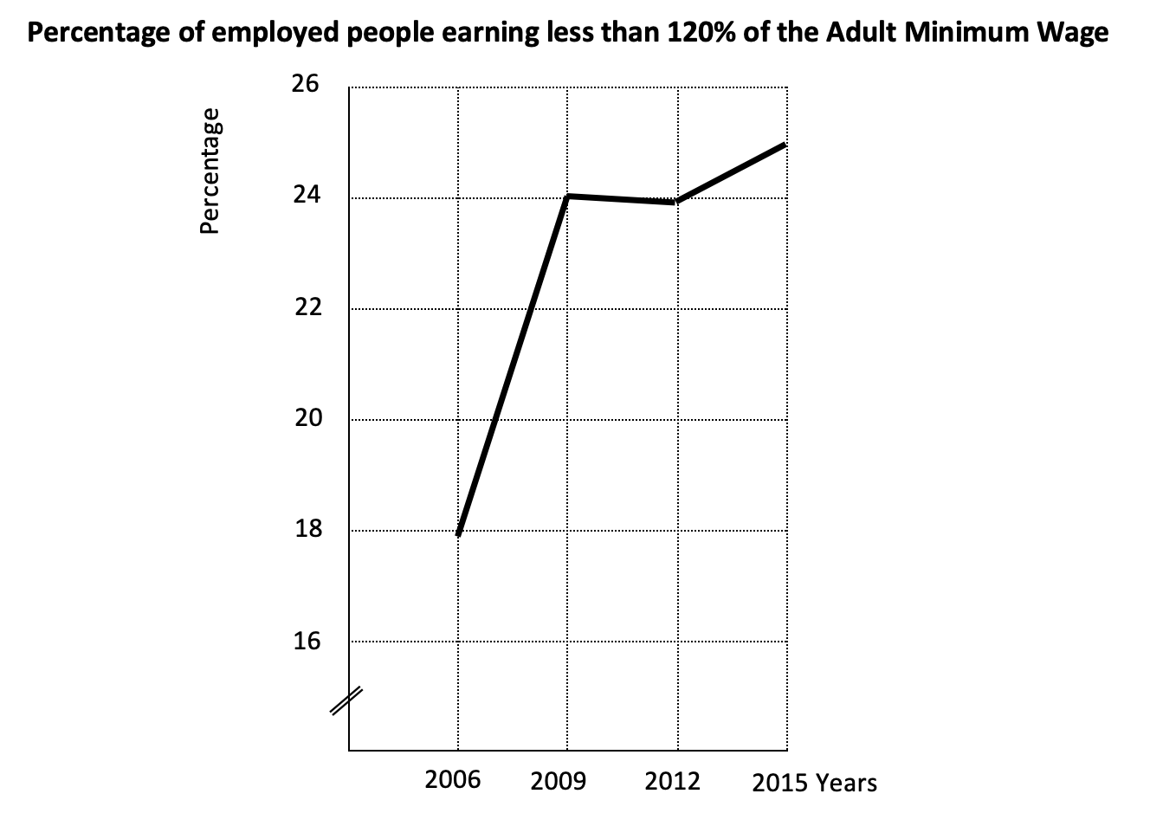

The percentage bar graphs perhaps give a better sense of increasing inequality, but the line graph does make it potentially easier to identify an upwards trend.

Presenting percentage change data
When presenting percentage change data across several time periods it is common to use a line graph. Percentage changes are on the vertical axis while years (time) is along the horizontal axis. If there are any negative percentage changes then the vertical axis will need to extend below zero.

For example, the following table presents data [5] relating to New Zealand’s net greenhouse gas emissions. Greenhouse gas emissions are a significant cause of climate change. Tracking greenhouse gas emissions over time provides valuable information to help reduce climate change.

New Zealand Greenhouse Gas Emissions 2009-2018
Year | Net Emissions CO₂ equivalent (kt) | Percentage Change  %
2009 | 49,274.98 | -
2010 | 49,360.38 | +0.17
2011 | 53,629.59 | +8.65
2012 | 57,018.05 | +6.32
2013 | 58,688.94 | +2.93
2014 | 57,122.65 | -2.67
2015 | 56,306.43 | -1.43
2016 | 55,089.01 | -2.16
2017 | 56,930.75 | +3.34
2018 | 55,468.22 | -2.57

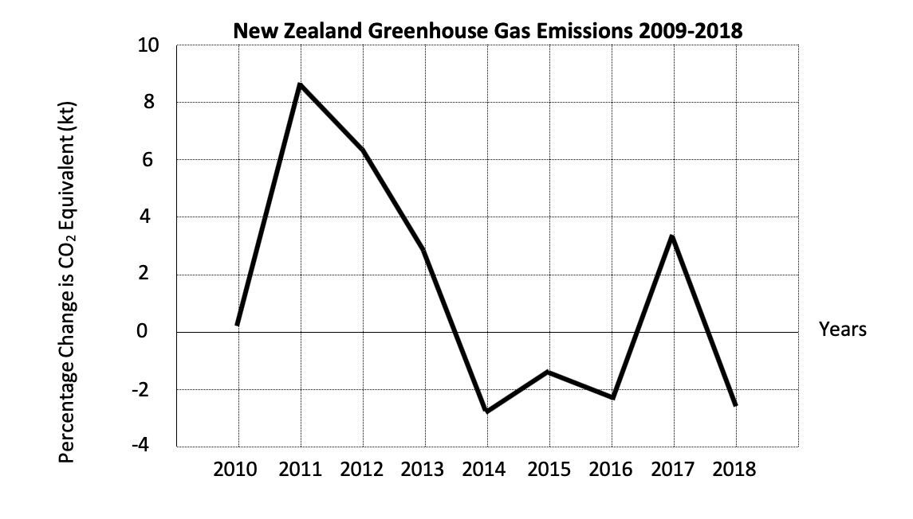

<Now do Topic 1, Activities 3 and 4>

Identifying trends
Assessment tip

To meet the achievement requirements of the standard you need to visually identify a trend and place a trend line onto your graph.

There is no need to do a mathematical calculation to identify a specific line that fits the best. If the line looks reasonable then that will meet the standard.
Here are examples to show you what is acceptable and what is not.

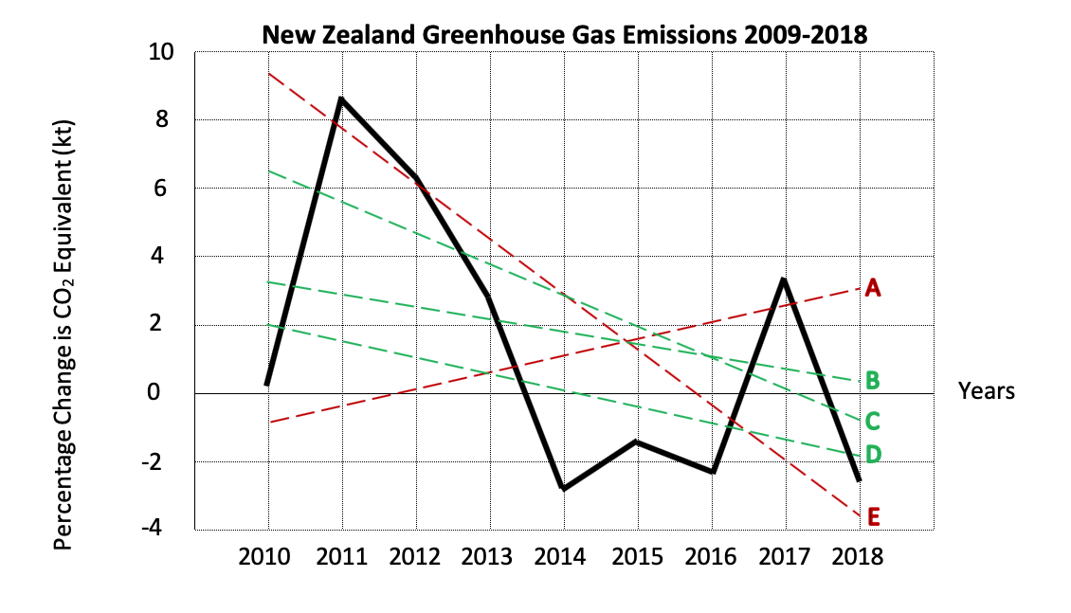

Lines A and E would probably not be accepted as showing the trend in the percentage change in CO₂ emissions. Whereas lines B, C and D probably would be assessed as showing the appropriate trend.

<Now do Topic 1, Activity 5>

Before moving on to Topic Two, check that you understand:
- How to calculate summations, means (averages), percentages and percentage changes
- How to identify a trend
- How to extrapolate data to make predictions.

Topic two: Explaining trends in statistical data
Learning Outcome for Topic two
- Understand how to provide detailed explanations of relationships in statistical data using economic concepts and/or models

Success criteria
- I can use a range of economic concepts and/or models to explain statistical data
- I can identify a trend and give a detailed reason for it
- I can provide economically sound and logical explanations.

This topic focuses on developing paragraph writing skills: the ability to write paragraphs that connect issues and economic models using relevant concepts, terms and economic theory.
After economists have gathered statistical data and processed it to show trends, they endeavour to communicate the significance of the trends to economic issues. It is important to explain how data is connected to economic issues, and what changes in data indicate about changes in economic issues. Economists use economic models to help communicate simplified explanations. By focusing on key relationships it is possible to create understanding of what makes the largest impact.
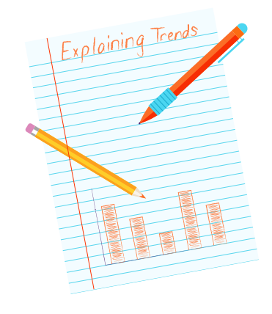

Using Economic Concepts and Models
When identifying suitable economic concepts, you need to consider finding economic language to support ideas related to people making decisions. Any list provided here would only be a very small sample of acceptable economic concepts. You may need to consult with your teacher about the suitability of the economic language and concepts that you intend to use.

<Now do Topic 2, Activity 1>

Here is a list of what would be acceptable economic models to use.
- Aggregate demand and aggregate supply (AD/AS)
- The quantity theory of money
- Trade markets and factor markets
- Production possibility frontier
- Circular flow
- Lorenz curve
- Gini-coefficient
- Or another simplified representation of the economic world.

You may need extra learning based around these models to gain success in this standard.

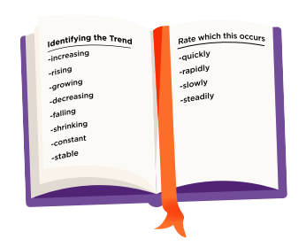
Writing an Explanation
To write an explanation of a trend the best first step is to identify the trend or relationship. Use terms like increasing, rising, growing, decreasing, falling, shrinking, constant, stable and perhaps the rate at which this occurs – quickly, rapidly, slowly, or steadily.

Assessment tip

Just identifying the trend will not be enough. The minimum for Achieved is to explain the relationship that the trend reflects. For you to explain the trend, you will need to identify the trend, provide specific data evidence, and give a reason for it.

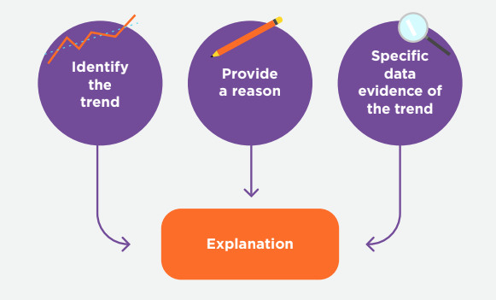

Assessment tip

The step up to Achieved with Merit is to provide a detailed explanation. That usually means that you provide multiple reasons, or you provide greater detail to the explanation of your reason(s).
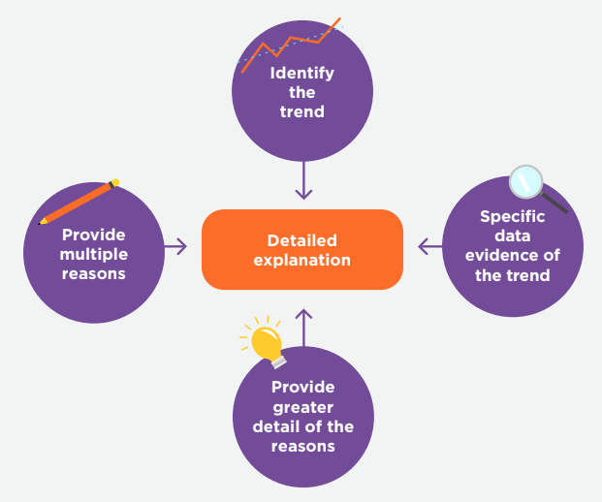

<Now do Topic 1, Activity 2>

Here is an example of the full expectation of the relationship between interest rates and wealth inequality.
After processing and presenting the data a trend has been identified.
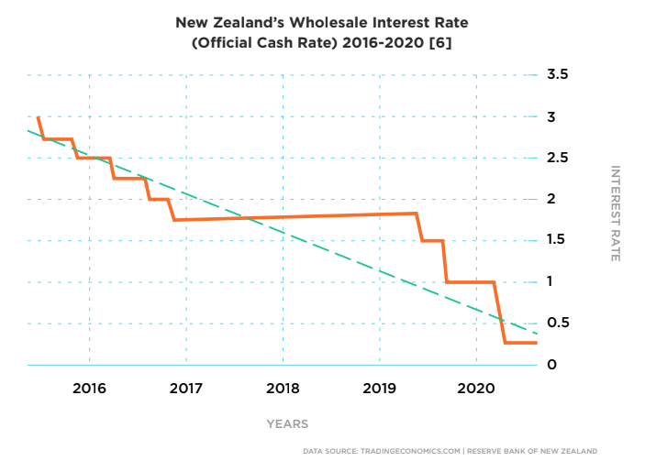
One explanation of the trend and its impact on the economic issue (inequality), using economic models and/or concepts, could be as follows.
Over the period of 2016 to 2020 wholesale interest rates in New Zealand have fallen, from 2.5% to 0.25%. This is a result of falling business and consumer confidence worldwide due to uncertainty about future social, political, and economic prosperity. Much of this uncertainty results from differences in attitudes and responses to environmental and social events occurring worldwide.
The fall in interest rates has resulted in a movement of wealth away from those who do not own assets that can generate income (or the ability to finance themselves into ownership of these assets) towards those that do own these types of assets. Members of our society that have been able to finance the purchase of rental property, through cheap interest debt, have been rewarded with increases in wealth through capital gains in their property values. Other members of society who have insufficient savings, and therefore cannot finance property purchases, have found that rising capital values of property make the financing of property purchases increasingly more difficult. This means that they are less able to build their own wealth.
The fall in interest rates can result in an increase in wealth inequality.

This answer is not the only possible answer. There are multiple different correct answers to this situation.

Assessment tip

To achieve the standard, ensure that your answer is economically sound and logical.

<Now do Topic 2, Activity 3>

Before moving on to Topic Three, check that you understand:
- How to use a range of economic concepts and/or models to explain statistical data
- How to identify a trend and give a detailed reason for it
- How to provide economically sound and logical explanations.

Topic three: Explaining the inter-relationships between climate change and inequality
Learning Outcome for Topic Three
- Understand how to provide detailed explanations of inter-relationships between statistical data using economic concepts and/or models.

Success criteria
- I can use the example provided to help me write a detailed, economically sound and logical explanation

This topic focuses on developing understanding of the interconnectedness of economic issues. Our economic world is a very complex place. Some parts are clear and easy to understand, while other parts have complex and seemingly invisible connections. Changes made in one area can have distant, unexpected consequences.
Much like a bridge over a river, made from thousands of individual parts, all relying on each other, damage to one part can create stresses in other areas that are some distance away. Those stresses can lead to further weaknesses and ultimately a failure of the bridge. An economist needs to identify and explain the weaknesses, and the stresses on other parts of the economy that those weaknesses create, and predict what those weaknesses and stresses will do to the economy.

The recognised link between Climate Change and Inequality
In 2017 the United Nations released a working paper by Nazrul Islam and John Winkel titled Climate Change and Social Inequality [7]. The paper aimed to explore how the impact of climate change was related to social inequality. The paper noted:

Climate change is negatively impacting prices, assets, productivity, and opportunities. Each of these impacts on the ability of people to move out of poverty. Low income households are disproportionately affected by climate change. Therefore, as the effects of climate change intensify it is likely that economic inequality will increase.

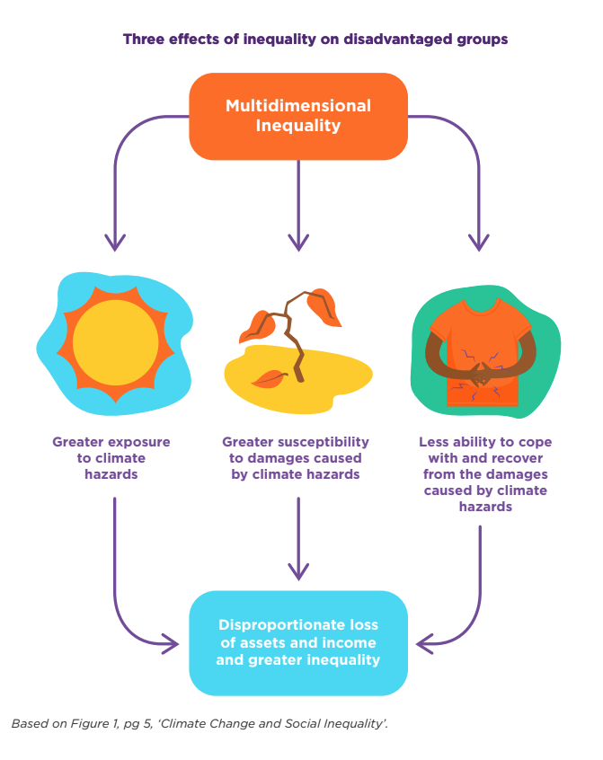

The increased exposure and loss from climate change are also a result of increased reliance on consumption and production that increases climate change. For example, low-income jobs are often in industries that are high polluting and low-income households often own older vehicles that are less efficient and have greater carbon emissions.

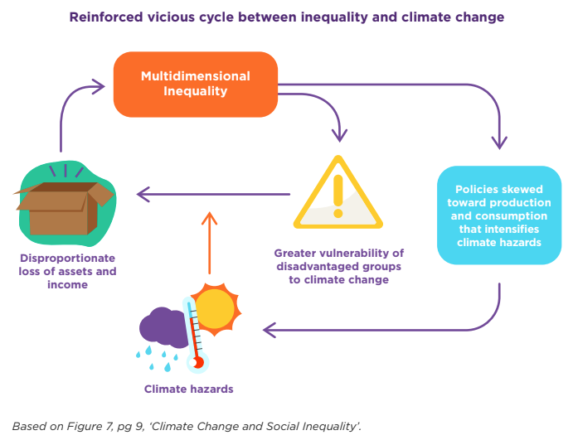
In addition to this, the disproportionate influence that politically and economically wealthy groups have in society further increases the vulnerability of disadvantaged groups and therefore intensifies the inequality of negative impacts of climate change.

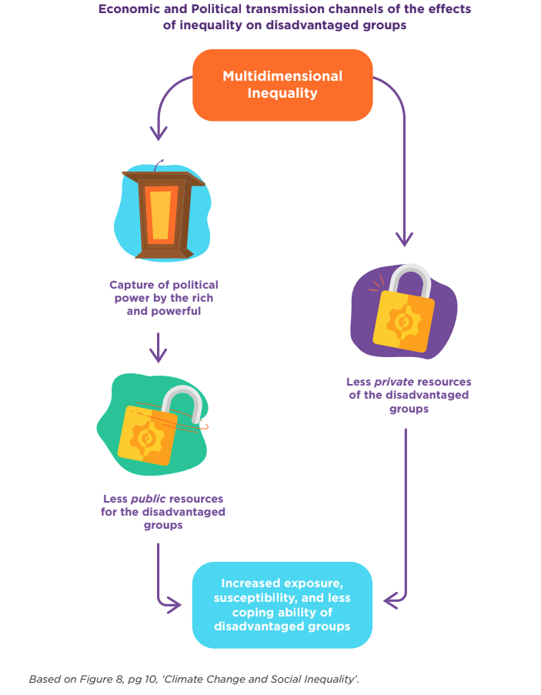

<now do Topic 3, Activity 1>
Before moving on to Topic Four, check that you understand:
- How to write a detailed, economically sound and logical explanation for inter-relationships between statistical data using economic concepts and/or models.

Topic four: Making a justified forecast
Learning Outcome for Topic Four
- Understand how to provide a justified forecast for one contemporary economic issue by using extrapolated statistical data.

Success criteria

- I can extrapolate data to provide a forecast
- I can justify my forecast using sound economic reasoning.

This topic focuses on predicting likely outcomes based on knowledge of history and changes in human behaviour. Are humans destined to continue on the same path, with the same attitudes, beliefs and behaviours, or will humans adapt their behaviour, and learn from what was done well and what was not done well?
Making predictions is not difficult. Justifying the predictions is significantly harder. Ultimately, your prediction can only be judged as correct or incorrect in hindsight. The quality of your justification, on the other hand, can be judged and therefore that is the most important part of this topic.
Making a forecast
This requires you to extend the graphs you have drawn by adding a prediction of the direction in which the graph might head.

Here are some forecasting suggestions:
- Use past data. If the last two years have shown increases, it might be fair to assume that next year will show an increase.
- Use related data. If greater borrowing results in greater risk to lenders and therefore higher interest rates, then a decrease in borrowing could lead to lower interest rates.
- Use knowledge, experience, and history. History tells us that our economy tends to operate in cycles. After a rise there usually comes a fall and after a fall usually comes a rise. An example of this is what economists refer to as the business cycle.

The justification is the reasoning behind the forecast and can be based on the forecasting suggestions above.
Using the graph from topic one, for example:
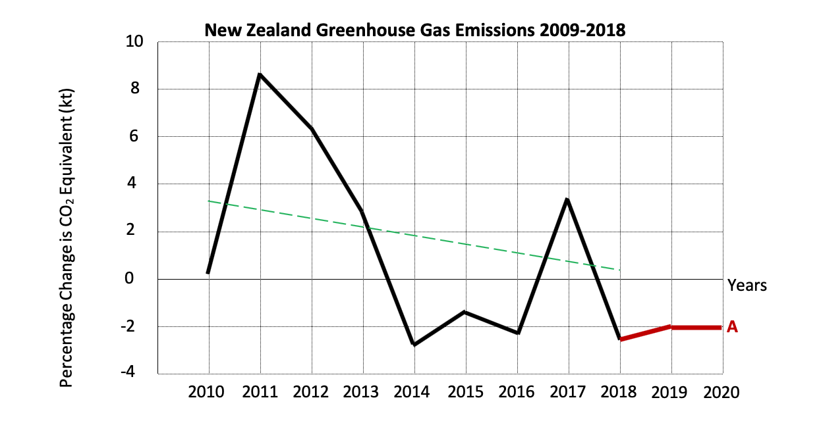

The data could be predicted to stabilize at about -2% as shown by line A . The justification of this could be that 2017 was an outlier and the trend over the previous 5 years has been results of about -2%. This also continues the overall trend of falling percentage changes into the negative territory. Economics could be included by stating that government and societal changes have resulted in previous production methods that added to carbon emissions being replaced by more environmentally friendly methods of production. Consumers have moved their preferences towards goods and services that are produced using environmentally friendly methods and producers have responded to this shift in demand.

Assessment tip

Your response is judged on the soundness of your economic reasoning not on the accuracy of your prediction.

<Now do Topic 4, Activities 1 and 2>
Before moving on to your assessment, check that you understand:
- How to extrapolate data to provide a forecast
- How to justify your forecast using sound economic reasoning.

References
1 https://www.stuff.co.nz/business/89957960/women-face-retirement-savings-battle
2 https://www.fma.govt.nz/assets/Reports/20191004-FMA-KiwiSaver-Annual-Report-2019.pdf
3 https://www.ird.govt.nz/about-us/tax-statistics/kiwisaver/datasets
4 https://www.mbie.govt.nz/assets/c92012e10c/low-pay-in-nz-january-2018.pdf
https://www.stuff.co.nz/national/education/118854795/student-loan-arrest-debt-at-crisis-level
5 https://www.mfe.govt.nz/publications/climate-change/new-zealands-greenhouse-gas-inventory-1990-2018
6 https://tradingeconomics.com/new-zealand/interest-rate
7 https://www.un.org/esa/desa/papers/2017/wp152_2017.pdf

