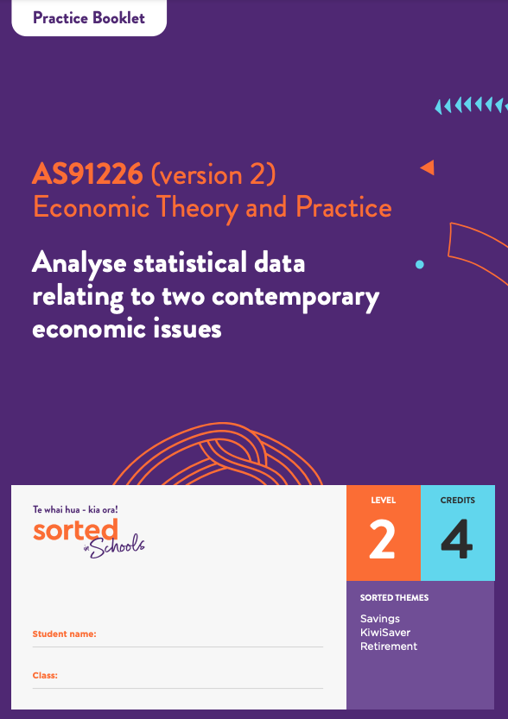

Practice Booklet

Economic Data, Issues, and Analysis

AS91226 (version 2)
Analyse statistical data relating to two contemporary economic issues
Economic Theory and Practice

Level: 2
Credits: 4

Sorted Themes:
Savings
KiwiSaver
Retirement

This workbook provides activities that you can use to develop and demonstrate your understanding of the analysis of statistical data relating to two contemporary economic issues.

The module is based on the societal issues of inequality and climate change so the first two activities introduce these themes.

Theme A: Introduction to inequality
Theme A, Activity 1
Decide whether you think the following situations are fair or unfair. Explain your choice. There may or may not be one common answer for each.

 |  | Fair?  Yes or No | Why?
1 | Females on average earn about 80% of the income received by males.
2 | Females receive the same amount in superannuation payments from the government per fortnight as males.
3 | Female models in the clothing industry are generally paid more than male models.
4 | Female tennis players receive the same amount of prize money for winning a Grand Slam tournament as male tournament winners.
5 | Female rugby players are at best semi-professional and often earn less than $50,000 per year while many male rugby players earn well in excess of $100,000 per year.
6 | Airline pilots are paid more than bus drivers.
7 | Police officers are paid more than nurses.

Theme A, Activity 2
Section 21 of the Human Rights Act (1993) outlines the prohibited grounds for discrimination. Can you think of any other grounds for discrimination that should be prohibited? Discuss your choice with someone else.

Discussion notes:

Theme B: Introduction to climate change
Theme B, Activity 1
Read Time Magazine’s article: The Climate Crisis Is Global, but These 6 Places Face the Most Severe Consequences. List five features that you think these places have in common.

1.
2.
3.
4.
5.

Theme B, Activity 2
Watch the Sorted in Schools Climate Crisis video and answer the following questions:

a) One of the suggestions of what you can do to reduce climate change is to buy locally produced ethical goods. List three of the other suggestions.

1.
2.
3.

b) Explain how you buying locally produced goods will reduce greenhouse gas emissions.

Theme B, Activity 3
Changes to land use and agricultural practices are likely to have major influence on New Zealand’s ability to reduce and manage our greenhouse gas emissions. These changes are likely to occur at a significant cost, but there is also the possibility that new opportunities will arise. List three benefits or opportunities that you predict are likely to arise from changes to land use and agricultural practices.

1.
2.
3.

Topic One: Processing and presenting statistical data
Topic 1, Activity 1
Processing inequality data
This activity uses an Excel spreadsheet of data showing the number of active/provisional KiwiSaver members, by income bracket that you can test yourself with. Make sure you use a calculator.

a) In June 2019 what percentage of the total number of contributors earned $120,000+?

b) In the same period of time, what percentage of the total number of contributors earned $1-$20,000?

c) What was the percentage change in the number of $120,000+ income earners between 2014 and 2019?

d) What was the percentage change in the number of $1-$20,000 income earners between 2014 and 2019?

Need more practice processing statistical data? Try doing the same four calculations for 2018 and the period 2013 to 2018.

Would you like to do the calculations a different way? Copy the spreadsheet, create two additional columns, and enter the formulae. Let technology do the work for you!
Topic 1, Activity 2
Processing climate change data
Here is some climate change data to test your processing skills on:

The total insurance cost of weather-related events (storms, floods, tornadoes, and fires) in New Zealand 2010 to 2019 [2].
Year | Cost ($m)
2019 | 166
2018 | 226.3
2017 | 242.66
2016 | 51.8
2015 | 116.3
2014 | 152.8
2013 | 175.3
2012 | 8.7
2011 | 57.5
2010 | 68.8

a) The 2019 Timaru hailstorm cost a total of $130.7m, which is what percentage of the total weather-related insurance costs for 2019?

b) In 2015 Cyclone Pam cost a total of $2.2m, which is what percentage of the total weather-related insurance costs for 2015?

c) What was the percentage change in the total amount between 2016 and 2017?

d) What was the percentage change in the total amount between 2017 and 2018?

Topic 1, Activity 3
Presenting consumer loan data
Present the following data on the graph provided.
Total Consumer Loans (as at year end) [3]
Year | Amount ($million)
2019 | 16,966
2018 | 16,736
2017 | 16,663
2016 | 15,377
2015 | 14,698

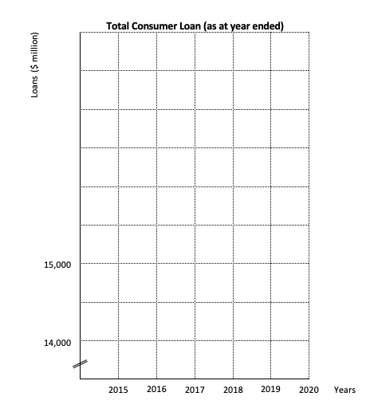

Topic 1, Activity 4
Presenting percentage changes in electric vehicle (EV) registrations data
Present the following EV percentage change data on the graph provided
Monthly EV Registrations (July) [4]
Year | Month of July Registrations | Percentage Change (%)
2020 | 482 | -14
2019 | 560 | 2
2018 | 550 | 90
2017 | 292 | 91
2016 | 153 | 219
2015 | 48

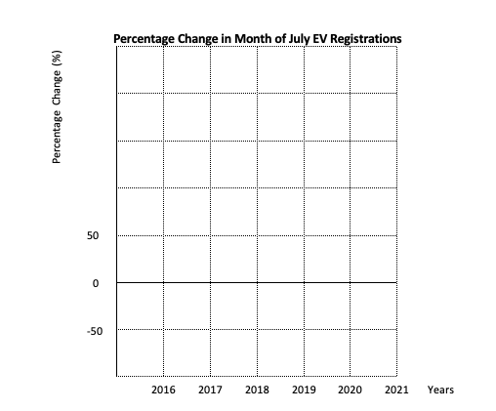

Topic 1, Activity 5
Insert an appropriate trend line onto the graphs that you have drawn for activities three and four.

Topic Two: Explaining trends in statistical data
Topic 2, Activity 1
- What is meant by the term “relative poverty”?

- What is meant by the term “tragedy of the commons”?

- How is climate change likely to impact on production in New Zealand?
Consider whether you think the total output of goods and services will rise or fall. Also think about whether the types of goods and services New Zealand produces will change, and whether the way that those goods and services are produced will change.

Topic 2, Activity 2
There is a recognised relationship between income and savings. The following resource is an explanation of this relationship, but the sentences have been jumbled. Rewrite the paragraph putting the sentences into an order that creates a detailed economic explanation of the relationship between income and savings.

Higher income households have more choice about how they spend their money because a greater percentage of their income is left over after paying for essential goods and services like food, housing, and energy. The reason for this is that these households have higher disposable income and are more able to save. Households that have higher incomes are more likely to have higher savings. Data from the Motu Working Paper ‘Household Wealth and Savings’ that tells us between 2004 and 2006 median individual savings were $1,248 whereas the savings of the 75th percentile were $32,221, supports this statement.

Topic 2, Activity 3
Use your answer to Topic 1, Activities 4 and 5, and the following graph from the Student Booklet, to provide a detailed explanation of the relationship between electric vehicle registrations and climate change.

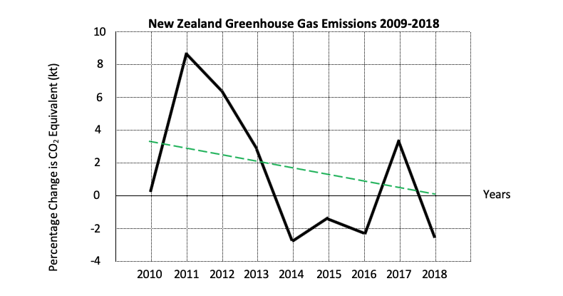

Space to Insert a model:

Topic Three: Explaining the inter-relationships between climate change and inequality
Topic 3, Activity 1
- Identify an economic model that you could use to help explain the inter-relationships between climate change and inequality.

- Use the diagrams from topic three in the Student Booklet to explain in detail the inter-relationship between climate change and inequality.

- Underline the economic terms and concepts that you have used in your explanation.

Topic Four: Making a justified forecast
Topic 4, Activity 1

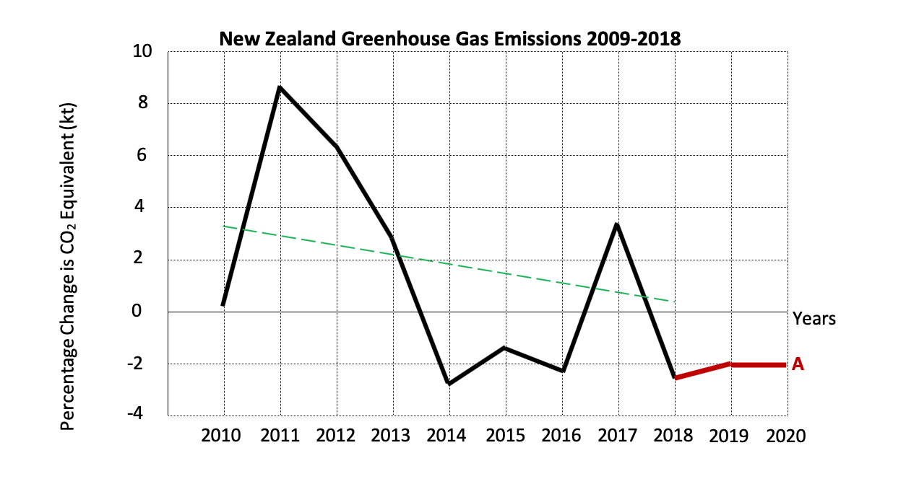
The example from the Student Booklet, copied above, uses past data as a justification.
- Use the cyclical nature of the economy to provide a justification for the forecast below.
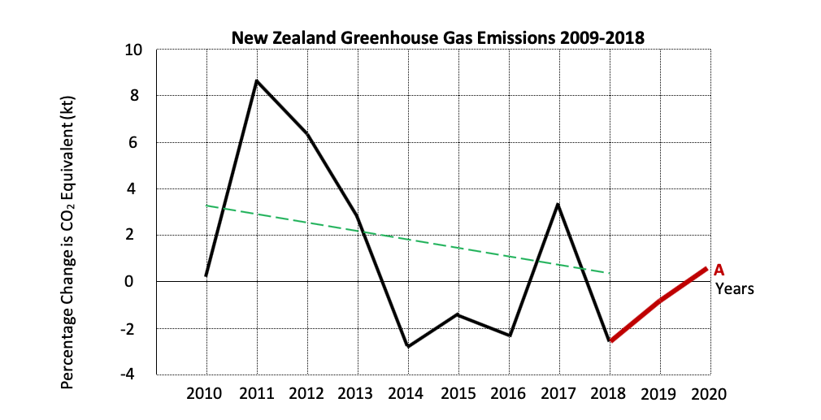

- Use the known impact of Covid-19 on the economy to provide a justification for the forecast below.
As an additional challenge try to use the aggregate supply and aggregate demand model as part of your justification.
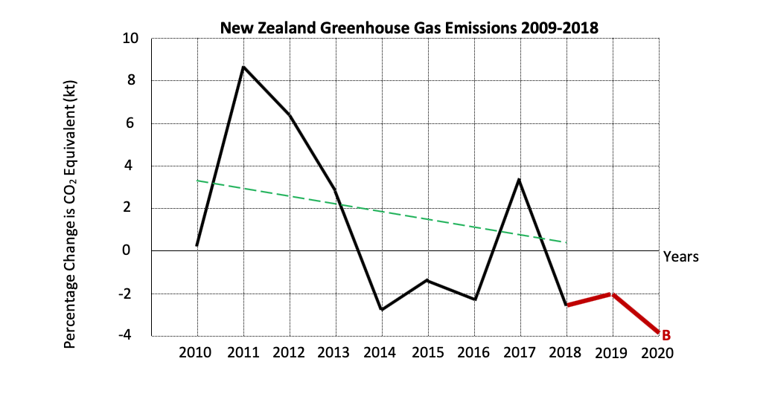
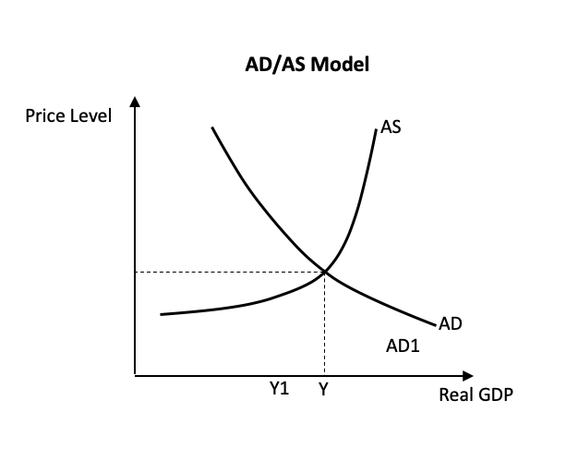

References
1 https://www.ird.govt.nz/about-us/tax-statistics/kiwisaver/datasets
2 https://www.icnz.org.nz/natural-disasters/cost-of-natural-disasters/
3 https://www.rbnz.govt.nz/statistics/c22
4 https://www.transport.govt.nz/mot-resources/vehicle-fleet-statistics

