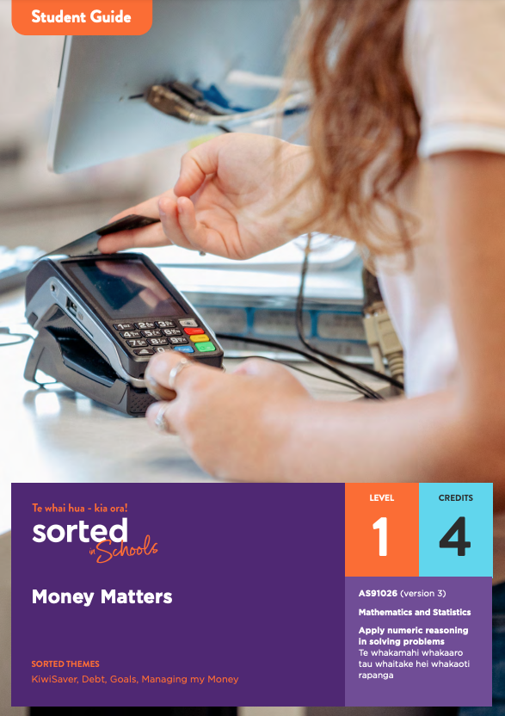

Student Guide

Money Matters

AS91026 Apply numeric reasoning in solving problems | Te whakamahi whakaaro tau whaitake hei whakaoti rapanga (version 3)

Mathematics and Statistics

Level: 1
Credits: 4

Sorted themes:
KiwiSaver
Debt
Goals
Managing my Money

Nau mai haere mai!
Welcome to the Money Matters module. This module will help you to develop your money making decision process through using your number knowledge skills. The module is part of a series of NCEA learning materials available from Sorted in Schools - Te whai hua - kia ora!
This student guide provides an overview of the content and context explored in the module, assessment information, resources, and useful links.

The other documents in the module are:

- A student booklet that supports you to develop the skills, knowledge, and understanding that you need to meet the requirements of an NCEA achievement standard.
- A practice booklet that provides opportunities for you to apply and consolidate your learning.
- An answer booklet to accompany the practice booklet.
- A vocabulary list of key achievement standard terms.

Each booklet is provided as a Word document and PDF to use online or printed. When used online, you can type your answers into the practice booklet.
As you work through the module, you’ll be completing activities that will prepare you for an internal assessment of AS91026 Apply numeric reasoning in solving problems | Te whakamahi whakaaro tau whaitake hei whakaoti rapanga (version 3).

Achievement Criteria
Achievement | Achievement with Merit | Achievement with Excellence
Apply numeric reasoning in solving problems. | Apply numeric reasoning, using relational thinking, in solving problems. | Apply numeric reasoning, using extended abstract thinking, in solving problems.

Achieving AS91026 contributes four credits towards the 10 Numeracy credits at Level 1 or above that you need for University Entrance (UE). Other Sorted in Schools modules that can support you to gain Literacy and Numeracy credits are:
- Statistical Reports (AS91266, Level 2, 2 credits)
- Statistical Inference (AS91264, Level 2, 4 credits)
- Questionnaire Design (AS91263, Level 2, 3 credits)
- Economic Data, Issues, and Analysis (AS91226, Level 2, 4 credits).

About Sorted in Schools – Te whai hua – kia ora!
Sorted in Schools is a government-funded financial capability programme fully aligned to the New Zealand Curriculum. Free to use, Sorted in Schools helps young New Zealanders develop their money skills.

Why financial capability matters
Being good with money is an essential life skill. Financial capability means being equipped with the knowledge, skills and confidence to make good financial decisions at each life stage, and attain goals with choices. Research shows that 16-24 year olds are, however, vulnerable to falling into debt that can hold them back. In addition, over 80% of school leavers told us they wished they had learned more about money at school. We’re changing that! Our learning materials equip you with know-how to start your financial journey on the right foot. The earlier you become good with money, the better you will fare throughout your life.

Build your financial capabilities while you learn about numeric reasoning
This module is designed to support you to both achieve success in the assessment and build your financial capability kete.
Financial capability involves developing skills that will help you to feel confident about how to use and manage your money in order to achieve your goals, both now and in the future.
All of the Sorted in Schools learning materials include a combination of key financial capability concepts, or Sorted Themes, to help you develop your financial skills, knowledge, and behaviours. In this module, you will come across these Sorted Themes:

KiwiSaver Debt
Goals Managing my Money

You can find resources linked to each of these themes on the student activities page of the Sorted in Schools website. Click on Theme and select an option from the dropdown menu. The resources include booklets, PowerPoints, infographics, videos, and interactive activities. You can search for different types of resources using the Media option.

Topic overview
Here is an overview of the topics you will explore in this module:

Topic One: Understanding your payslip
Common elements of payslips, using rates of pay to calculate earnings, overtime, deductions from pay, calculating income tax.

Topic Two: Buying goods and services
Goods and Services Tax (GST), GST calculations, using ratios to divide amounts.

Topic Three: Borrowing money
Credit and debt, hire purchase, calculating percentage change, student loans, order of operations (BEMA).

Topic Four: Financial goals
Savings accounts, term deposits, compound interest, KiwiSaver.

Topic Five: Tools that support financial decisions
Budgets, SMART goals, applying number knowledge to adjust a budget.

Understanding how you will be assessed
Evidence/Judgements for Achievement | Evidence/Judgements for Achievement with Merit | Evidence/Judgements for Achievement with Excellence
I can:  - use my number knowledge, skills, and strategies to solve problems using at least three different numeric methods, for example, methods relating to:  - factors, multiples, powers, and roots  - exponents  - fractions, decimals, and percentages  - rates  - rounding with decimal places and significant figures  - standard form.  - decide which methods to use to solve problems (the problems will usually just have one or two steps).  - show my working and communicate what my calculated answers represent. | I can:  - solve problems that require two or more steps  - use my solution to one part of a problem to solve another part of the problem  - indicate what I am calculating at each step and use appropriate mathematical statements  - link each of my solutions to the context. | I can:  - think beyond the immediate problem which could involve considering:  - other factors mentioned in the scenario and the effect they might have on my solution  - a change in one aspect of the scenario and an exploration of how this change might impact on my recommendation.  - clearly communicate what I am calculating using words and correct mathematical statements.  - explain any decisions I have made when solving problems.

Assessment tips
The student booklet provides assessment tips that will help you understand the requirements of achieving at Merit and Excellence level.

Resources
There are lots of useful resources for exploring financial capability related to managing your money, achieving financial goals, saving and investing, credit and debt, and KiwiSaver.

Sorted in Schools resources that have particular relevance to this module are:
- Managing My Money Sorted booklet
- Goals Sorted booklet
- Investing Sorted booklet
- Debt Sorted booklet
- KiwiSaver Sorted booklet.

You can find these resources on the Student Activities page of the Sorted in Schools website by clicking on the relevant Theme and selecting from the dropdown menu. You’ll also find a range of videos, PowerPoint presentations, infographics and interactive activities that can strengthen and extend your financial capabilities.

