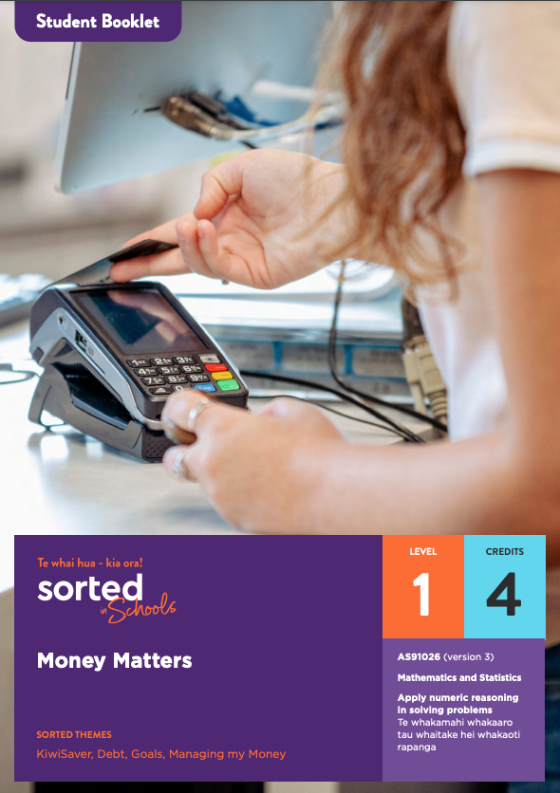

Student Booklet

Money Matters

AS91026 Apply numeric reasoning in solving problems | Te whakamahi whakaaro tau whaitake hei whakaoti rapanga (version 3)

Mathematics and Statistics

Level: 1
Credits: 4

Sorted themes:
KiwiSaver
Debt
Goals
Managing my Money

Contents
Topic One: Understanding your payslip
Topic Two: Buying goods and services
Topic Three: Borrowing money
Topic Four: Financial goals
Topic Five - Tools that support financial decisions

Nau mai haere mai!
Welcome to the Money Matters module. Please read through the Student Guide for an overview of the module and assessment before starting this Student Booklet.

The focus of this module is on building strategies to support money decisions when you earn, spend, borrow, save and invest money through using number knowledge skills. As well as helping you to strengthen your financial capabilities, this module will help you develop the skills and knowledge that you need for success in the Level One Achievement Standard AS91026 Apply numeric reasoning in solving problems.

Assessment tip
In your assessment, you need to clearly communicate your reasoning. This means that you need to:
- show the calculations that you have used
- use mathematical statements
- explain what you are calculating at each stage.
The example answers in this module provide a model you can follow when you explain your own reasoning in the assessment.

Introducing Roimata
Throughout the module, you’ll learn about some of the money decisions made by a 22-year-old student called Roimata. Roimata is training to be an electrician. She is doing an apprenticeship, which means that she is learning and working at the same time.
Roimata is in her final year of training and she has decided to set up a flat with two friends.

Topic One: Understanding your payslip
Learning outcomes for Topic One:
- Understand items on a payslip
- Apply number knowledge related to pay calculations
- Apply number knowledge related to deductions from pay.
Success criteria:
- I can use decimals to solve problems involving rates
- I can convert between fractions, decimals, and percentages
- I can calculate a percentage of an amount
- I can round money calculations to two decimal places.

Payslips
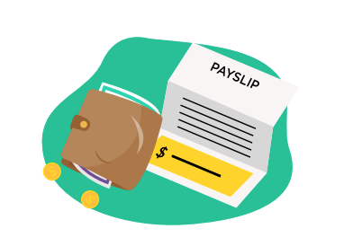
Roimata gets paid every fortnight (two weeks). Each pay, she receives an email with a payslip that shows how much money she has earned over the past fortnight (two weeks). The payslip explains money that has been taken off or added to her earnings so that she knows exactly how much money will be paid into her bank account each fortnight (two weeks).
This video shows you the different parts of a typical payslip.
Here is Roimata’s fortnightly (two-weekly) payslip:
Figure Electrical Ltd |  | IRD Number | 027-598-412 | Annual leave available | 7.5 days
Roimata Paerata |  | Tax Code | MSL | Sick leave available | 3.0 days
16 Main Road
Greytown
Period End | 28/05/2021
Annual Salary | $42,540
Description | Quantity | Units | Rate | Total | This Pay
Ordinary time | 81.00 | Hours | $20.45 | $1,656.45
Overtime | 0.00 | Hours | $30.68 | $0.00
Gross Pay |  |  |  |  | $1,656.45
Income Tax (PAYE) |  |  |  |  | -$248.63
ACC Levy |  |  |  |  | -$22.74
Student Loan Repayment |  |  |  |  | -$105.14
Kiwisaver 3% |  |  |  |  | -$49.08
Net Pay |  |  |  |  | $1,230.86
KiwiSaver Employer Contribution |  |  |  |  | $49.08

A payslip typically includes the following items - you’ll be learning more about each of these components throughout the module.

IRD Number
This is an eight- or nine-digit number that only you have. It is given to you by the Inland Revenue Department (IRD). This number will be on all of your payslips and KiwiSaver statements when you are working.

Gross Pay
The amount that you have earned before any deductions (such as tax) have been made.

Net pay
This is the amount that you will have in your pay packet each week or fortnight (two weeks) after the deductions have been taken out.

Hourly Rate
This is the amount you get paid for every hour that you work.

Hours Worked
These are the total hours that you have worked over this pay period.

Overtime
These are the extra hours that you have worked in this pay period. These are above the number of hours you have agreed to in your employment contract.

Holiday Pay Entitlements
You are entitled to a number of holiday days each year and the amount you have are shown on your payslip.

Sick Day Entitlements
You are entitled to a number of paid sick days each year and the amount you have are shown on your payslip.

Deductions
Money is deducted from your gross pay before you get it. Deductions might include:

- Tax Deductions
For every dollar you earn you will have to pay tax. The amount that you pay will depend on how much you earn.

- Student Loan
A student loan is a loan that the government provides to help you pay for your education when you have left secondary school. This can cover expenses such as the costs of fees, books and course materials and living expenses. Once you start earning over a certain amount, you need to start paying back the money you have borrowed.

- KiwiSaver
KiwiSaver is a voluntary government investment scheme to help you save for your retirement. You decide whether to save 3%, 4%, 6%, 8%, or 10% from your pay. Your employer will also contribute at least 3% to help your fund grow. After contributing to KiwiSaver for three years, you can use your funds to help buy your first home.

- ACC Levy
The Accident Compensation Corporation (ACC) levy is used to pay for the prevention, care, and recovery costs related to people having accidents.

< Now do Topic 1 Activity 1>

Using rates of pay to calculate earnings
A rate is a comparison between two measurements, for example, the number of kilometres travelled per hour (speed) or the number of heart beats a person has per minute (pulse). Rates often use the word “per”.
A pay rate is the amount that a person is paid for the work they do, most commonly expressed as the number of dollars earned per hour worked.
If you know how much a person earns per hour, you can work out how much they will earn for any length of time.

Assessment tip
Writing correct mathematical statements is an important part of your assessment. This means that you need to use both mathematical symbols and written text to explain any calculations that you make.
When dealing with money, you need to include a currency symbol ($) and write your answer with two decimal places.
For example, if your calculator gives you an answer of 73.2 you need to write it as $73.20.

Example
Roimata’s pay rate is $20.45 per hour. She wants to know how much she will earn before tax and deductions if she works 32 hours in a week.
Answer:
1 hour : $20.45
32 hours : x
x = $20.45 x 32
x = $654.40
You can use the same method regardless of whether you are working with whole numbers or with fractions or decimals.

Converting fractions, decimals, and percentages
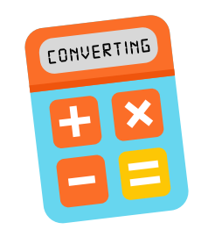
Numbers can be written in different forms, for example, one half can be written as a fraction (½), a decimal (0.5), or a percentage (50%).
Being able to convert fractions, decimals, and percentages is a useful skill, allowing you to work with the number form you feel most confident with.

Converting between fractions and decimals
To convert a fraction to a decimal, divide the top number of the fraction (the numerator) by the bottom number of the fraction (the denominator).
Example:
To convert ¾ to a decimal, divide 3 by 4.
3 ÷ 4 = 0.75
To convert a decimal to a fraction, you need a good understanding of place value and how to simplify fractions.
Example:
0.425 = $\frac{425}{1000}=\frac{17}{40}$
Watch the Khan Academy Rewriting decimals as fractions clip if you need further support and practice.
Converting between decimals and percentages
To convert a decimal to a percentage, multiply the decimal by 100. Remember to add a percentage sign! (%)
Example:
0.75 x 100 = 75
0.75 = 75%
To convert a percentage to a decimal, divide by 100 and remove the percentage sign.
Example:
2.5% = 2.5 ÷ 100 = 0.025
Converting between percentages and fractions
To convert a percentage to a fraction, place the percentage over 100, then simplify.
Example:
66% = $\frac{66}{100}$= $\frac{33}{50}$
To convert a fraction to a percentage, first convert the fraction to a decimal, then multiply the result by 100 and add a percentage sign (%).
Example:
$$\frac{2}{5}=2÷5=0.4$$
$$0.4×100=40$$
0.4 = 40%

< Now do Topic 1 Activity 2>
Examples
- How much will Roimata earn before tax and deductions if she works an extra ¾ of an hour?
Answer:
Pay for 1 hour : $20.45
Pay for ¾ hour : x
x = 3 ÷ 4 x $20.45
x = $15.34
- How much will Roimata earn before tax and deductions if she works 16.25 hours at her ordinary pay rate?
Answer:
Pay for 1 hour : $20.45
Pay for 16.25 hours = x
x = 16.25 x $20.45
x = $332.31

Extra pay rates
Sometimes there are opportunities to earn higher rates of pay. An example of this is when you are asked to work on a public holiday such as Anzac day or Labour day. By law, if your employer requires you to work on a public holiday, they need to pay you “time and a half”. This means that you get 1.5 times as much per hour as you would on a regular work day.

Example
Roimata’s employer asks her to work on New Year’s Day. Her normal pay rate is $20.45 per hour. How much will she earn if she works for 8 hours on time and half pay?

Answer:
Public holiday pay rate : $20.45 x 1.5 (1.5 is the same as 1 and a half hours)
: $30.68
Pay for 8 hours = x
x = $30.68 x 8
x = $245.44

Pay deductions
Roimata’s “gross pay” or “gross earnings” (the amount of money she earns each fortnight) is never the same as her “net pay”, which is the amount of money that gets paid into her bank account. One reason for this is that Roimata pays tax directly from her pay.

Taxes
Tax is money that New Zealanders pay to the government and there are lots of different types of taxes. Our taxes pay for things such as:
- government agencies who help people
- supporting emergency services like police, firefighters, search and rescue and ambulance
- public services such as hospitals and schools
- the salaries of government workers
- building and maintaining highways and other major roads
- public places, parks, and areas of conservation.

For every dollar you earn, you have to pay some to the government. This is called income tax.

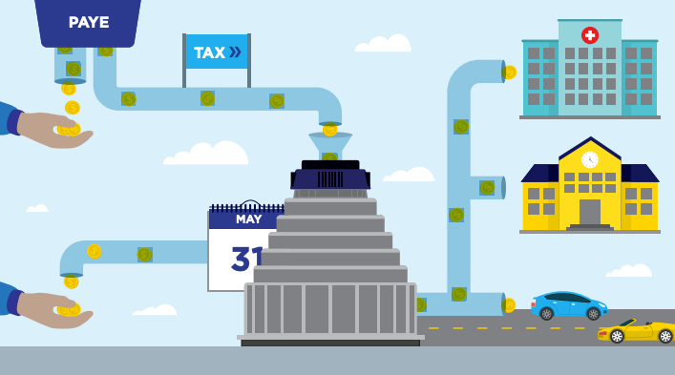

Pay As You Earn (PAYE)
Pay-As-You-Earn or PAYE is a tax system that involves automatic tax payments that come directly out of people’s pay. This money is collected for the government by The Inland Revenue Department - Te Tari Taaki (IRD). Each pay period your employer will calculate and deduct PAYE from your pay. PAYE makes it easy to keep on top of your tax payments — without it, people would need to set aside money throughout the year. Your payslip shows how much tax has been deducted from your pay.

Income tax rates
The amount of income tax you pay will depend on how much you earn. The more you earn the higher your tax rate will be. The less you earn the lower your tax rate will be.

Note: Some mathematical terms can have a slightly different meaning when they are used in everyday life. We’ve just learned that a rate is a comparison between two measurements. Tax rates are a bit different - they are the percentage of tax that you pay per dollar that you earn.

New Zealand income tax rates (based on April 2021 rates)

Row | For each dollar of income | Income tax rate
A | Up to $14,000 | 10.5%
B | Over $14,000 and up to $48,000 | 17.5%
C | Over $48,000 and up to $70,000 | 30%
D | Over $70,000 and up to $180,000 | 33%
E | Over $180,000 | 39%
Source: Inland Revenue - Te Tari Taaki

Calculating a percentage of an amount
To calculate income tax you need to know how to calculate a percentage of an amount. There are different ways to do this. Here is one option:

Convert the percentage into a decimal by dividing it by 100 then multiply the result by the amount.
Find 33% of $2,800
Answer: $\left(\frac{33}{100}\right)×\$2,800=\$924$

You can use this method when working with any percentage, for example:
Find 2.5% of $72,000
Answer: $\left(\frac{2.5}{100}\right)×\$72,000=\$1,800$

Find 0.75 % of $8,000
Answer: $\left(\frac{.75}{100}\right)×\$8,000=\$60$

To calculate the amount of income tax you need to pay, you need to know your annual (yearly) salary. This salary is then split up into the different bands and the tax payable for each band is calculated separately. The rows of the income tax table above show each tax band.

Example
Roimata’s brother Jack earns $58,900 per year. He wants to work out his income tax. To do this he works from the bottom of the income tax rates table up to the top:

Rows D and E: Jack isn’t earning over $70,000, so he can ignore the information in these two rows.

Row C: Jack calculates how much he earns over $48,000:
$58,900 - $48,000 = $10,900.
Jack needs to pay 30% of this income as tax:
30% of $10,900
= 0.3 x $10,900
= $3,270.

Row B: Jack calculates how much of his income is between $14,000 and $48,000:
$48,000 - $14,000 = $34,000
Jack needs to pay 17.5% of this income as tax:
17.5% of $34,000
= 0.175 x $34,000
= $5,950.

Row A: Jack needs to pay 10.5% income tax on the first $14,000 he earns:
10.5% of $14,000
= 0.105 x $14,000
= $1,470.

The total amount of income tax Jack will pay is: $3,270 + $5,950 + $1,470 = $10,690

Another useful skill is being able to calculate what percentage one amount is of another amount. To do this, you divide the two numbers and multiply by 100.

Example
What percentage of Jack’s income will he pay as income tax?

Answer: $\left(\frac{PAYE income tax}{total income}\right)×100$
= $\left(\frac{10690}{58900}\right)×100$
= 0.181494 x 100
= 18.1
Jack will pay 18.1% of his salary as PAYE income tax.

Assessment tip
When you are working out something that involves a number of steps, write each step on a single line, placing the next step beneath it. This will help you to communicate your thinking in a clear and concise way. It also helps you to avoid making mathematically incorrect statements that sometimes occur when you try to work across a single line.
Remember that to meet the requirements of the standard, it’s essential to explain in words what your answer represents - calculations alone are not enough. To gain a Merit grade or higher, you need to link your answers to the context of the situation or scenario.

< Now do Topic 1 Activities 3 and 4>
Before moving on to Topic Two, check that you understand:
- how to use rates of pay to calculate earnings
- how to convert between fractions, decimals, and percentages
- how to calculate overtime
- how to work out PAYE based on a person’s annual salary.

Topic Two: Buying goods and services
Learning outcomes for Topic Two:
- Understand how to add and remove GST
- Understand how to use ratios to divide up an amount.
Success criteria:
- I can add and remove GST from an amount
- I can divide an amount based on a given ratio.

This topic focuses on some of the mathematics involved in buying goods and services, including the use of credit cards and hire purchase to pay for items you can’t afford to pay for straightaway.

Goods are things that you buy, from small things such as clothing or a jar of Marmite to large items such as a computer, car, or fridge.

Services are activities provided by other people, for example, a dentist fixing a hole in your tooth or someone giving you a haircut.

Goods and Services Tax (GST)
Goods and Services Tax (GST) is a tax you pay on things that you buy and on services that you pay for.
In Aotearoa New Zealand GST is currently 15%.

GST is already included in the price tag of most things you buy, so you may not be aware that you are paying tax when you purchase them. But services are often advertised as being “GST inclusive” or “GST exclusive”.

GST inclusive (often shortened to “incl GST” or “GST inc”) means that the price already includes the GST.
GST exclusive (often shortened to “excl GST” or “GST exc”) means that the GST is not included in the price. The amount you pay will be 15% percent higher.

Watch this Sorted in Schools GST video to learn more

GST calculations
When it comes to GST, there are two key things you need to be able to calculate.

A: Calculating the GST-inclusive cost of a GST-exclusive good or service.
Finding the GST-inclusive cost of a good or service involves increasing the GST-exclusive cost by 15%. There are two methods you can use to do this; the two-step method and the one-step method:

Example
What is the GST-inclusive cost of a haircut that is advertised at $65.00 excl GST?

Two-step method
Step 1: Find 15% of the GST exclusive price:
$$\left(\frac{15}{100}\right)×\$65=\$9.75$$
This is the GST.

Step 2: Add your answer to the GST-exclusive cost:
$65.00 + $9.75 = $74.75

One-step method
The one-step method involves a stronger understanding of the relationship between percentages and decimals.
15% written as a decimal is 0.15.
If you want to increase something by 15% in one step, we can multiply it by 1.15. This gives us the original amount with an additional 15% added on.

GST-exclusive price x 1.15 = GST-inclusive price
$65.00 x 1.15 = $74.75

Understanding the maths that underpins the one-step method will help you remember how to work out the GST-exclusive cost of a good or service, explained below. The two are closely related.

Assessment tip
Always read the information in the task carefully, especially when it comes to identifying whether GST is included or excluded from an amount. A GST-exclusive amount is sometimes written as GST(exc) and a GST-inclusive amount is sometimes written as GST(inc).

B: Calculating the GST-exclusive cost of a good or service.
Calculating the GST-exclusive cost of a good or service involves applying the one-step method but working backwards.

Example
To increase $65 by 15% using the one-step method, we multiplied $65 by 1.15 to get $74.75.
To find the GST-exclusive amount, we divide $74.75 by 1.15.
$74.75 ÷ 1.15 = $65

Why can’t we use a two-step method?
A common error when asked to remove the GST from the cost of a good or service is to find 15% of the GST-inclusive cost and then subtract this amount to find the GST-exclusive cost. This sounds logical, but it won’t give you a correct answer. The reason this doesn’t work is that 15% of the GST-inclusive amount is not the same as 15% of the GST-exclusive amount.

Let’s explore this using an example.

Example
A person who mows lawns charges $40 per hour + GST.
The GST is 15% of $40, which is 0.15 x $40 = $6.
So, the GST inclusive amount is $40 + $6 = $46.

Now let’s calculate 15% of $46:
15% of 46 is 0.15 x $46 = $6.90
Notice that $6.90 is 90 cents more than the $6 that was added on to the GST exclusive amount. If we remove $6.90 from the GST inclusive cost, we’ll get an incorrect answer:
$46 - $6.90 = $39.10.
As you can see, we’ve taken away too much. The correct answer should be $40.

This diagram shows the relationship between the one-step method of adding GST and the one-step method of removing it.
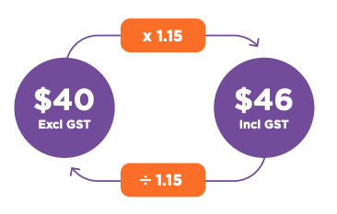

Dividing by 1.15 reverses the effect of adding 15% by multiplying by 1.15.

Assessment tip
To get an Achieved grade in your assessment, you need to select and apply at least three numerical methods.

Being able to use increasing and decreasing percentages such as calculating GST-exclusive and GST-inclusive amounts is one of the accepted numerical methods.

Once you’ve found the GST-exclusive cost of something, you can use this to work out the GST of a GST-inclusive amount.
Example
Roimata pays a mechanic $167.35 including GST. How much GST did she pay?
Answer:
GST-exclusive cost: $167.35 ÷ 1.15 = $145.52
The GST paid is the difference between the GST-inclusive and the GST-exclusive cost:
$167.35 - $145.52 = $21.83
Note: another way to solve this problem would be to find 15% of the GST-exclusive cost:
0.15 x $145.52 = $21.83

< Now do Topic 2 Activity 1>

Using ratios to split costs
When you live in a flat, sometimes costs need to be split between people unevenly.
Example
Roimata and her flatmates decide to divide the cost of a renting agent’s fee of $125 based on the ratio of rent they are each paying.
Roimata will pay $210 per week and her flatmates, a couple, will pay $300 ($150 each).
This can be written as a ratio: 210:150:150
Ratios can be simplified by dividing (or multiplying) each amount by a common factor. This can make them easier to work with. A ratio in its simplest form uses whole numbers, not decimals or fractions.
Example
Simplify 210:150:150
= 21:15:15 (each amount divided by 10)
= 7:5:5 (each amount divided by 3).
The agent’s fee is $125. This is how Roimata and her flatmates can calculate how much each person should pay:
Step one: Add each amount together to find out how many parts there are.
7 + 5 + 5 = 17
Step two: Divide the total amount in this number of parts.
125 ÷ 17 = 7.3529411 (avoid rounding at this point)
Assessment tip
When solving a multi-step problem, don’t round your answers until the final step.

Step three: Multiply this amount by each person’s allocated parts
Roimata’s part
7 x $7.3529411 = $51.47
Flatmate’s part
5 x $7.3529411 = $36.76
Based on the ratio 7:5:5, Roimata should pay $51.47 and her flatmates should each pay $36.76.
Note that even though we haven’t rounded until the final stage, the solution still doesn’t quite add up to $125 ($51.47 + $36.76 x 2 = $124.99). One person will have to pay an extra cent.

Ratios and rates - what’s the difference?
A ratio compares two or more amounts of the same kind of thing, for example, the ratio of water (measured in mls) to cordial (also measured in mls) for a drink mixture. Rates are a special kind of ratio that compare different kinds of measures such as pay per hour ($ and time).

Using fractions to solve ratio problems
The problem could also have been worked out using fractions:
Example
The total rent is $510.
The fraction of the rent Roimata is paying is $\frac{210}{510}$.
Her flatmates are each paying $\frac{150}{510}$.
The amount each person should pay of the $125 is:
Roimata: $\frac{210}{510}$ x $125 = $51.47
Each person in the couple: $\frac{150}{510}$ x $125 = $36.76

< Now do Topic 2 Activity 2>
Before moving on to Topic Three, check that you understand:
- how to calculate a GST-inclusive amount
- how to calculate a GST-exclusive amount
- how to find the GST content of an amount
- how to split costs using ratios.

Topic Three: Borrowing money
Learning outcomes for Topic Three:
- Understand interest and fees related to credit cards and hire purchase
- Understand how to use percentages to calculate the total cost of a loan
- Understand student loan repayments
- Understand the correct order of operations (BEMA).
Success criteria:
- I can calculate simple interest
- I can calculate percentage change
- I can use BEMA to solve problems.

No one likes being in debt, whether it’s financial debt or just owing someone a favour. But when it comes to money, a debt is considered good debt if you’re using the money borrowed to buy something that will increase in value over time. Examples of good debt can include paying for education or buying a house.

Credit and Debt
Sometimes we need (or perhaps just want) something that we can’t afford. As a general rule, it’s best to try to save up enough money to pay for things before we buy them, especially if they’re a want not a need. But if the fridge has stopped working or we need a car in order to be able to get a job, and we don’t have savings to draw on, we may be forced to borrow money.
Borrowing money involves using someone else’s money to make a purchase, with the promise of paying that person or organisation back at a later stage. Borrowing can be informal, such as borrowing $5 from a friend to pay for a bus fare, or formal, such as borrowing $5,000 from the bank to buy a car.
Debt
Debt is money that you owe to someone else. For example, if you borrow money from a whānau member, a bank or a loan company, you have debt. Debt doesn’t just come from purchases. If the bank charges you interest or fees for borrowing the money, the interest becomes part of your debt.

Credit
Credit is a way to buy goods and services and then pay for them later. When you use a credit card, you are spending money that you don’t have. If you have a credit card, the bank lets you borrow money up to an agreed amount to pay for things. You have a set amount of time, usually until the end of the month, to pay the money back before you are charged interest.

It’s important to remember that when you buy something on credit, you are taking on a debt. If you use a credit card to buy something that costs $120, you have a debt of $120.

Credit and Debt video
Borrowing money can seem like a quick fix, but debt can end up being a serious drag on your finances. This is especially true when you borrow money to pay for goods and services that lose their value after you’ve bought them, for example, a television, a game console or a holiday. These things aren’t bad in themselves, but borrowing money to pay for them can create problems for your future self if it takes you a long time to pay the money back. The additional costs of interest and fees can stop you from being able to get ahead financially and can even lead to you financially rolling backwards.
Common costs associated with most loans are:
- interest rates – the amount of interest you need to pay on the loan
- fees – some money lenders charge a set-up fee when you set up a loan
- penalties – some loans have penalties if you miss a payment.
To find the best loan for your circumstances, you need to know what the fees and interest rates are. Before taking out a loan, it’s important to add up the total costs and see how long it will take you to get out of debt.
Example
When Roimata first got a credit card, she used it to pay for some equipment she needed for her course. This seemed like a great idea at the time, but Roimata soon discovered how hard it can be to pay off debt. The interest and fees she needed to pay each month quickly built up. Now that she’s finally paid off her debt, Roimata tries to only use the card for online payments that she knows she can afford.

Hire purchase
Stores that sell larger items such as washing machines and televisions often offer hire purchase. When you buy something on hire purchase, you can take it home and use it while you’re paying it off. Hire purchase can seem like an easy way to pay when you don’t have enough money to pay for something in full, especially if the deal is interest free at first. However, it’s important to find out the true cost of hire purchase before signing up. Most hire purchase agreements come with a range of charges and fees. For example, you might have to pay a $100 set up or account fee even when you’re on an interest-free deal. Some retailers insist that you buy repayment insurance as well. This insurance means that if you have a loss of income, for example, because you have a serious injury, the insurance company will continue paying your hire purchase payments.
You can learn more about hire purchase by reading this Sorted.org guide to tackling debt.
Example
Roimata and her flatmates need a fridge for the flat. They find one online that costs $1,099 if they can pay for it in full, or they can pay it off at $10.88 a week for 60 months.
Roimata calculates the actual cost of the fridge if they take the $10.88 option.
Assessment tip:
Check out the way Roimata explains her reasoning in the example below. This is a useful model for how to explain your own reasoning in your assessment task.
60 months is 5 years (60 ÷ 12 = 5)
5 years = 5 x 52 weeks
= 260 weeks
Total cost of payments: 260 x $10.88 = $2,828.80
Difference between buy now price and hire purchase price: $2,828.80 - $1,099 = $1,729.80
Calculating percentage change
Percentage change problems involve finding out the percentage that an amount has increased or decreased by. The formula for this is:
$$Percentage change = \frac{final amount - initial amount}{initial amount} ×100$$
Let’s use this formula to find out what percentage increase the hire purchase option is:

$$Percentage change = \frac{final amount - initial amount}{initial amount} ×100$$
$$=\frac{\$2,828.80 - \$1729.80}{\$1729.80}×100$$
= 63.53333%
The hire purchase price is an increase of 63.5% on the buy now price. This is considerably more than the interest Roimata and her flatmates would pay if they used a credit card to pay for it.

< Now do Topic 3 Activities 1 to 3>

Student loans
A student loan is a government loan designed to help students pay for things such as course costs, living costs and study materials such as tools or a laptop. You don’t need to be studying full time to be eligible for a student loan but you do need to be studying a minimum number of hours each week.

There are limits to how much you can borrow using a student loan, so although you can use a student loan to cover living costs such as rent, the amount you can borrow may not cover the full cost. If this is the case, you will need other forms of income, for example savings, a part-time job or support from your whānau/aiga.
Student loans do come at a cost, although it’s small compared to the costs of being a student. You need to pay a fee each time you set up a new student loan. You’ll also be charged an admin fee each year if your loan balance is $20 or more.
Once you start earning over a certain amount it’s compulsory to start paying off your student loan. If you earn a wage or a salary the payments come straight out of your pay, although if you are working and studying at the same time then you might be able to get an exemption from this.
In 2021, the amount you can earn without making a loan repayment is $20,020 before tax, which is $385 per week. 12 percent of any amount over this amount goes towards your student loan repayment.

Calculating student loan repayments using BEMA
Calculating student loan repayments is an opportunity to apply your understanding of “the order of operations” or BEMA.

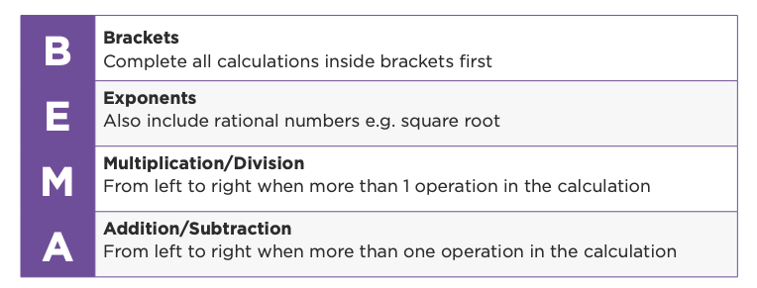

To work out a person’s student loan repayment, we first need to find out how much they are earning above the threshold: weekly earnings - the repayment threshold.
When writing this as a mathematical statement, we place this part of the calculation in brackets. The brackets are needed because scientific calculators are programmed to use BEMA.
Next, we find 12% of the amount in brackets.
Example
If a person with a student loan earns $600 a week, their student loan repayments each week will be:
Student loan repayment
= ($600 - $385) x 0.12
= ($215) x 0.12
= $25.80
Even without interest it can still take many years to pay off a student loan, and having a percentage of your pay go towards your student loan can make things quite tight when you first start earning.

< Now do Topic 3 Activity 4>
Before moving on to Topic Four, check that you understand:
- how to use BEMA to work out a student loan repayment based on a person’s salary
- how to calculate the interest payable on a loan.

Topic Four: Financial goals
Learning outcomes for Topic Four:
- Understand interest gained through savings accounts and term deposits
- Apply a compound interest formula to calculate the value of an investment at maturity
- Understand KiwiSaver.
Success criteria:
- I can use a formula to calculate compound interest
- I can rearrange formulas to solve for a new subject
- I can solve problems through multi step calculations.

Financial goals
A financial goal is a savings, investment, or spending target that you hope to achieve over a set period of time. The purpose of setting financial goals is to achieve something that has meaning or value to you or your whānau; it’s not about just accumulating your money for the sake of it. Most financial goals are focused on saving up for something, paying off debt or investing. They might also focus on helping family or contributing to your community.

Investing can help us to achieve all sorts of goals; from paying for our education, supporting a whānau member, buying a home to having money to spend in retirement. Take a look at the Sorted in Schools Investing Powerpoint for an overview.

What financial goals do you have?

Watch this Sorted in Schools Savings video for an overview of why and how you should save some of your income.

Savings accounts
Putting money into a bank account is one way to grow your money. When you have money in a bank account, the bank usually gives you interest, a percentage of the amount in your account, to encourage you to leave your money in their bank. This is because banks can make money by lending your money out to other people and charging them interest.

Term deposits
When you set up a term deposit with a bank, you agree not to withdraw any of your money for a fixed period of time, say 30 days or 5 years. If you take your money out before the agreed amount of time, you’ll be charged a penalty such as earning a lower rate of interest. On the upside, a penalty can be a good incentive not to splash out and to only use these funds if you really need them. Term deposits usually offer a higher interest rate than most savings accounts. Term deposits won’t make your money grow very fast but they are low risk.

Savings accounts and term deposits are just two options from a range of investment options. To learn about other ways of investing, watch this 6 minute Financial Markets Authority (FMA) video to get an overview of what investing involves.

Understanding compound interest
Compound interest, which is interest paid on interest, is a way to supercharge your savings and investments. You earn compound interest when you don’t spend the interest you earn on savings. Instead, you leave this income in your account to earn more interest. Compound interest is an easy way to make your money grow faster.
Watch Making money work for you, a video about compound interest, to discover what a big difference compound interest can make, especially if you start investing when you are young.

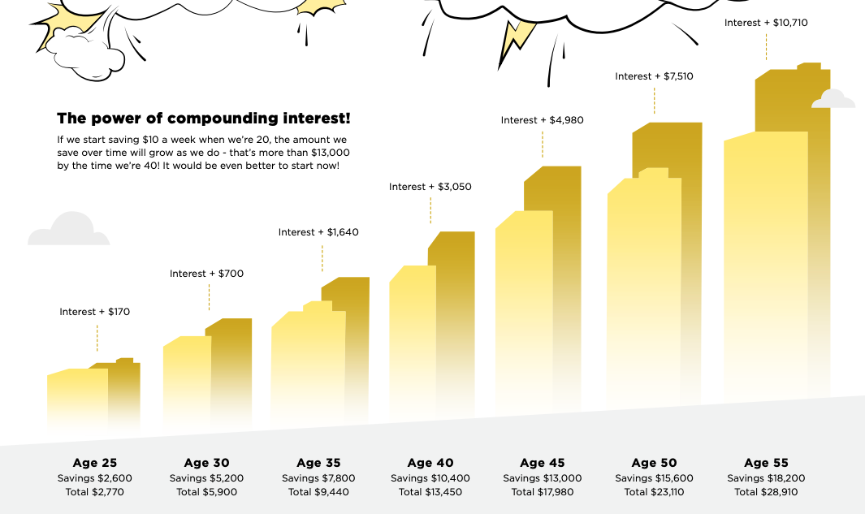

Calculating compound interest
Compound interest can be calculated using a formula:
$$A ={P\left(1+\frac{r}{100}\right)}^{t}$$
- A represents the final amount of your investment after a certain number of years (t)
- P represents the principal, which is the amount that you invest
- r represents the interest rate per annum, for example, if the interest rate is 3.45% per annum, r = 3.45
- t represents the number of years.
Notice how the formula uses brackets and also has an exponent (t). Remember to use BEMA when using this formula: brackets, then exponents, then multiplication.
Not sure how to calculate an exponent on your calculator? Different calculators use different symbols for this function. Some use a ^ key, others have a symbol such as $x{}^{y}$. If you’re not sure, check with your teacher.
Example:
Charlie invests $2,400 for 5 years at a compounding interest rate of 4.25%. How much interest will he earn in 5 years?
Answer:
$$A ={P\left(1+\frac{r}{100}\right)}^{t}$$
$$A = \$2,400(1 + \frac{4.25}{100}){{}^{5}}^{}$$
= $2,400 x 1.0425⁵
= $2,400 x 1.231346…
= $2,955.23

Assessment tip
When you’re solving an equation that has multiple steps, avoid rounding your answer until you get to the final step.

The formula can be rearranged to work out what principal you would need to invest to reach a particular amount. For example, if Charlie wants his investment to be worth $4000 after 5 years, how much should he invest if the investment rate is 4.25%?
$$A ={P\left(1+\frac{r}{100}\right)}^{t}$$
$$\$4000 = P(1 + {\frac{4.25}{100}){{}^{5}}_{}^{}}^{}{}^{}$$
$$P = 4000 ÷(1.0425){}^{5}$$
$= 4000 ÷1.231346 ...$
= $3,248.48
Charlie should invest at least $3,248.50 to reach his goal of $4,000 in 5 years.

< Now do Topic 4 Activities 1 and 2>

KiwiSaver
KiwiSaver is a voluntary investment scheme set up by the government to help people get ready for retirement.
People who choose to join KiwiSaver typically put money into a KiwiSaver account each time they get paid. The payments happen automatically, so it’s a really easy way to put money aside. Investment experts invest the money that is in KiwiSaver accounts so that it grows over time.
Timeframe
KiwiSaver funds are mainly for retirement, so even though it’s your money, you can’t use it until you turn 65.
An important exception is that you can use your funds to help buy your first home. You can do this if you have been a KiwiSaver investor for at least three years.
In extreme financial situations, you can also request access to your funds before you turn 65. However, this is usually only if there is no other way for you to access money. For example, if you owned a house, you would need to sell the house and use that money before you could access your KiwiSaver funds, so it’s not helpful to rely on these KiwiSaver funds as a backup plan.

How much do you need to invest?
If you are employed by someone else, you can choose how much of your pay goes into your KiwiSaver account. The options are 3%, 4%, 8%, or 10% of your pay. You can also make additional voluntary payments.
If you are self-employed, a contractor, on a benefit, or not currently working, you can make contributions directly.
Once you join KiwiSaver, you generally keep contributing unless you:
- stop working
- move overseas permanently
- are seriously ill
- are in significant financial hardship.
However, if you need to, you can take a break from saving for 3–12 months and you can do this more than once.

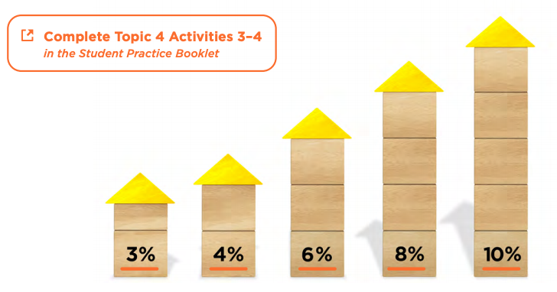
Returns from investing in KiwiSaver

People who invest in KiwiSaver are often surprised at how quickly their money mounts up. This is because as well as your own contributions, your employer also contributes at least 3% of your pay. That’s extra money that you don’t get if you’re not a KiwiSaver investor. The government also puts money in, up to $521 a year. On top of this, your money usually grows as a result of being invested.

< Now do Topic 4 Activities 3 and 4>
Before moving on to Topic Five, check that you understand:
- how to calculate simple interest
- how to calculate compound interest
- how to calculate total KiwiSaver contributions.

Topic Five - Tools that support financial decisions
Learning outcomes for Topic Five:
- Understand how tools such as SMART goals and budgets can support money decisions
- Apply number knowledge through financial decision making or financial problems
- Apply number knowledge to create, monitor and maintain a realistic budget.

Success criteria:
- I can write a SMART goal that supports a financial goal
- I can use fractions, percentages, and decimals to solve multiple step mathematical problems
- I can understand and analyse variables within a budget
- I can use mathematical statements and calculations to communicate sound budgeting decisions.

Budgets
Creating a budget can show you how much income you have coming in and how much money you have going out. You can also use a budget as a planning tool, experimenting with minor changes in different areas of income or expenses to see how much money you can save. When it comes to budgeting, making several minor changes can create a big difference.
A budget lets you see whether you have money left over (a surplus) or not enough money to cover your spending (a deficit). The aim is to make as much surplus as possible so you have spare money to pay off debt, save, or invest towards your goals.

Creating a budget
To create a budget:
Step One: create a list of any money you have coming in, for example, money you earn or receive on a regular basis.
Step Two: create a fairly accurate list of how much you spend each week and what you spend it on. It may take a couple of weeks to get all the information you need. When it’s all together in one place, you’re ready to build a budget.
One way to track your spending is to keep shopping receipts; there are also smartphone apps that can help track spending, for example, the YNAB (you need a budget) app. You can also track your spending by looking at your bank account.
As well as listing your daily or weekly spending, you need to list your regular costs such as your mobile phone data. If you’re creating a weekly budget, you can convert monthly payments into weekly payments by multiplying them by 12 and then dividing by 52.
Step Three: add any money you save regularly to your budget.
Step Four: identify how much your income is and how much your expenses are and calculate the difference between the two using the equation difference = income – expenses.
If the result is a positive number, you have a surplus. You’re spending less than you have coming in.
If the result is negative, you’re on shaky ground financially. You’re spending more than you have coming in.

 |  | Time period | Calculating weekly amount | Weekly amount
Income
Net pay | $1230.86 | Fortnightly (two weekly) | $1230.86 ÷ 2 | $615.43
Expenses
Rent | $210 | Weekly | - | $210
Food | $145 | Weekly | - | $145
Power | $25 | Monthly | $25 x 12 ÷ 52 | $5.76
Cell phone | $30 | Monthly | $30 x 12 ÷ 52 | $6.92
Internet | $20 | Monthly | $20 x 12 ÷ 52 | $4.61
Transport | $50 | Weekly | - | $50
Entertainment | $120 | Weekly | - | $120
Total expenses |  |  |  | $542.29

Making a budget that works
For a budget to work, the information you put in it needs to be accurate and complete. This includes little things like ice-creams or bus fares. A budget also needs to be up to date, so it’s a good idea to check it regularly.
Budgets need room to breathe. If you make your budget super tight, without leaving yourself some flexibility and room for a bit of fun, it will be hard to stick to it. Try to be realistic about how much you need and include some fun money if you can.

Monitoring and maintaining a budget
Setting up a budget is one thing, but sticking to the budget and adjusting it if necessary are what really makes a budget work. Monitoring and maintaining progress are closely connected. Firstly, you won’t know whether you have made any progress if you aren’t monitoring it. Monitoring your progress can also help you to:
- feel a sense of achievement if you’re on track for meeting your goals
- motivate you to try a bit harder if you’ve let things slip
- adjust your budget if it’s not working for you. This may involve adjusting your SMART goals as well.
It’s important a budget provides some room to move. Making minor adjustments across a number of expenses, instead of making one major change, can help ease the pain of cutting down on spending.
Have a look at your existing circumstances and see whether you can negotiate some minor changes. For example, if you have a job and are a reliable worker, you might be able to negotiate a small pay increase. A pay rise of even a few cents per hour can help your savings to mount up over the course of a year.
Assessment Tip
Exploring alternative options or solutions is a common feature of Numeric Reasoning assessment tasks. This gives you an opportunity to show that you can make links to the context of the problem you are solving.
For Excellence, your responses will need to be clearly communicated through correct mathematical equations and statements. You must explain any decisions that you make, relating them to factors in the scenario that support your solution to the problem.

Setting SMART Goals

Whāia te iti kahurangi ki te tūohu koe me he maunga teitei
Seek the treasure you value most dearly: if you bow your head, let it be to a lofty mountain
This well-known whakataukī is about aiming high and setting your sights on achieving something truly valuable. It also encourages you to be persistent about reaching your goals.
Financial goals can be small or large and can be set for any length of time. It’s good to have a few spread over the short, medium and long terms.
One common way to set goals is by using the SMART goals framework:

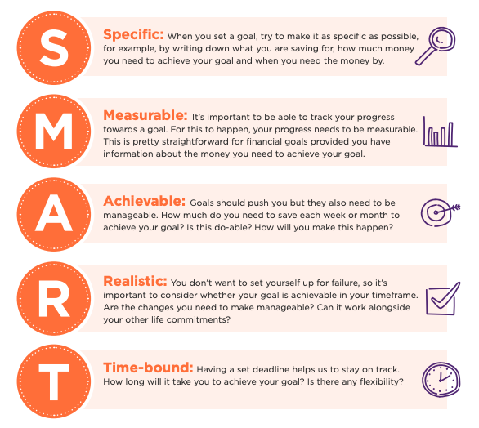
Watch this video about setting goals as a summary.

Read the scenario below about Roimata’s sister Ameria, who is in year 11. Ameria uses a SMART goal tool to clearly define her steps to achieve the financial goal of going to a music festival.

Ameria has recently started work and would like to go to a music festival in three month’s time.
She gets paid every month. She is earning a gross salary of $800 per month from her job (before tax and other deductions). The Inland Revenue Department deducts $95.11 income tax and levies each month. Ameria contributes 3% of her gross salary to her KiwiSaver.
Ameria pays ⅓ of her net income into her savings account. She funds her own expenses such as clothing, travel, phone plan, entertainment etc. which usually comes to at least $120 a month.
The festival ticket is $376 including GST. The transport costs are around $500. Ameria will also need some spending money for food and drinks. She estimates that $40 a day will be enough.
Ameria needs to pay for the festival ticket as soon as possible (before the festival is sold out) and for the flights within the next month.

Specific | Ameria wants to be able to cover the cost of going to the festival, including the festival ticket, flights, and spending money.
Measurable | The total cost of the festival is $996.
Achievable | Ameria is currently saving one-third of her income each month.
Realistic | If Ameria budgets carefully she will be able to meet her goal.
Time-bound | Ameria wants to pay for the flights and festival ticket within a month. She has three months to save up for the rest of the costs.

Using mathematical statements and calculations Ameria can determine what amount of her total pay she will have to save to achieve her goal.

Steps to determine whether the goal is attainable
- Calculate the costs involved for the festival
- Calculate Ameria’s average income for each month
- Calculate Ameria’s average outgoings for each month
- Determine how much Ameria has available to pay for the festival tickets, flights and spending money.

- Calculate the costs involved for the festival.
Costs for festival to save for:
= ticket + flight + spending money
= $376 + $500 + (3 x $40)
= $996

- Calculate Ameria’s average income for each month
Monthly deductions from gross pay:
= income tax/levies + KiwiSaver
= $95.11 + ($800 x 0.03)
= $71.11
Monthly net income:
= gross income - deductions
= $800 - $71.11
= $728.89
- Calculate Ameria’s average outgoings for each month
Monthly outgoings:
= expenses + savings
= $120 + ($728.89 x ⅓)
= $362.96
- Determine how much Ameria has available to pay for the festival tickets, flights and spending money.
Monthly surplus:
= net income - outgoings
= $728.89 - $362.96
= $365.90
Surplus in next three months:
= $365.90 x 3
= $1,098
Ameria’s surplus after the second month is enough to cover the cost of the flights but doesn’t cover the cost of the tickets. As long as the festival does not sell out, Ameria can purchase the festival ticket in the third month.
Her SMART goal can be achieved but there is not a lot of room for Ameria to reach her goal. To make it more achievable, Ameria could adjust her outgoings for this period of time or calculate a sensible short-term loan option to purchase the festival tickets. However, this would not meet her specific goal.

< Now do Topic 5 Activities 1 to 3>

Ka pai! You have completed the Money Matters module. To get ready for your assessment, make sure that you understand how to communicate your numeric reasoning using correct mathematical statements.

