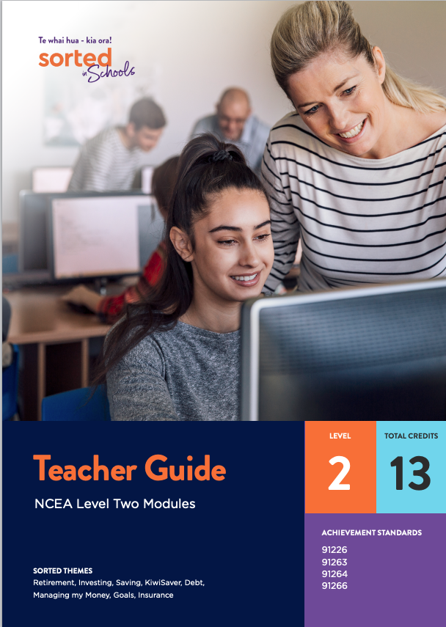

Teacher Guide - NCEA Level Two Modules

This teacher guide provides an overview of the Sorted in Schools - Te whai hua - kia ora! Achievement Standard modules.

These modules provide opportunities for students to develop their financial capability skills and knowledge while gaining ncea credits in mathematics and statistics and economics.

The benefits of using financial capability as a context for learning mathematics and statistics and economics
Financial capability is an ideal context for strengthening literacy and numeracy skills and understandings, developing the key competencies, and exploring values. Supporting learners to become confident, responsible, and capable in managing their finances contributes to:
- achieving The New Zealand Curriculum vision for young people to be "confident, connected, actively involved, lifelong learners"
- the graduate profile of Te Marautanga o Aotearoa, specifically that students are "able to contribute to and participate positively in the community" and "living successful and fulfilling lives."
“Financial capability is highlighted in The New Zealand Curriculum as an example of the type of theme that schools could use for effective cross-curricular teaching and learning programmes.” TKI’s Financial Capability web page.

Overview of the learning materials
The learning materials can be used either as teacher-led lessons or for students to work individually at their own pace. Each booklet is provided as a Word document and PDF to use online or printed. When used online, students can type answers into the practice booklet.

Teacher resources:
- this teacher guide which introduces each module, including curriculum and assessment links and information about the contexts and financial capabilities explored within each module
- a full course outline and design that provides the rationale for the Levels 1 and 2 modules, possible resources, an overview of the contexts for learning and possible approaches to programme design
- a course outline for NCEA Level Two modules that provides a summary of the Level Two modules’ themes and contexts
- an answer booklet to accompany the student practice booklet for each module. You can choose whether or not to share this with students.

Student resources:
Each module includes:
- a student guide that introduces students to the requirements of the standard they will be assessed against, the contexts they will be exploring, and the areas of financial capability that are incorporated into the resource
- a student booklet that supports students to develop the content knowledge, processes, skills and thinking that they need to successfully meet achievement standard outcomes. The student booklets draw on real life examples that are linked to Sorted in Schools financial capability themes and have a strong Aotearoa New Zealand focus. They include tips on what to expect in the assessment.
- a vocabulary list of key terms.
- a video highlighting one of the social issues or statistical processes explored in the module
- a practice booklet that provides opportunities for students to apply and consolidate their learning.

Assessment materials:
NZQA quality-assured assessment materials, including:
- an assessment task
- an assessment schedule
- a marking schedule.

Assessing the achievement standards
Each module includes an assessment task that can be used to consistently assess students’ progress in relation to the standard.
The assessment schedules provide indicative responses at Achieved, Merit, and Excellence level, and teacher judgment is required for awarding of grades.
For more information and support on how to assess standards, see additional assessment support for mathematics and economics standards on the NZQA website.

Sorted Themes
In each module students are given information, videos, examples, and activities that relate to some of the Sorted Themes. These help students build financial skills, knowledge, and behaviours specific to each theme.

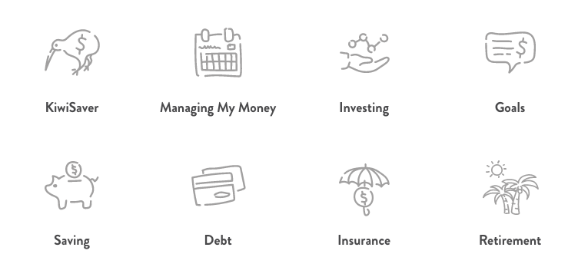

Societal issues as contexts for learning
As well as financial capability, the learning materials use current societal issues as contexts for learning. These are outlined in the teacher notes below. By supporting students to explore these issues as they work through the learning materials, the learning will be more engaging and relevant to their everyday lives.

Teacher notes for each module
This section provides a brief overview of each module and teacher notes specific to each module.
All of the Sorted in Schools learning materials include a combination of key financial capability concepts, or Sorted Themes, to help students develop their financial skills, knowledge, and behaviours.
Each module also introduces students to a societal issue as outlined below.

Economic Data, Issues, and Analysis module

Sorted Themes: Savings, KiwiSaver, Retirement

Contexts for learning: Inequality, climate change and the New Zealand economy

In the Economic Data, Issues and Analysis module students learn about processing and presenting statistical data as well as explaining how the data sets are interrelated. The data relates to two economic issues, inequality and climate change. The explanations relate to the data and their interrelationships while using economic models and/or concepts. Extrapolation of data needs to be justified by the analysis of the data and the interrelationships.
The Sorted Themes are used as contexts for practice tasks.

Links to Level 7 Financial Capability progressions:
- Investment: Describe and explain how age, income, and circumstance affect financial decisions, e.g. buying a car.

Assessing the standard
The assessment task looks at factors that impact on income and how income impacts on inequality. It also looks at factors that impact on climate change and how those might impact on income and inequality. Students should consider that it is possible for conflicting views to both be valid and therefore factors impacting climate change and inequality can be both positive and negative. Students also need to ensure that they present economic explanations using economic models and/or Level 7 concepts.
TKI resources and conditions of assessment related to this achievement standard can be found at the Resources for Internally Assessed Achievement Standards page.

Questionnaire Design module

Sorted Themes: Saving, Investing, KiwiSaver

Contexts for learning: Financial identity; Māori identity and financial attitudes
In the Questionnaire Design module, students learn about the concept of financial identity. Financial identity is defined as the values, knowledge, skills and behaviours that influence how people manage money to build personal or collective financial wellbeing. Exploring financial identity can help students understand their values, beliefs, and behaviours related to money.
Throughout the module, students hear from Dr Carla Houkamau, a lecturer at The University of Auckland. Dr Haukamau and her team are conducting a study called Te Rangahau o Te Tuakiri Māori me Ngā Waiaro ā-Pūtea; The Māori Identity and Financial Attitudes Study (MIFAS). This is a questionnaire-based, longitudinal, national study. Dr Houkamau provides students with expert insight into the process her team has used to develop their questionnaire and conduct their survey.

Links to Level 7 Financial Capability progressions:
- Spending: Describe different views about making wise spending choices in relation to age and circumstances.

Assessing the standard
The assessment activity requires students to design a questionnaire that can provide the Commission for Financial Capability (CFFC) with information about the behaviours, knowledge, or attitudes of young New Zealanders towards money.
Students are assessed on the process they use to design and develop the questionnaire, as well as their final product. The Student Guide provides a checklist of key stages, from initial draft through to the completed questionnaire. It also provides questions that students can answer to gather evidence of their decision making throughout the process. It’s a good idea to sign off the completion of each checkpoint to ensure that students are meeting the requirements of the standard as they may be unfamiliar with the iterative nature of the design process.
Students are encouraged to discuss the presentation of their report with you, for example, as a PowerPoint presentation with a voiceover, a written report, or an oral presentation.
TKI resources and Conditions of Assessment related to this achievement standard can be found at the Resources for Internally Assessed Achievement Standards page.

Statistical Inference module

Sorted Themes: KiwiSaver, Retirement, Managing my Money

Contexts for learning: Inequality, especially the gender pay gap
In the Statistical Inference module, students learn about the gender pay gap, with a particular focus on KiwiSaver investments. This context provides an opportunity for students to explore statistical inference using a real life scenario that affects them and their whānau.
Students may already be aware that there is a gender pay gap in Aotearoa New Zealand. In 2020, the gender pay gap (measured as the difference in median hourly pay of men and women) was 9.5 percent.
One consequence of the gender pay gap is that females have less money to save and invest and, as a result, less money when they reach retirement age. This disparity is called the gender investment gap. Research conducted by the ANZ bank in 2017 showed that females’ KiwiSaver balances are, on average, lower than males in all age ranges. This places an extra financial burden on females and is compounded with the fact that females tend to live longer than men. Supporting females to keep investing in KiwiSaver is one way to help reduce the gender investment gap.
The student booklet explains the importance of being able to track the gender investment gap. To do this, we need up-to-date information about how much money people have invested in KiwiSaver. There’s no straightforward way to get this information from the entire population, which is why we need to make an inference based on a sample.

PEEL framework
The student booklet introduces the students to the PEEL framework as a strategy for structuring their responses. If you’re not familiar with this framework, you may like to watch Sophie Wright’s (Mt Roskill Grammar School) presentation available on the CensusAtSchool website.

Links to Level 7 Financial Capability progressions:
- Investment: Describe and explain investment options in relation to age, income and circumstance, e.g., KiwiSaver, term deposits, bonds, property, shares.
- Budgeting and financial management: Plan for life-stage financial event(s) and make the financial decisions required, e.g., going flatting, getting a job, retiring.

Assessing the standard
The assessment activity requires students to pose a comparative question based on customised 2018 Stats NZ data containing 831 records and eight variables. The data has been presented as being from a small town in Northland in order to meet the requirement of the standard for students to select a sample from a population. You may like to change the location of the town to a region the students will be familiar with.
Before giving students the assessment activity, ensure that they have access to relevant background information on income inequality. Useful examples include:
- the Ministry for Women website, which provides information about the gender pay gap, including the proportion of unpaid caring work that is done by women
- StatsNZ, which provides information on why they use median hourly pay as a measure to explore the gender pay gap rather than weekly pay on their measuring the gender pay gap page.
TKI resources and conditions of assessment related to this achievement standard can be found at the Resources for Internally Assessed Achievement Standards page.

Statistical Reports module

Sorted Themes: KiwiSaver, Retirement, Investing

Context for learning: Ethical investment
In the Statistical Reports module, students learn about KiwiSaver, with a particular focus on ethical investments. This context provides an opportunity for students to explore aspects of decision making that go into choosing a KiwiSaver fund provider, emphasising that investment should always be an active and informed process that requires people to recognise and weigh up their personal needs, goals, and values. You can read more about ethical KiwiSaver investments in this Looking for Ethical Options blog on the Sorted.org.nz website.
The statistical report used as an exemplar throughout the module is the Mindful Money report Responsible Investment: NZ Survey 2019. You may like to limit the number of pages that you give to the students, based on your understanding of their learning needs.
Mindful Money is an Aotearoa New Zealand charity that aims to shift the ways that people invest their money away from investments involving pollution and exploitation and towards sustainability. You can read more about Mindful Money by visiting the Mindful Money website.

Links to Level 7 Financial Capability progressions:
- Investment: Describe and explain investment options in relation to age, income and circumstance, e.g., KiwiSaver, term deposits, bonds, property, shares.

Assessing the standard
The assessment activity requires students to evaluate the statistically based ANZ Bank report on the financial wellbeing of adults in New Zealand (2018). An abridged version of the report has been provided as part of the assessment task.
You may like to explore the concept of financial wellbeing with your class before giving them the assessment activity. This Spinoff article explores the interrelationship between financial strain and overall well being. Teacher discretion is required to assess the suitability of this article for their students.
TKI resources and conditions of assessment related to this achievement standard can be found at the Resources for Internally Assessed Achievement Standards page.

https://www.anz.co.nz/content/dam/anzconz/documents/personal/investments-kiwisaver/KiwiSaver-10-Year-Anniversary-Report.pdf

