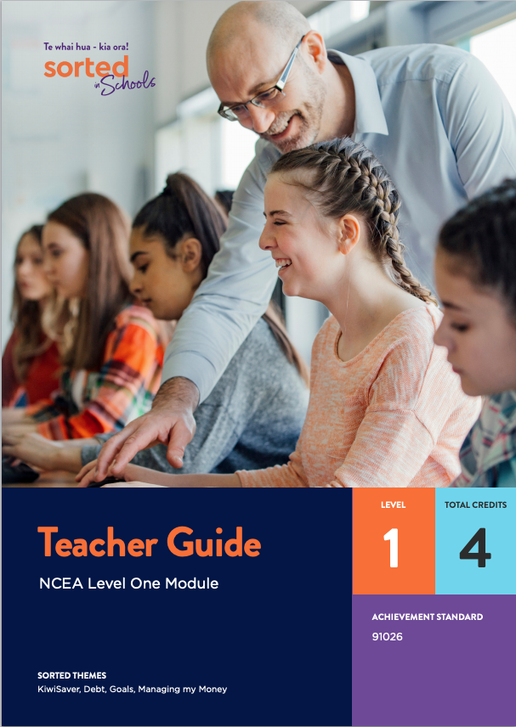

Teacher Guide - NCEA Level One Module

AS91026 Apply numeric reasoning in solving problems | Te whakamahi whakaaro tau whaitake hei whakaoti rapanga (version 3)

Mathematics and Statistics

Level: 1
Credits: 4

This teacher guide provides an overview of the Sorted in Schools - Te whai hua - kia ora! Level One Achievement Standard module Money Matters.

This module provides opportunities for students to strengthen their financial capability skills and knowledge while developing the skills and knowledge they need for success in the Level One Achievement Standard AS91026 Apply numeric reasoning in solving problems.

The benefits of using financial capability as a context for learning mathematics
Financial capability is an ideal context for strengthening literacy and numeracy skills and understandings, developing the key competencies, and exploring values. Supporting learners to become confident, responsible, and capable in managing their finances contributes to:
- achieving The New Zealand Curriculum vision for young people to be "confident, connected, actively involved, lifelong learners"
- the graduate profile of Te Marautanga o Aotearoa, specifically that students are "able to contribute to and participate positively in the community" and "living successful and fulfilling lives."
“Financial capability is highlighted in The New Zealand Curriculum as an example of the type of theme that schools could use for effective cross-curricular teaching and learning programmes.” TKI’s Financial Capability web page.

Overview of the learning materials
The learning materials can be used either as teacher-led lessons or for students to work individually at their own pace. The module is not designed to cover all of the skills covered in a standard Number course. Instead, the focus is on number skills related to earning, spending, borrowing, saving and investing money. These contexts provide a useful opportunity for students to apply and consolidate key numeric reasoning skills.
Each booklet is provided as a Word document and PDF to use online or printed. When used online, students can type answers into the practice booklet.

Teacher resources:
- this teacher guide which introduces each module, including curriculum and assessment links and information about the contexts and financial capabilities explored within each module
- a full course outline and design that provides the rationale for the Levels 1 and 2 modules, possible resources, an overview of the contexts for learning and possible approaches to programme design
- a course outline for the NCEA Level One module that provides a summary of the Level One module themes and contexts
- an answer booklet to accompany the student practice booklet for each module. You can choose whether or not to share this with students.

Student resources:
Each module includes:
- a student guide that introduces students to the requirements of the standard they will be assessed against, the contexts they will be exploring, and the areas of financial capability that are incorporated into the resource
- a student booklet that supports students to develop the content knowledge, processes, skills and thinking that they need to successfully meet achievement standard outcomes. The student booklets draw on real life examples that are linked to Sorted in Schools financial capability themes and have a strong New Zealand focus. They include tips on what to expect in the assessment.
- a practice booklet that provides opportunities for students to apply and consolidate their learning.
- a vocabulary list of key terms.

Assessment materials:
NZQA quality-assured assessment materials, including:
- an assessment task
- an assessment schedule
- a marking schedule.

Assessing the achievement standards
The module includes an assessment task that can be used to consistently assess students’ progress in relation to the standard.
The assessment schedule provides indicative responses at Achieved, Merit, and Excellence level, and teacher judgment is required for awarding of grades.
For more information and support on how to assess standards, see additional assessment support for mathematics standards on the NZQA website.

Sorted Themes
In the module, students are given information, examples, and activities that relate to some of the Sorted Themes. These help students build financial skills, knowledge, and behaviours specific to each theme.

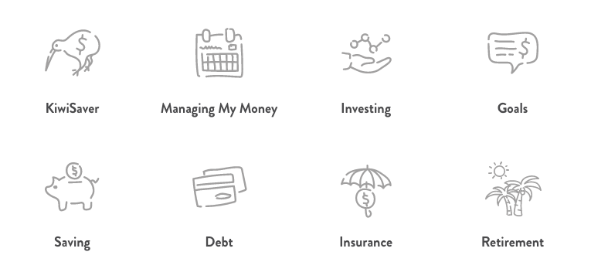
In the Money Matters module, students learn about payslips, tax, GST, student loans, term deposits, compound interest, KiwiSaver, budgets, and SMART goals.
Key maths skills include rates, ratios, fractions, percentages, decimals, rounding, order of operations (BEMA), using a formula to calculate compound interest, adding and removing GST, and percentage change.

Links to Level 6 Financial Capability progressions:
- Spending: Describe different ways of spending, e.g., online purchasing, layby, hire-purchase, phone plans.
- Credit and debt: Calculate and compare interest rates charged by banks and other financial institutions.
- Saving and investing: Explain and calculate compound interest.
- Income and taxation: Investigate the way people get paid, including wage and salary deductions; Make income-related calculations for financial management, e.g., hourly, weekly, net pay, annual gross pay; compare different rates of taxation commitments; describe how taxation contributes to community well-being.
- Budgeting and financial management: Use financial management tools to monitor a given budget.

Assessing the standard
The assessment activity requires students to use extended abstract thinking to perform operations with fractions, decimals, percentages, and ratios. The context is a young person who has just started her first job and is also moving into a new flat.
The module provides opportunities for students to develop useful contextual knowledge about KiwiSaver, PAYE, student loan repayments, tax, and aspects of flatting such as the need to share expenses.
TKI resources and conditions of assessment related to this achievement standard can be found at the Resources for Internally Assessed Achievement Standards page.

