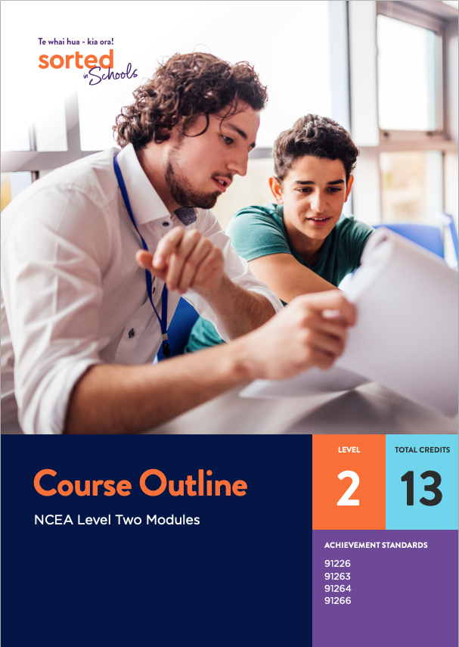

Course Outline - NCEA Level Two Modules

There are currently four Sorted in Schools NCEA Level Two Achievement Standard modules:
Module name | Achievement standard | Sorted Themes | Key learning contexts | Suggested contact teaching time
Questionnaire Design | AS91263 Design a questionnaire  3 credits | KiwiSaver  Saving  Investing | Students are supported to explore aspects of financial identity when they create their own questionnaire as part of their assessment.  Refers to a questionnaire-based study that is being used to research the relationship between Māori identity and financial attitudes as an example. | 25 hrs
Statistical Inference | AS91264 Use statistical methods to make an inference  4 credits | KiwiSaver  Retirement  Managing my Money | The gender pay gap, with a particular focus on how much money New Zealanders have invested in KiwiSaver. | 30 hrs
Statistical Reports | AS91266 Evaluate a statistically based report  2 credits | KiwiSaver  Retirement  Investing | Understanding some of the decisions involved in investing in KiwiSaver, especially ethical KiwiSaver investing. | 20 hrs
Economic data, issues, and analysis | AS91226 Analyse statistical data relating to contemporary economic issues  4 credits | Savings  KiwiSaver  Retirement | Interrelationships between inequality, climate change, and the New Zealand economy. | 30 hrs
The time required to teach each module is provided as a guide only.

The modules are designed for students to be able to work independently or, preferably, with their peers. While not essential, it is expected that students will be able to access expertise from their teacher to support their learning and guide them through the assessments.
The modules can be used separately or combined to form a programme of learning.
The modules can be completed in any order.
The modules can form the basis of a Level Two statistics course, with an additional achievement standard selected by the teacher, for example, AS91265 - Conduct an experiment to investigate a situation using statistical methods or AS91268 - Investigate a situation involving elements of chance using a simulation.
Alternatively, teachers may like to select one or more of the modules to weave into a financial capability course that combines both unit standard assessments and achievement standards. The Sorted in Schools NCEA Toolkit provides resources for a range unit standard assessments.
For example, the Statistical Inference (AS91264 Use statistical methods to make an inference) module would be a natural complement to the following unit standard based modules:
- Ages and Stages (US28089 Demonstrate understanding of the effect of life stages on personal income)
- Future Focus (US28090 Demonstrate knowledge of personal financial saving and investment options for given scenario(s)).
The Statistical Reports module (AS91266 Evaluate a statistically based report) could also build on explorations of KiwiSaver that students developed through the Future Focus unit standard module.
The modules make important connections with societal issues such as the gender pay gap, social inequality, and climate change. Students may be able to use and extend the contextual knowledge they develop through the Achievement Standards modules to contribute to the following Achievement Standards:
- AS91101 Produce a selection of crafted and controlled writing
- AS91102 Construct and deliver a crafted and controlled oral text
- AS91103 Create a crafted and controlled visual and verbal text.

