Kete Timatanga - aratohu whakaakoranga
He aha te painga o taku whakamahi?
Ko te whāinga o tēnei rauemi ko te āwhina kia mārama ai ngā tauira ki ngā tikanga me ngā kupu matua o te āheitanga ahumoni.
Ka taea te whakamahi:
- hei huinga akoranga e whakamahia ai i mua i te whakaako ā-tuihono i ngā hōtaka me ngā akoranga o Te whai hua – kia ora tau 9/10
- hei huinga akoranga motuhake ki te whakaako i te āheitanga ahumoni ki ngā rōpū whānau
- kia tirohia ngā mātauranga kua mōhio kē ngā tauira
- hei rauemi tīmata mō ngā tau 7/ 8

Hei aha kei roto?
KŌWAE AKO | RAUEMI | ATAATA | KAI RORO | KUPU AHUMONI
Aratohu paetīmata ki te moni | Whakatakinga ki ngā kōwae whakaako, kōwae akoako.
TE WHAKAPAU I Ō MONI |  |  |  | pēke, pūkete pēke, moni penapena, utu o ia rā, ATM, nama, pēke tuihono, moni tāpui, tango pūtea, utu huamoni, utu pēke, hanga me te ratonga, EFTPOS, moni taurewa, hoko tāpui, utu ukauka, nama, kupu ārahi ahumoni, hiahia me ngā matea, nama pai, nama kāore i utua, hoko tuihono, GST.
INA HAERE KOE KI TE MAHI |  |  |  | utu ā-haora, utu ā-tau, utu iti katoa, utu pēke, utu more, tāke, KiwiSaver, tangohanga. Moni whiwhi, tāke moni whiwhi, utu harangote, puka utu, Tari Tāke (IRD), tau IRD, rā mate, rā hararei, wā utu, haora hemihemi, whakahokinga moni, tau Pūtea.
TE PENAPENA I Ō MONI |  |  |  | moni penapena, māha tōmuri, auau, whāinga, pūtea whawhati tata, huamoni penapena, kupu ārahi ahumoni, ōrau huamoni, pūtea penapoto, pūtea penaroa.
TE MINO MONI |  |  |  | mino moni, huamoni, kaituku moni mino, pēke, pūtea taurewa, kirimana, konihi pūtea taurewa, kamupene pūtea taurewa, utu pēke, tāpaenga ukauka wawe, moni taurewa, nama, nama pai, nama kāore i utua.
WERO  -Whakaritea he pātī kanikani  -Whakaritea he haerenga hākinakina ki waho o te taone |  | Ka kōwhiria e ngā tauira tētahi o ētahi wero e rua, ka whakamahi ai i ngā uka kua haupū i ngā kōwae hei whakaoti i te mahi.

He pēhea te mahi?
Mātakihia te kōwae “He kupu ārahi mō te moni mā te tauhou” hei whakatakinga.
E whā ngā kōwae hei whakaoti mai mā ngā tauira. Ko tā ia kōwae he whakataki kupu hou ka tautokohia e te wheako ako, te tikanga o te kupu, tētahi ataata e hāngai ana me tētahi kai roro. Ka arahina te kaiwhakamahi e ia kōwae ako ki te tohuāki, ka whakaatu anō i te ahu whakamua i te kōwae.
Inoihia ō tauira kia whai whakaaro tonu ki ngā kōwae kua tutuki i a rātou mēnā e whai ana koe kia tutuki te Kete Tīmatanga nei i roto i ētahi whakaakoranga maha.
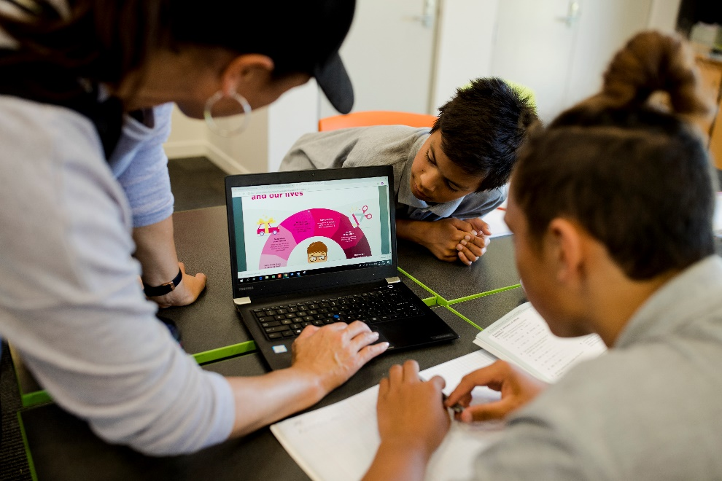
I ia kōwae ako, ka whakautua e ngā tauira he pātai whirirau. Ka whakawhiwhia rātou ki te 100 uka kōura iti iho rānei. Ki te tika i a rātou tētahi pātai i te whakamātautanga tuatahi, ka whiwhi rātou i te 100 uka kōura - ka tatauhia te tapeke i te roanga atu o te tukanga. Ka whiwhi uka ngā tauira ina whakamātau tonu engari ka iti iho ngā uka i ia whakamātautanga.
Ka kōwhiria e ngā tauira tētahi wero hei tūmahi whakamutunga. Ka whakamahia e rātou te uara moni tapeke o ngā uka kua whiwhi rātou mō te wero nei.
Me tikiatu ngā Wero ā-PDF kia pai ai te whakatutuki a ngā tauira i te wero ki te akomanga. E āhei ana ngā tauira ki te mahi ā-rōpū, ka whakakotahi ai i ā rātou tapeke mō te wero. E āhei ana rātou ki te whakaatu i te wero kua tutuki i a rātou ki te akomanga, kia pai ai te pōti a ngā tauira mō te wero ka tino pai ki a rātou i runga i te whai whakaaro ki te uara pai katoa mō te moni ka whakapaua.
Kei te āhua tonu o ngā hiahia o ō tauira, engari ka taea e rātou te whai motuhake haere i ngā kōwae, ka taea rānei e koe te whakamahi te rauemi hei kaupapa whakaako māu ka whai ai i ngā takahanga. Ahakoa tāu ka kōwhiri, me tino mātau koe ki te kōwae ako kia pai ai tō whakatau tata i te roa o te wā e tutuki ai i ngā tauira te mahi.

