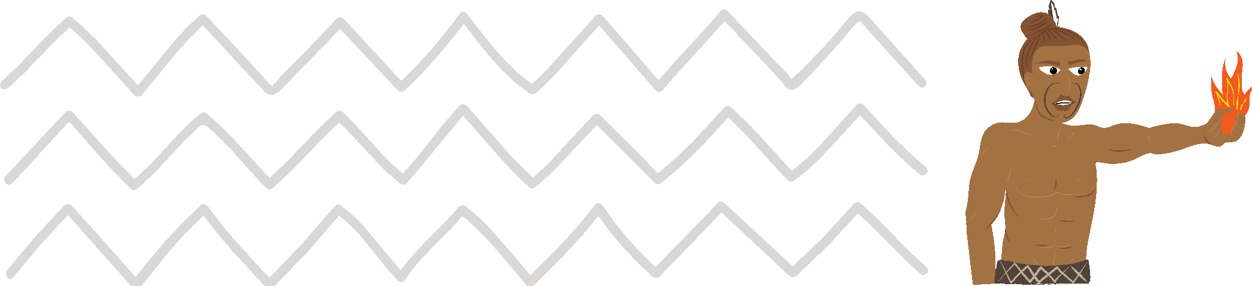
Māui Ātea Te Ngohe Whakatānga 1
I roto i tēnei ngohe, ka:
- ako mē pēhea te whakaara ake i te whakaaro pai
- ako ki te whakamahi i tēnei pūkenga hei āwhina i a rātou ki te waihanga whāinga pae tawhiti, pēnei i te whakatā (kua mutu te mahi)

Pērā ki ō tātou tīpuna, ka taurite tonu te māramatanga o Māui Ihumanea ki te uarā/wāriu o te whakaaro pai.
I tutuki ai ana mahi whakahirahira, nā tana kaha whakapono ki a ia anō. Ahakoa ngā kutukutuahi, pērā ki ōna tuākana, kāore nei i tautoko i a ia i te nuinga o te wā. Nā tēnei tūmomo āhuatanga i maha ai ana mahi whakahirahira. Kei te kōrero tonuhia e te tangata ngā mahi tuku iho ā Māui Ihumanea, ā mohoa noa nei.
I roto i te wāhanga Māui Rautaki o tēnei rauemi, Te Whakatakoto Whāinga; ka whakaatuhia ki a koe ngā mātāpono o te waihanga mahere. I roto i tēnei ngohe, ka tirohia e tātou ētahi pūkenga hei awhina i a tātou ki te whakatakoto whāinga pae tawhiti, pēnei i te whakatā.
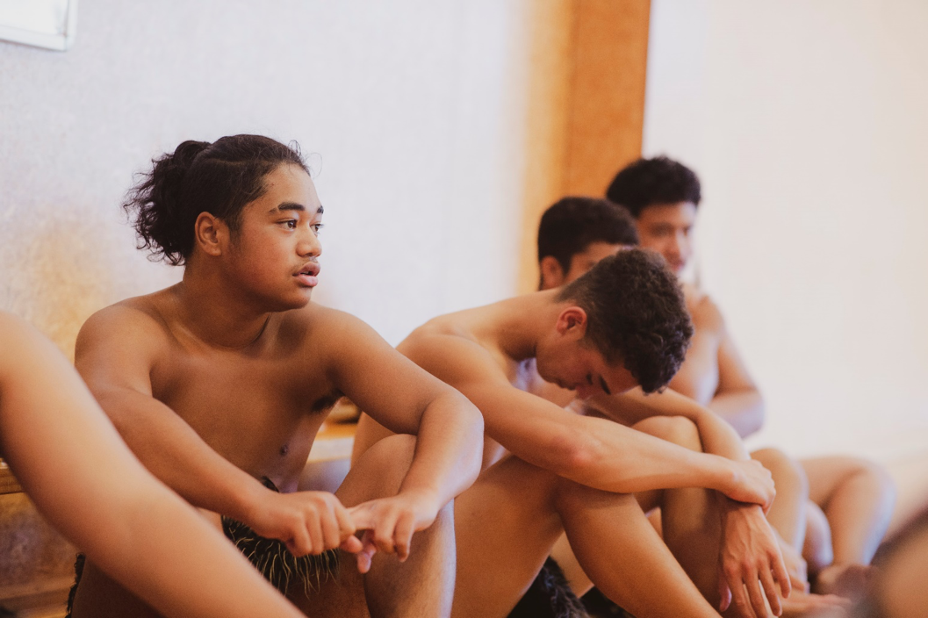

E whakaara ake ana i te whakaaro pai
Tuatahi: Me aroha ki a koe anō, me whakapono ki a koe anō
He rorirori pea te whakaaro me aroha koe ki a koe anō, engari ka piki ake ō kare
ā roto, ka pai anō koe ki ētahi atu. Ko te pono ki a koe anō, ahakoa taua reo whakatūpato, ko te āhua nei ka whāia e koe kia tutuki i runga i tāu i pono ai.

Tuarua: Karakia ia ata, whakahou, whakaaro pai:
Tuatahi ko te whakahaere karakia ia ata, te whakatinana i ngā whakaaro pai, te whakakapi i ngā mahi ki te karakia ia pō, e rongo ai koe i ngā painga kei roto i a koe. Ka pūmau ki te whakaaro pai, pēnei, ‘He ātaahua ahau, he kerewa au, he pai ahau ki ahau anō, me ētahi atu (tāngata) hoki’ i muri i te karakia i te ata, i mua o te karakia i te pō, ka kaha kē atu te whakaaro i roto i a koe, me tō āhua ki ētahi atu hoki.

Tuatoru: Te āwhina i ētahi atu
Ia ata, oho ake ai koe, e pai ana koe ki te āwhina i ētahi atu. Pēnei i te mahi noa i te mahi, kaua e tatari kia kōrerohia koe, ki te awhiawhi, ki te kihikihi i tō whānau, i āu kararehe, i ō hoa. Ko te awhiawhi, ko te menemene ngā tino tāonga mai i tētahi ki tētahi. Ka pārekareka katoa tātou.
Tuawhā: Ia rā me tika te whakatakoto whāinga:
Me whakarite kia rima ngā whāinga ia rā, a, kia māmā noaiho. Pēnei i te:
- whakapai i tō moenga
- paraihe i ō niho
- heru i ō makawe
- whakarite i o kākahu mō āpōpō
- parakuihi
Whiu, e rima kua oti, kāore anō au kia neke.
Tuarima: Whakatauria, ka whakawhanake pūkenga hou
Ko te painga o tōu rēanga, ko te maha o ngā hapa ka puta i a koutou, kāore noa he aha ki te tangata, nā te mea kei te ako tonu koe. Kapohia, karawhiua! Whakaritea to taurangi ki te mahi i ētahi mahi kāore i pai ki a koe ahakoa mo taua wā noiho. Koia kei a koe ki te mahi i te mahi.
Tuaono: Kia māia

Kāore a Māui i noho i tana kokonga me te whakataruna ki te mahi, i te mea kei pēneitia ia, he rorirori, he heahea ki te kore e ekea e ia. Otirā, he tangata māia kē ia. Kaua e mahue i tētahi whēako i te mea kai te mataku koe, tēnā mahia, ka aha ra.
Tuawhitu: Whakaputaina ō raruraru
Ma te kōrerero i ō raruraru ki tētahi atu e kaha ai koe ki te kōrerorero mo ō āwangawana. Ka wehi tonu te tangata ki te whakaputa i ana raruraru, engari ka pai kē ake o kare ā roto ki te whakaputaina e koe. Kaua e wareware, he hoa ōu.
Tuawaru: Ko koe tonu ā runga!
He tipua a Māui, he tipua hoki koe. Ko koe tonu ā runga, kaore i tua atu i a koe. Ko koe te whakakanōhitanga o ngā tātai kāhui i whakatōpū ai, a, ka puta mai ki a koe. Koinei tāu ki a rātou, engari ki a koe anō, me kaha ake, ko koe tonu hoki ā runga.
Tuaiwa: Noke neke nuku
He mea hanga tō tinana kia neke, ā, ia wā ka neke koe, kai te awhina koe i tō manawa. Kei te awhina hoki koe i tō hinengaro, mā te oreore, mā te harikoa. Whakaritea kia korikori mō te toru tekau meneti ia rā, ā, me te puta anō ki waho.

Tekau: Kai ora, kai pai
He toiora te tinana. E noho pakari tonu ai te tinana, me hauora ngā kai. Me kai pata kai hēki runga paraoa tōhi hei parakuihi kaua ko te inu reka. Me kai hua rākau, kaua ko te rare.
Ma te kaiora e piki ai te ārai mate, ā, e roa ake ai ta tātou noho i runga i te mata o te whenua.
Katoa o ēnei āhuatanga mahi, hei awhi i tō whakatakoto mahere pae tawhiti,
i te mea:
- Ka whakaatu i ētahi paku huarahi whai tikanga hei haratau, kia mau ai
ngā whāinga
- Te hau oranga, taha tinana, taha hinengaro, taha wairua
- Te whakapakari, ki te whakamānawa i a koe e tutuki ai ō whāinga pae tawhiti
- Hei awhi i a koe ki ngā akoranga hou, pūkenga hou, ā, māramatanga hoki

Te Ngohe Whakatānga 1
Kei a koe te wā ināianei ki te whakakikī i te tūtohu i raro iho nei.

Taku Whakaaro Pai
Kaupae | Te Wā Haratau | Ō kōrero, ō whakaaro | E hia ngā wā, kōrero, whakaaro rānei
Tuatahi: Me aroha ki a koe anō, me whakapono ki a koe anō
Tuarua: Karakia ia ata, whakahou, whakaaro pai:
Tuatoru: Te āwhina i ētahi atu
Tuawhā: Ia rā me tika te whakatakoto whāinga
Tuarima: Whakatauria, ka whakawhanake pūkenga hou nei
Tuaono: Kia māia
Tuawhitu: Whakaputaina ō raruraru
Tuawaru: Ko koe tonu ā runga!
Tuaiwa: Noke neke nuku
Tekau: Kai ora, kai pai

He Tauira:
Taku Whakaaro Pai
Kaupae | Te Wa Haratau | O korero,  ō whakaaro | E hia ngā wā, korero, whakaaro rānei
Tuatahi: Me aroha ki a koe anō, me whakapono ki a koe anō | I mua o taku maranga, i te wā e paraihe niho ana au | Taku aroha ki a au anō, taku aroha ki ētahi atu | 10 x
Tuarua: Karakia ia ata, whakahou,  whakaaro pai: | I mua o te moe,  i mua o taku maranga ake i taku moenga i te ata | He ataahua, he kerewa, kei te rata au ki au anō,  ā, ki ētahi atu | 10 x
Tuatoru: Te awhina  i etahi atu | Ki te mōrena atu  ki taku māmā | Ka kī atu au ki a ia, kei te aroha au ki a ia, kātahi ka awhiawhi, ka menemene ki a ia, ā, ka mahi kawhe,  tī rānei māna | I nga wā  ka taea
Tuawhā: Ia ra me tika te whakatakoto whāinga | I te kura, i te kāinga | 1. Whakareri mo te kura  2. Kia harikoa, kia pai  3. Ki te ako i ngā mea katoa ka taea e au  4. Whakarongo ki taku  kaiako  5. Ki te whakangahau i te taha o ōku hoa, ki tōku whānau | Te roanga  o te rā
Tuarima: Whakatauria, ka whakawhanake pūkenga hou nei | I te kura, i te kāinga | Ka taea e au ngā mea katoa, ka mau taku wehi! | Te roanga  o te rā
Tuaono: Kia māia | Te roanga o te rā | Ka whakapātaringia e au mea kāore i te pai ki au. Ka pono tonu taku kōrero. | Te roanga  o te rā
Tuawhitu: Whakaputaina ō raruraru | Me tere tonu | Ka kōrero atu au ki taku parata, i taku māharahara mo tētahi o ōku hoa | I ngā wā  ka taea
Tuawaru: Ko koe  tonu a runga! | Te roanga o te rā | Me harikoa, me whakarongo ki waku mātua, Kaiako, haututū me ōku hoa, me te rekareka ki aku akoranga | Te roanga o  te rā
Tuaiwa: Noke  neke nuku | I ngā wā ka taea | Haututū i te papa tākaro, kapa haka, tākaro pā ringa, omaoma i te whīra | I ngā wā ka taea
Tekau: Kai ora, kai pai | I ngā wā ka taea | He kaiora hei whakakaha  i taku ārai mate. Ka pai taku parakuihi, ka kai hua rākau i tēnei rangi. | I ngā wā ka taea

