Wāhanga Tahi: Tō tuakiri, me tō āheitanga ahimoni.
- Ka pēhea ō mōhiotanga ki te āheitanga ahumoni e whai awenga ai ki tō tuakiri, ki tō papa kāinga, me tō tūnga i te ao?
He nanakia a Māui. Heoi anō, i mōhio nō hea ia me tōna tūnga i te ao. Nā tēnei i whakakaha tōna māia, te pūtake mō te nuinga o ana whakatau. Ko te mutunga iho, i taea ngā mahi nunui te whakaoti pērā i te whakapōturi i te rā. Pēnei i a Māui, ki te pai ake tō mōhiotanga ki tōu ake tirohanga rangatahi Māori ahurei, ka āwhinatia koe i ō whakataunga, ngā whakataunga taha ahumoni anō hoki.
Pēnei i te tokomaha o ngā rangitahi Māori, kāore pea koe i te mahi moni i tēnei wā. Heoi anō, kāore e kore kua kite koe i ō mātua e hoko mai ana i ō hū kura, te hoko kai mā te whānau, te utu nama rānei. Tērā pea kua kitea anō hoki te mahere pūtea rua wiki a ō mātua, ko te tikanga ko ngā hiahia o te whānau te papa whakarite, ā, e pā ana ki te moni i ngā wā katoa, nā te mea koia te mea kotahi ka whai wāhi ki tēnei momo mahere pūtea. Whakaroarohia ētahi atu mahi a tō whānau, ka takoha hoki ki te oranga o te whānau. E hiahiatia ana te wā me te whakapau kaha ki te whakatutuki i aua mea, engari ko te tikanga kāore i te āhukahukatia.
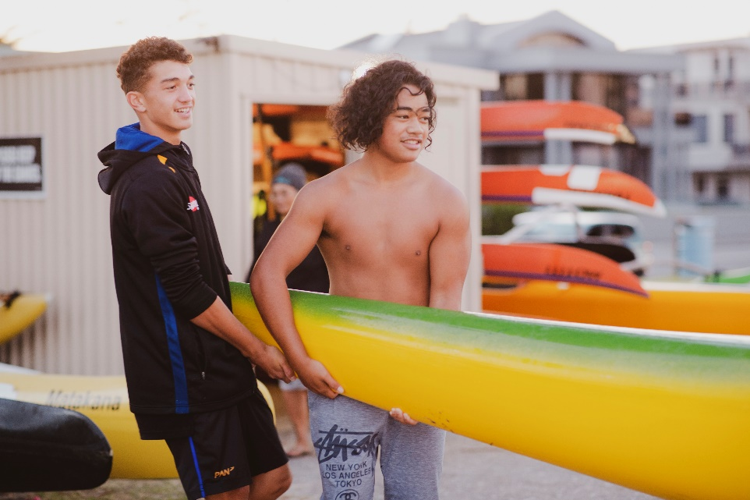
I riro i a koe tō tirohanga Māori rangatahi ahurei i tō whakapapa, i te taha o ētahi atu āhuatanga tuku mai i ngā atua me ngā tipua pēnei i a Māui. Nā reira, nā tō tirohanga ā-ao ka nui ake te uara kia tau ki ngā mea pēnei i te aroha, mana, whanaungatanga, kaua ki te moni. He wāhi tino nui tō te koha ki te whakahaere o ngā whānau Māori, ko tōna pūtake ko te aroha, te manaakitanga me te mana. Ka āhei te tuku i tāu e hiahia ana hei koha, kei a koe te tikanga, ā, kāore e herea ki te wā. Ka whakatinanahia i ngā wā katoa i ngā pōhiri, ko te tikanga he moni te koha ka hoatu e te manuhiri ki te tangata whenua. Heoi, i roto i te wā he nui ngā takoha kai pērā i ngā hipi, poaka, pāua, kōura, ngā aha, ngā aha. He wā ano ka whakatakotoria he momo koha rerekē pēnei i ngā taputapu hiko ka kohaina ki tētahi marae i te wā e tāhopukina ana te hōtaka DIY Marae i reira.
Me whakaroaro ngā wā i hoatu koha ētahi o tō whānau. Pēnei i:
- te haere ki te kohikohi mātaitai, te whakangau poaka mō tētahi marae, hui kura rānei.
- te āwhina i runga i te paepae, i roto i te kāuta rānei i tētahi tangihanga
- te kawe i ngā tamariki katoa i tētahi kōhanga reo, kura, wharekura rānei ki te tangihanga me te whakahoki i a rātou i muri.

He mea takoha te wā ki tō whānau ki te mahi i ēnei mahi mō te oranga o te whānau, ā, he tino waiwai aua ritenga ki tā te Māori tirohanga ki te ao, me te whairawatanga o te whānau.

Engari i tua atu, e kite kē ana tātou i ētahi tauira o ngā whānau e whakatinana ana i ngā ariā matua o te āheitanga ahumoni, engari hāunga te whakahaere i tā rātou moni, e whakahaere kē ana i tō rātou wā, me te takoha mai i ā rātou ratonga, te whakamahi i ā rātou rawa whānau pēnei i ngā pūkenga, huanga tauwhāiti, me te haumi atu ki roto i tō rātou whānau me te hapori whānui atu mā te whakapau wā me te manaakitanga. Mā te whakatutuki i te takoha me te manaakitanga i roto i tō tātou whānau ka whakahaumakotia tātou ki te aroha. Ahakoa te kohikohi kai, ahakoa te mahi moni mō ngā hui me ngā haerenga, ahakoa he āwhina i te marae, ka tino whai wāhi te katoa ki te oranga o tō tātou whānau.

