Māui Mataara Te Inihua Ngohe 3
Te Ao Māori - Te whakarite kia whai Inihua ā tātou taonga tino puiaki
Mā ngā ākonga i tēnei ngohe e:
- ako anō mō te Inihua mai i te tirohanga ao Māori.
- mārama ake ki ngā take e hira ai kia whai Inihua ngā marae me te nui
o ā tātou taonga
Nā Māui tōna ake ora i whakamōrea hei whakarite kia whakawhiwhia te ahi ki te tangata hei puna mahana me te tūrama. He mea waiwai ēnei i ēnei rā. I ēnei rā, he tūraru tēnei mea te ahi, me ētahi atu āhuatanga ko te whakangaromanga me te tūkino ngā hua.
Manaakitanga
- Te Ao Māori
Ko Ngāi Māori te mātāwaka e tino iti rawa ai tō rātou whai Inihua i Aotearoa nei. Ko ngā āhuatanga e pērā ai ko te utu o te Inihua, ko te iti o te moni whiwhi, ko te tokoiti rānei e mōhio ana ki ngā hua o te Inihua.
Mātakitakitia te ataata ka whakautu ai i ngā pātai i raro:
https://www.tvnz.co.nz/one-news/new-zealand/why-do-so-few-m-ori-have-any-insurance
- I turakina te whare rēti i noho ai a Nat rātou ko ana tamariki e te aha?
- He aha ngā taonga i puta ora?
- He aha ia i kore ai e hiahia ki te hoko i tētahi atu momo Inihua, i tua atu i tērā mō tōna waka?
- Ko tēnei mea te manaakitanga he tikanga tiaki tētahi i a tētahi he mea tuku mai e ngā tūpuna. Ki tō whakaaro, i whakaatu te marae i taua manaakitanga? Tēnā whakamāramahia mai.
- I kōrerotia te Inihua Tangata i tēnei ataata. He aha tērā?
- He aha a ngāi Māori e whakatikia ai ina hoko Inihua rātou?
- He aha ngā tohutohu a Peter Cordtz mō te Inihua?

2. Te whakatau uara mō ngā taonga Māori
I roto i te ataata i whakaarohia tētahi kete i waiho e tētahi kuia hei taonga.
He tino uaua te whakatau i tētahi uara mō tētahi mea e whakaaro rauangitia ai e te tangata. I te nuinga o ngā wā e kore pea e taea te whakatau uara ki ngā taonga Māori. Nō reira, mō te whakarite kia rīia tētahi taonga pērā, me whai kaituku uara motuhake ki te aromatawai i tōna uara. Ki te kore e kitea he āteha, tētahi atu rānei ka taea te whakamana i te uara o tō taonga, ka āhei koe te toro i te whare tongarewa o tō takiwā.
I a Māui te Inihua taonga. Waimarie, i taea tōna pahikara te whakakapi. Heoi anō,
he uaua tonu ki a Māui te whakatau i te uara o tōna tiki pounamu, neke atu i te 200
tau te tawhito. He mea tuku iho ki a ia e tōna whānau.
        - Me haere a Māui ki hea kia whakatauria ai te uara o tōna taonga?
        - Mēnā ki a Māui he nui ake te uara o tōna taonga i tērā i hoatu e te āteha, me aha atu anō pea ia?
        - Me aha atu anō a Māui ki te whakarite ka āhei ai te whakaatu i te atahanga pū o tōna taonga?

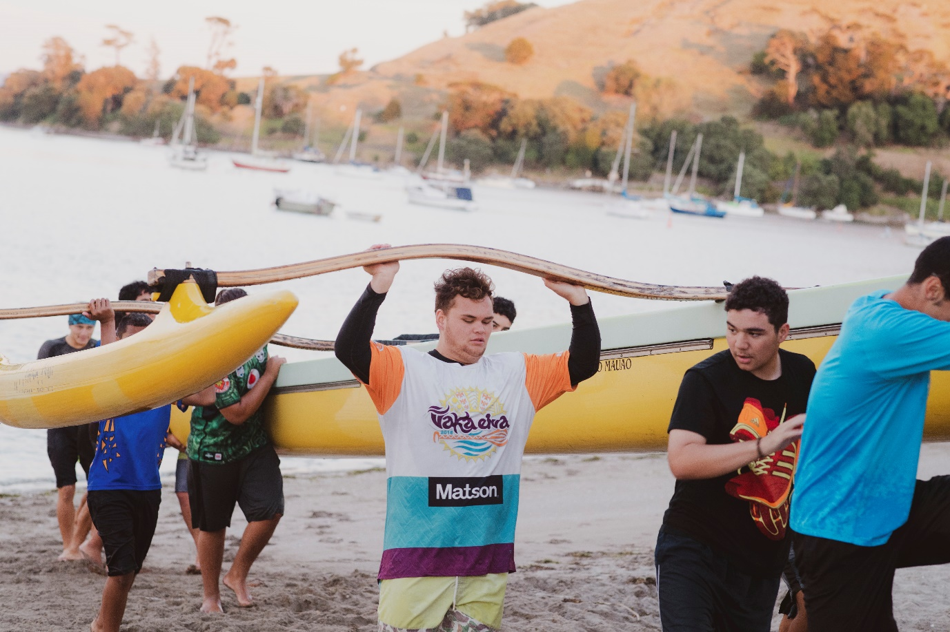

3. Inihua Marae
Ehara i te mea ka pēhia anake ō tātou iwi e te utu mō te Inihua, ka pēhia anō hoki te maha o ō tātou marae. Nā te nui o te utu mō te riānga marae, ka noho he tūmanako moemoeā ki ngā tarahiti marae te utu i ngā nama Inihua ia tau. E whakawhirinaki ana ngā pūtea whakahaere a ngā marae ki ngā koha.
Nā konei i uaua rawa ai ki ngā marae te hoko Inihua. He uaua rawa te whakatau uara ki ngā taonga kāmehameha pērā i ngā whakairo, tukutuku, whāriki, korowai, taonga pounamu, taonga parāoa, me te maha noa atu. He uaua rawa te hoko Inihua e mauri tau ai ngā marae ka parematatia mō te ngaromanga, te whakamōtī hoki/rānei.
He wāhi tino hirahira a Tapu te Ranga Marae i Te Whanganui-a-Tara. Hanga aroha ana ka pau i te ahi i te 11 o Pipiri 2019.
I ngaro i te mura ngā whakairo me ngā mahi toi i waihangatia i roto i te 45 tau. Kāore a Tapu te Ranga Marae i whai Inihua, nā te mea he nui rawa te utu mō te hoko Inihua,
ā, kāore ētahi o ōna whare i whakaaehia e te Kaunihera. Koirā te wheako whakaari tino kino rawa ka tūpono ki tētahi taonga mana nui, taonga ahurea hira e rongonui ana puta noa i te whenua.
- Mahia he rangahau tuihono kia mōhio ai ki ngā kamupene Inihua ka whakarato Inihua ki ngā marae.
- E hia ngā kamupene Inihua Māori?
  - He tauira tō rāua ka taea te whakamahi ki wāhi kē?
  - He rerekē ētahi o ngā mahi o aua kamupene?
  - Ka penapenatia ētahi moni e ngā marae ki te whāia taua tauira e ngā marae?
- Ka pēhea te haumitanga ā-iwi e tautoko ai i ngā nama ā-tau mō te Inihua marae?
